Friday 14th February 2020
Dear Parents/Carers,
I can’t believe that we are halfway through the school year already. What a busy year so far! I do hope that the half-term brings you all some respite from the awful weather we have been having and you and your children manage to get some much needed fresh air and sun.
This week, we welcomed our local Police Community Support Officer and Police Officer, Jenny and James, who delivered a Key Stage 1 and 2 assembly on internet safety. The children were very excited to ask questions about their roles in the community and were particularly interested in all of the equipment they have to carry with them. Pupils spent the afternoon learning about their internet use and the many online dangers. However, despite many of our pupils appearing confident that they know how to be safe online, our activities during the day and our assemblies highlighted that some pupils may not always think about the consequences of their actions, which can cause them to share too much information about themselves and access apps that are not age related. I have set up an ‘Internet Safety’ tab on our school website, where I will leave information sheets and useful websites to support you with this at home.
Portholland class visited The Roseland Multi-academy Trust’s music department on Tuesday for their first music producing session. All the children were amazed at the level of technology available and began producing tracks to be added to their very own album. Watch this space for details of the album launch later in the term!
Please don’t forget to sign up for Parents' Evening, which is being held from 3.30pm - 7. 30 pm on Wednesday 26th February. The sign up form is in the front reception or alternatively you can phone Mrs Kirby on 01872 530 643. It is crucial that you attend this meeting to discuss your child’s progress and we look forward to welcoming you with a cup of tea and some cake.
I am putting out a plea. If you have an animal hutch and/or run that you no longer need, we would gladly take it off your hands. We are looking to welcome some guinea pigs to our school community, but need to have a home for them before we do. Also, if you or anyone you know has an interest in gardening, we would welcome your support with open arms. Our school garden is looking very sorry after a terrible winter and we would love to start up a thriving gardening club. Please let me know if you can help with this or any of the above on head@tregony.cornwall.sch.uk or see Debbie in the office. Thank you.
After half-term, it will be Summers’ and Portholland’s turn to swim. Please see the revised timetable below. Mrs Kirby will also be placing a school uniform order; this needs to be handed in by Friday 28th February. Please can we politely request that you reverse into parking spaces for health and safety reasons. There was a very near miss this week, where a child nearly got their toes run over. Thank you.
Have a lovely half-term holiday and we look forward to welcoming you back to school on Monday 24th February.
Kate Douglass
Headteacher.
Our Basketball team played really well on Wednesday, showing great teamwork. Unfortunately, Par cross country had to be postponed again this week due to the weather conditions. We had our swimming assessments this week and nearly everyone improved on their previous distance. Well done!
Please see below for updated swimming dates.

Miss Mulroy

P.E lead
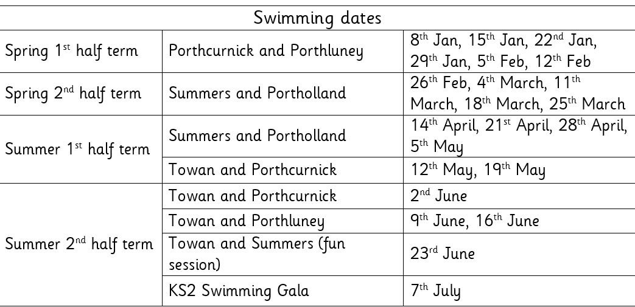

- Multi-academy Trust letter  - Parents’ Evening Letter  - Clubs letter | Value of the Week: Care
Finally, don’t forget to check our website for school related information, which we are in the process of updating.
- Monday 17th February - Half term
- Wednesday 26th February - Parents’ Evening
- St Piran’s Day Menu 5th March
- Tuesday 3rd March - Year 6 Flambards/Britain in the Blitz trip
- Thursday 5th March World Book Day
- 13th March Fun Fest
- Tuesday 17th March Summers’ trip to Truro Museum
- Thursday 19th March - NSPCC assemblies

Oscar Grunberger-Miles for super phonics work and application of his reading skills when completing his maths assessment.  James Trudgeon, Summer Gibson, Matthew Dinsdale, Beau Matthews, Ethan Humphries, Anna Wadham for excellent teamwork when competing a Roseland Cluster basketball tournament  Curtis Andrew, Maddie Heslip, Eva Rothwell, Seth Merrick, Ollie Baker and Georgia Tuby for a super continuation of the story ‘How to Train a Dragon’. | Towan: Arthur Coghlan for writing super sentences in phonics this week.  Summers: Max Spackman for working hard at all of his assessments during assessment week  Porthcurnick: Maddie Heslip and Eva Rothweel for super story writing. Alfie Whale and Ben Bush for super song writing.  Portholland: Polly Lewis for amazing progress in her reading comprehension.  Porthluney: Evarose Punton and Carl Agar for achieving a set of mock SATs results to be proud of.  P.E: James Trudgeon for excellent defending at the basketball tournament and being a valuable member of the team.
Godrevy: 821  Trevose: 820  St Antony: 1242  Lizard: 1071 | Towan: 92.23%  Summers: 95.88%  Porthcurnick: 93.16%  Portholland: 100.00%  Porthluney: 97.32%
White band:  Yellow band: Layla Bush, Arthur Blewett, Georgia Tuby, Evie Tuby, Eddie Chapman, Brandon Rescorla  Orange band: Imogen Martin, Liam Trebilco, Lowenna Collins, Ruby Keast, Oli Baker, Merryn Edwards | Blue band: Max Spackman, Jan Jedrysiak  Green band: Rowan Appleyard, Sienna Andrew, Jack Bowden, Tyler Williams, Megan Merrick, Riley Flbey, Anna Wadham, Ashton Cookman, Emily Ives  Brown band: Amie Grunberger-Miles, Hope Blades, Lola Blades, Matthew Dinsdale  Black band:

Star of the Week:

Tregony Clockhouse Players will be performing their pantomime during half-term week. Lots of our pupils will be performing, so please support this community event.

