Tregony C P School
Back Lane
Tregony
Truro
Cornwall
TR2 5RP
Phone/Fax: 01872 530643
Email: secretary@tregony.cornwall.sch.uk
www.tregony.eschools.co.uk
Head teacher: Mrs K Douglass
(1:1 BA Hons in Education)
17th April 2020

Dear Parents/Carers,

I do hope that you have settled back into a routine after the Easter holidays and that you and your families are safe and well, having enjoyed some family time together. I hope that you are managing to negotiate home learning in a manner that is convenient to you and your children. I have had some lovely photos of activities your children have been doing and some of the work they have completed. I am impressed by how inventive some of you are, with some even getting grandparents involved in teaching using FaceTime!

As we complete our fourth week of lockdown and a further three weeks before that is reviewed, I am sure that many of you are wondering when your children will return to school. At this stage, there is no government decision on this and any media-based discussions around schools reopening are formed on speculation. It is inevitable that there is a lot of debate focused upon what people think should happen, why and when. Difficult though it is, the message is that schools remain closed to most children at this time and will do so until there is a directive from our government. Our position is that schools should only re-open when the scientific evidence is clear that it is safe to do so. With this in mind, there are many uncertainties for parents, pupils and staff and it is therefore impossible for us to prepare for a dateless future. I will, however, ensure that you remain up-to-date with any changes. Please can I ask that you check your emails, the school website and our Facebook page to remain updated. I have added some links below that may be of use to you throughout this period.
Please can I remind you that, if you have any well-being or safeguarding concerns, I can be contacted on head@tregony.cornwall.sch.uk. In the meantime, we all miss you and your children enormously and look forward to seeing you in the not too distant future. Please take care during this time.

Yours sincerely

Kate Douglass
Headteacher

Below is a link to a list of Department for Education recommended sites to support home learning. It includes a wide range of resources for all ages that you may consider using as part of our planned curriculum. These are not compulsory, but may be of use as supplementary or alternative ideas. They are also free! https://www.gov.uk/government/publications/coronavirus-covid-19-online-education-resources/coronavirus-covid-19-list-of-online-education-resources-for-home-education

At home shouldn’t mean at risk. If you or someone you know is suffering from domestic abuse, isolation rules do not apply. Police response and support services remain available. Find support at gov.uk/domestic-abuse or call 999 if you are in immediate danger.
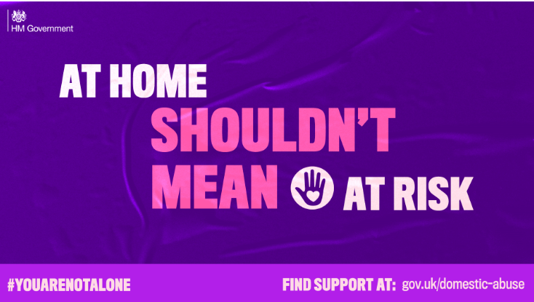
https://www.gov.uk/guidance/domestic-abuse-how-to-get-help?fbclid=IwAR3BlLoud7E-0USFZGWlSYOAJttGPJku1Y6VyclOcb20N5x174KpGiqZ99s
Summer Term -
online events
Keap are excited to announce a whole new Summer Season of events – all online – to support and offer inspiration through these strange times. Many of the events are FREE or for donation. https://mailchi.mp/ba4b9d9ffb03/online-summer-season-of-events?e=758e902938

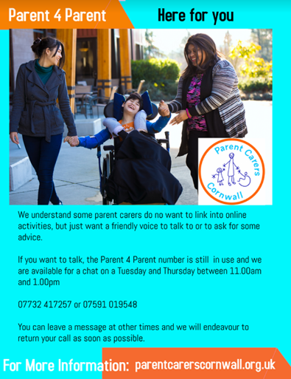
Advice for parents and carers on looking after the mental health and wellbeing of children or young people during the coronavirus (COVID-19) outbreak.
https://www.gov.uk/government/publications/covid-19-guidance-on-supporting-children-and-young-peoples-mental-health-and-wellbeing?fbclid=IwAR0D1ytwXaXdTO0ZisUJZYB7VkY8iIGCB0GvYFzF4n9yBXg_1W0cmFiUNH0
If you are in need of support regarding food, please email me head@tregony.cornwall.sch.uk and I will put you in touch with a contact for the foodbank.

