Reception | You Choose  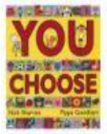  To say what you think | Blue Chameleon  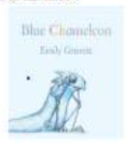  To make friends with someone different | Red Rockets and Rainbow Jelly  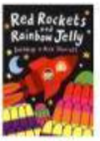  To understand that it is okay to like different things | Monny, Mumma and Me  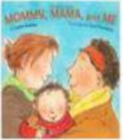  To celebrate my family | The Family Book  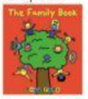  To understand that all families are different
Year 1 | Elmer  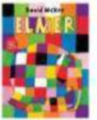  To like the way I am | Ten Little Pirates  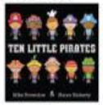  To play with boys and girls | Max Champion  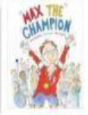  To understand that my body works on different ways | My Grandpa is Amazing  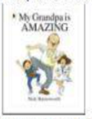  To recognise that we are all different ages | My World, Your World  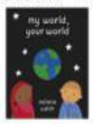  To understand that we share our world with lots of people
Year 2 | The First Slodge  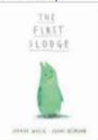  To understand how we share the world | The Great Big Book of Families  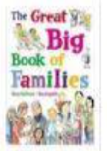  To Understand what diversity is | Just Because  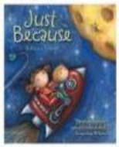  To feel proud of being different | The Odd Egg  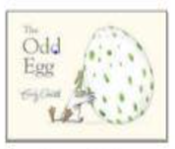  To understand what makes someone feel proud | Blown Away  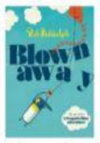  To be able to work with everyone in my class
Year 3 | Oliver  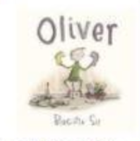  To understand how difference can affect someone | This is Our House  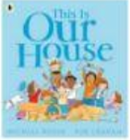  To understand what discrimination means | The Hueys in the New Sweater  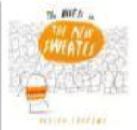  Use strategies to help someone who feels different | Two Monsters  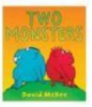  To find a solution to a problem | Beegu  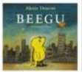  To be welcoming
Year 4 | Dog’s Don’t Do Ballet  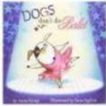  To learn when to be assertive | Kind and King  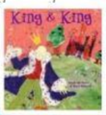  To understand why people choose to get married | The Way Back Home  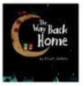  To overcome language barriers | Flower  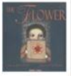  To ask questions | Red  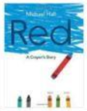  To be who you want to be
Year 5 | Where the Poppies Grow  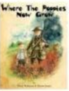  To learn from the past | Rose Blanche  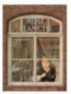  To justify actions | How to Heal a Broken Wing.  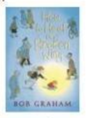Recognise when someone needs help | The Artist Who Painted a Blue Horse  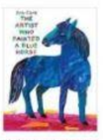  To appreciate artistic freedom | And Tango Makes Three  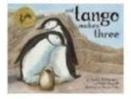  To accept people who are different from me
Year 6 | My Princess Boy  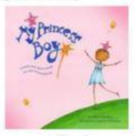  To promote diversity | Love You Forever  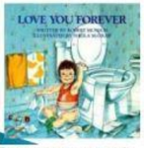  To consider how my life may change as I grow up | The Whisperer  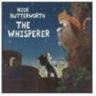  To stand up to discrimination | The Island  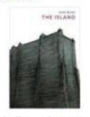  To challenge the causes of racism | Dreams of Freedom  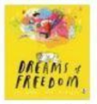  To recognise my freedom

