 | Autumn 1 | Autumn 2 | Spring 1 | Spring 2 | Summer 1 | Summer 2
Towan
Summers |  | 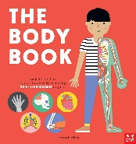  The Body Book (Hannah Alice)  Lists, labels, captions  List poems | 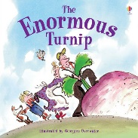  The Enormous Turnip (Katie Daynes and Georgien Overwater)  Narrative – retelling and innovation  Poems with simple repetition | 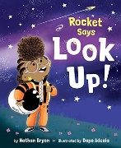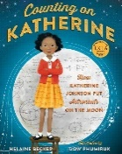  Look Up (Nathan Byron)  Counting on Katherine (Helaine Becker)  Narrative - retelling  Letter  Non-chronological report | 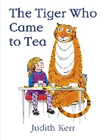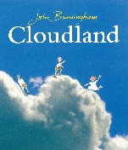  The Tiger Who Came to Tea (Judith Kerr)  Cloudland (John Burningham)  Narrative – retelling and innovation  Free verse poems based on the senses | 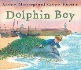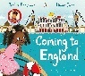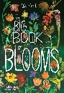  Dolphin Boy (Michael Morpurgo)  Coming to England (Floella Benjamin)  The Big Book of Blooms (Yuval Zommer)  Narrative – retelling and innovation  Setting description  Instructions  Recount
Pendower | 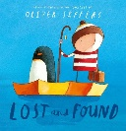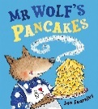  Lost and Found (Oliver Jeffers)  Mr Wolf’s Pancakes (Jan Fearnley)  Narrative retelling and innovation Non-chronological report  Instructions  Haikus | 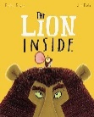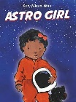  The Lion Inside (Rachel Bright)  Astro Girl (Ken Wilson-Max)  Diary entry  Narrative - retelling and innovation  Non-chronological report | 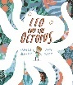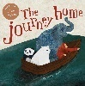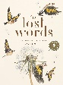  Leo and the Octopus (Isabelle Marinov)  The Journey Home (Frann Preston-Gannon)  The Lost Words (Robert Macfarlane)  Narrative – retelling and innovation  Non-chronological report  Question and answer poetry | 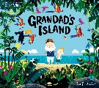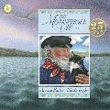  Grandad’s Island (Benji Davies)  The Mousehole Cat (Antonia Barber)  Narrative – retelling and setting description  Non-chronological report  Explanation text | 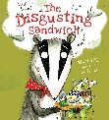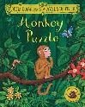  The Disgusting Sandwich (Gareth Edwards)  The Monkey Puzzle (Julia Donaldson)  Narrative retelling  And innovation  Instructions  Riddles | 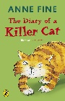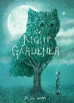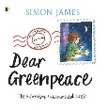  The Diary of a Killer Cat (Anne Fine)  The Night Gardener (Terry Fan)  Dear Green Peace  (Simon Matthews)  Diary Entry  Narrative - innovation  Instructions  Explanation
Porthcurnick (Year A) | 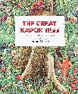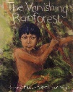  The Great Kapok Tree (Lynne Cherry)  Vanishing Rainforest (Richard Platt)  Ride of Passage  (Literacy Shed)  Narrative poetry (Rangtan) | 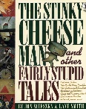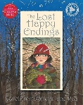  The Lost Happy Endings (Carol Ann Duffy)  The Stinky Cheese Man and other Fairly Stupid Tales (Jon Scieszka) | 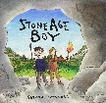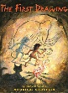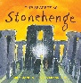  Stone Age Boy (Satoski Kitamura)  The First Drawing (Mordicai Gerstein)  Secrets of Stonehenge (Mick Manning) | 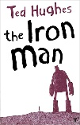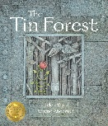  Aladdin  The Ironman (Ted Hughes)  The Tin Forest (Helen Ward)  Narrative – Rags to Riches | 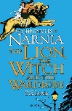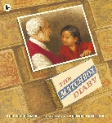  The Lion, Witch and the Wardrobe (C.S. Lewis)  The Matchbox Diary (Paul Fleischman) | 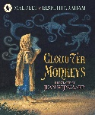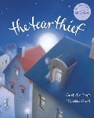  Cloud Tea Monkeys (Mal Peet)  The Tear Thief (Carol Ann Duffy)
Portholland (Year A) | 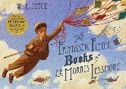  The Fantastic Flying Book of Morris Lessmore (WE Joyce)  Tabula Rasa (Literacy Shed)  Setting Descriptions  Narrative - retelling  Diary entry  Explanations  Blackout poems | 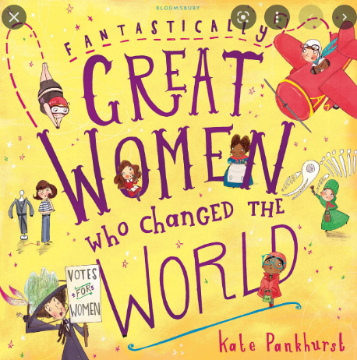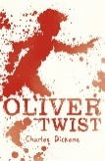  Great Women Who Changed the World (Kate Pankhurst)  Oliver Twist (Charles Dickens)  Titanium (Music Video)  Setting Description  Narrative - rags to riches  Non-chronological report  Newspaper Article | 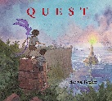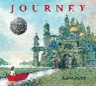  Quest (Aaron Becker)  Journey (Aaron Becker)  Titanic (Dorling Kindersley)  Setting Description  Diary entries  Non-chronological report  Persuasive Letter  Free verse with figurative language | 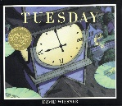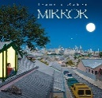  Tuesday (David Wiesner)  Mirror (Jeanie Baker)  Narrative – Overcoming the monster  Diary entries  Non-fiction  Newspaper Article | 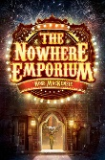  The Nowhere Emporium (Ross MacKenzie)  Setting Descriptions  Non-chronological reports  Balanced Arguments  Modal verb poems | 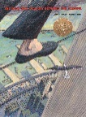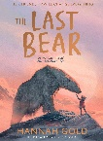  The Man Who Walked Between the Towers (Mordicai Gerstein)  The Last Bear (Hannah Gold)  Character profile  Narrative - voyage and return  Diaries  Newspaper Articles  Non-chronological reports  Persuasive Writing
Porthluney (Year A) | 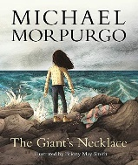  The Giant’s Necklace (Michael Morpurgo)  The Lighthouse (Literacy Shed)  Narrative  Dialogue  Diary  Character description  Newspaper report  Advert | 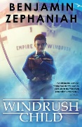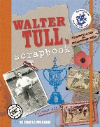  Windrush Child (Benjamin Zephaniah)  Walter Tull’s Scrapbook (Michaela Morgan)  Persuasive pitch  Informal letter  Diary  Narrative - Voyage and Return  Biography  Poem based on Windrush Child by John Agard | 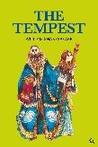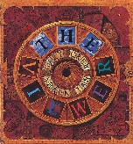  The Tempest (William Shakespeare)  The Viewer (Gary Crew and Shaun Tan)  Playscript  Dialogue  Setting description  Character description  Comic verse | 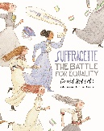  Suffragette, The Battle for Equality (David Roberts)  Derby Day (Maz O'Connor - Literacy Shed)  Narrative - tragedy  Formal letter  Balanced argument  Persuasive campaign  Newspaper report | 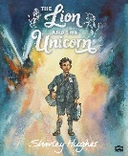  The Lion and the Unicorn (Shirley Hughes)  Beyond the Lines (Literacy Shed)  Narrative - voyage and return (Alice in Wonderland)  Character description  Instructions  Blackout Poetry | The Island (Armin Greder)  Pandora (Literacy Shed)  Diary  Narrative sequel  Imagined conversation  Narrative - rebirth  Non-chronological report

 | Autumn 1 | Autumn 2 | Spring 1 | Spring 2 | Summer 1 | Summer2
Porthcurnick (Year B) | 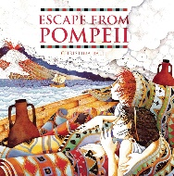  Escape from Pompeii (Christina Balitt)  Black Dog  (Levi Pinfold)  The Present  (Literacy Shed)  Recount  Setting description  Narrative  Dialogue | 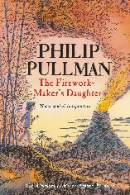  The Firework Maker’s Daughter (Philip Pullman)  John Lyons Poetry  Dancing in the Rain  Narrative - Quest  Letter  Cinquains | 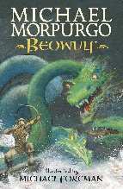  Beowulf (Michael Morpurgo)  The Boy Who Grew Dragons (Andy Shepherd)  Overcoming the monster | 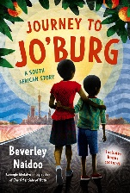  Journey to Joburg (Beverley Naidoo)  Amazing Africa  Long Walk to Freedom (Illustrated Children’s Edition)  Mandela  The Legend of Sally Jones (Jakob Wegelius)  Old Possum’s Book of Practical Cats (TS Lewis)  Narrative - Rags to riches  Non-fiction: non-chronological report | 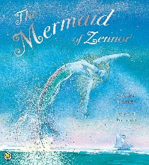  Mermaid of Zennor (Charles Causeley)  Hidden Depths  Exploring the Deep  Jabberwocky (Lewis Caroll) | 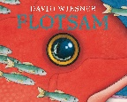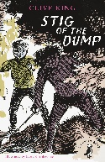  Flotsam (David Wiesner)  Stig of the Dump (Clive King)  Narrative - Overcoming the monster
Portholland (Year B) | 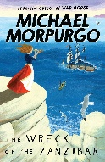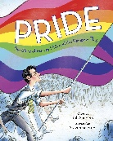  Wreck of the Zanzibar (Michael Morpurgo)  Pride (Rob Sanders)  Character description  Setting description  Narrative - legend  Narrative - retelling  Diary  Non-fiction:  Non-chronological reports  Blackout poems | 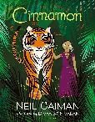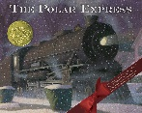  Cinnamon (Neil Gaiman)  The Polar Express (Chris Van Allsburg)  Diary  Narrative - Rags to riches.  Narrative - mythical tale  Informal letters  Adverts  Persuasive writing  Rhyming couplets | 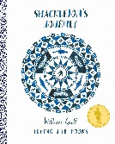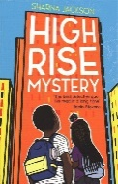  Shackleton’s Journey (William Grill)  High Rise Mystery (Sharna Jackson)  Character description  Setting description  Narrative  Newspaper report  Letters (informal and formal)  Non-chronological report  Persuasive letter  Free verse with figurative language | 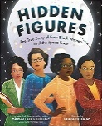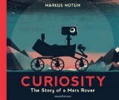  Hidden Figures (Margot Lee Shetterly)  Curiosity: The story of a Mars rover (Markus Motum)  Narrative - overcoming the monster  Character description  Diary entry  Non-chronological reports  Newspaper report  Persuasive letter  Character memoir | 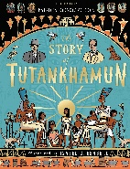  The Story of Tutankhamun (Patricia Cleeveland-Peck)  The Secrets of Tutankhamun (Patricia Cleeveland-Peck)  Tadeo Jones (Literacy Shed Video)  Narrative - retelling  Character descriptions  Diary entry  Non-chronological report  Biography  Instructions  Modal verb poems | 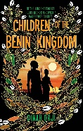  Children of Benin Kingdom (Dinah Orji)  The Mega City (Literacy Shed Video)  Dialogue  Story summaries  Narrative - voyage and return.  Diary entries  Non-chronological  report  Informal letter
Porthluney (Year B) | 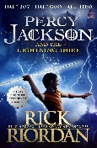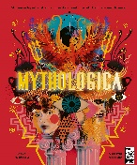  Percy Jackson and the Lightning Thief (Rick Riordan)  Mythological (Stephen Kershaw)  The Odyssey (Gillian Cross)  Character description  Diary  Non-Chronological Report  Comic verse | 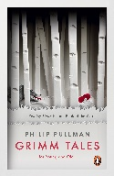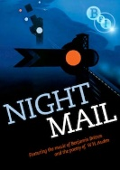  Grimm Tales for Young and Old (Phillip Pullman)  Night Mail (WH Auden)  Dialogue  Traditional tale  Narrative - Voyage and return  Couplets | 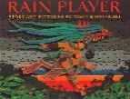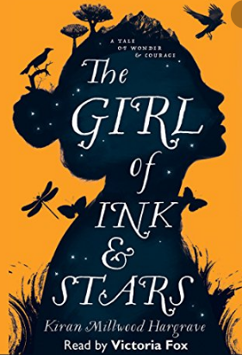  Rain Player (David Wisniewski)  Blackface (Literacy Shed)  The Girl of Ink and Stars (Kiran Millwood)  Dialogue (Commentary)  Diary  Recount  Instructions  Advert  Reverse Poetry | 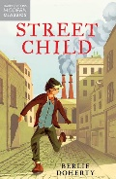  The Piano (Literacy Shed)  Street Child (Berlie Doherty)  Diary  Narrative - Rebirth (A Christmas Carol)  Narrative with flashbacks  Recount  Setting description  Persuasive letter  Balanced argument | 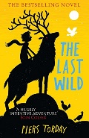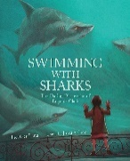  The Last Wild (Piers Torday)  Swimming with Sharks (Heather Lang)  Maps (Aleksandra Mizielinska)  Setting description  Diary entry  Alternative ending  Formal letter  Dystopian narrative  Non-Chronological report | 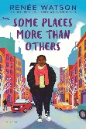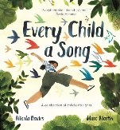  Some Places More Than Others (Renee Watson)  Every Child a Song (Nicola Davies)  Letter  Diary  Narrative - Tragedy (Frankenstein)  Non Chronological Report  Figurative language

