Our Trust Mission
The Roseland Trust provides outstanding education for our communities, where everyone succeeds
Tregony School 3Rs
Respect, Resilience and Responsibility

Uniform
Our uniform code reflects the school’s ‘Three Rs’ Respect, Resilience and Responsibility. It also reinforces our Trust vision of Outstanding education for our communities where everyone succeeds. All pupils must dress according to the uniform policy. Our school uniform is important to us. It is one way in which we identify ourselves as a school community and promotes high standards and expectations in all areas of school life. If pupils are not wearing the correct uniform, parents will be informed in writing.
It is essential that all uniforms are labelled with your child’s name and that PE kits are in school all week. We do not enforce that pupils wear uniform with the school logo but this can be purchased online from School Trends by following either of the links below. There are no minimum order quantities and your uniform will be delivered directly to your chosen address.
https://www.schooltrends.co.uk/uniform/TregonyCommunityPrimarySchoolTR25RP

alternatively visit www.schooltrends.co.uk

School Uniform:
Black or grey trousers/shorts or skirt/pinafore dress
Red checked dress for the warmer months
Red jumper or cardigan (no hooded tops are permitted)
Plain white/grey/black socks or tights

PE Kit:
Back shorts
Plain white tee shirt (not one that is worn all day)
Back plimsolls or trainers

Shoes:
Pupils must wear closed-toed, hard-soled, all black, plain shoes with a flat sole. Boots are not allowed. Open-toed sandals should not be worn, even in the Summer Term. In the case of extreme weather, children can wear boots to school but must change into a pair of shoes on arrival to school. Pupils can wear trainers or back plimsolls for outdoor PE lessons. Barefoot work is undertaken for indoor gymnastic and dance lessons. Pupils in Key Stage 1 and 2 can change into trainers for their break times but must change back into their shoes afterward.
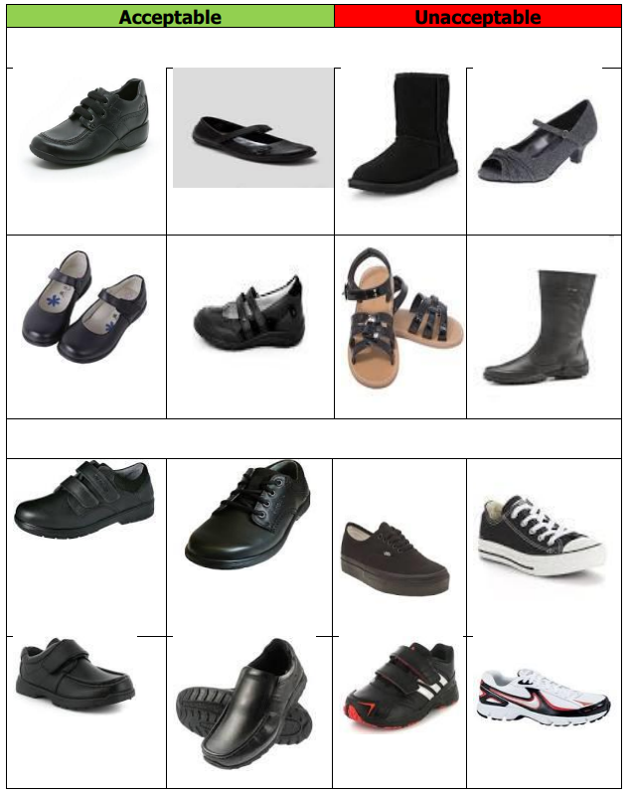

Coats:
Children need to have a coat in school, especially as we will be endeavouring to have pupils outside as much as possible. There are red fleeces available or red waterproof jackets both with the school logo, but any coat that will keep children warm and dry is suitable.

Hair, Make-up and Jewellery:
• Hair should be clean, tidy and of a natural colour only. Extreme hairstyles are not permitted.
• Long hair should be tied back when requested for health and safety reasons
• Make-up should not be worn. Nail varnish must not be worn.
• A wrist watch and/or one plain small stud in each ear is permitted; all other jewellery is prohibited for health and safety reasons.

Smart Watches and Phones:
We know that mobile phones/smart watches can be a valuable and important resource for our children; we frequently discuss the safe use of these devices, both in general and as part of our online safety lessons. Despite the obvious distraction that these devices can pose, smart watches and phones are internet and camera enabled and therefore present concerns in terms of safeguarding. Therefore, we ask that pupils do not wear smartwatches to school. Should your child need a phone, then these must be given to the class teacher at the start of the day. We thank you for your understanding and support with this matter.

Other Equipment:
We will provide your child with all the equipment they need. We discourage your child from bringing in toys etc. We ask that your child brings in their provided, red school bag with their reading book and reading record book each day.

Thank you for your cooperation with this.

