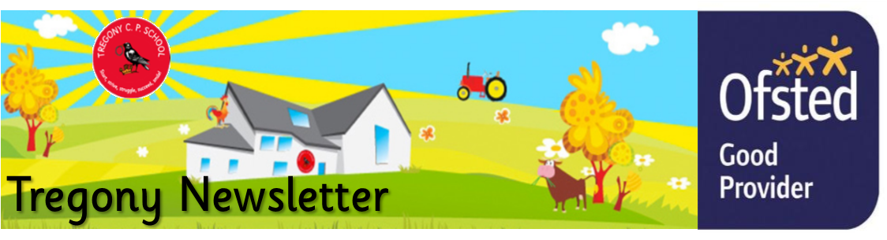
Friday 31st January 2020
Dear Parents/Carers,
There have been lots of exciting but intriguing things happening across the school this week. On Monday morning, Portholland Class found that their classroom had been left in disarray over the weekend. Pupils have been busily investigating the situation and will be reporting their findings next week. Summers Class were excited to see the safe return of their superhero, Flash Lightning Boy, and are going to ask him about what had happened to him since the day he was stolen. Next week, they will be writing diary entries based on his adventures. Porthcurnick Class have found no further CCTV footage of the dragon, who had left an egg in their classroom a few weeks ago, but have been inspired to write their own dragon descriptions using similes and metaphors. Porthluney Class have been immersing themselves in their Battle of Britain topic by writing truly empathetic descriptions of evacuees. Towan class have been exploring bugs as part of their topic. This week they have been learning about lifecycles and writing facts about bugs.
Class Porthcurnick had some exciting news this week. During their last topic, ‘The Rainforest’, pupils submitted some of their John Dyer inspired artwork to a competition. We are so proud to announce that Isobel Curgenven was awarded a prize from the judge, John Dyer, for her amazing picture. This can be viewed on https://www.lastchancetopaint.com/. Class Porthcurnick were also excited to hear that John Dyer was so impressed with their rainforest artwork that he will be visiting them at school very soon.
I am currently taking part in an oracy project with other schools around Cornwall. Speaking and Listening are vital skills that need to be taught as much as reading and writing. Correct spoken language is fundamental to learning. From the first days in school, speaking and listening play a large part in a child’s progress in all curriculum areas and teachers will be planning to develop these skills in a wide variety of ways . Our aim is to develop and encourage fluent speakers, who can confidently articulate their ideas in a wide range of situations. I have added more information about how Tregony School is planning to make oracy a priority and how this impacts on children's education, on our school website. So please take some time to see how you can support this at home too.
As we approach Safer Internet Day, on the 11th February, I wanted to pass on feedback from Richard Pomfrett, who worked with our Year 6 pupils on keeping safe on the internet. He has asked us to inform you that there was an overwhelming amount of children who are either using social media or playing online games aimed at young people much older than themselves. Please see the links/sites below to help not only find out more about what children are accessing online but to also help you set them up safely.
On the 27th February, some of our pupils will be holding a cake sale to raise money for the charity STAC. This charity helps to feed and clothe the homeless which is desperately needed at this time of year. All cakes will be £1.00 so please support this worthwhile charity.
This week we have been struck with a nasty sickness bug. We have reminded pupils about washing hands and personal hygiene whilst using copious amounts of antibacterial solution to combat the germs! Hopefully, the weekend will help to contain the virus.
Kate Douglass
Headteacher.
There has been another excellent set of results from Par cross country this week. Well done to everyone that took part. For the next and final race on 13th February, I will only be choosing those pupils who have finished in the top 25 each time to compete; they have a chance of qualifying for the semi finals in Newquay on 12th March.

Miss Mulroy

P.E lead
- Key Stage 1 and Key Stage 2 Family Learning SATS group.  - Data collection sheets overdue | Value of the Week: Care  Our winner this week is
Finally, don’t forget to check our website for school related information, which we are in the process.
- Tuesday 11th February - Safer internet day
- Monday 17th February - Half term
- Wednesday 26th February - Parents Evening

Swimming Dates
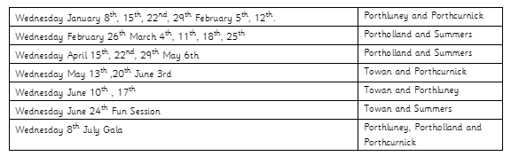

Taylan Hodgkiss for super handwriting practice.  Chester Marchant for super independent maths work.  Isla Floyd-Norris, Jasper Wicks and Brandon Rescorla for super independent writing about The Hungry Caterpillar.  Jayden Gregory for super improvement with his letter formation. | Towan: Arthur Coghlan for fantastic phonics skills and trying really hard with his letter formation during phonics.  Summers: Tyler Varley for showing a fantastic attitude towards his learning and progressing in all areas,particularly his reading. Oli Hill for working hard in English, using commas in his writing and having very neat handwriting  Porthcurnick: Annablee Coghlan and Nancy Craddock for super work in mathematics.  Portholland: George Gray for excellent description when writing a police report.  Porthluney: Amie Grunberger-Miles for having an excellent attitude towards maths when learning new methods.  P.E: Caitlin Beel for an excellent effort at running club, powering up Back Lane.
Godrevy: 533  Trevose: 623  St Antony: 906  Lizard: 910 | Towan: 94.78%  Summers: 93.31%  Porthcurnick: 96.92%  Portholland: 99.31%  Porthluney: 96.21%
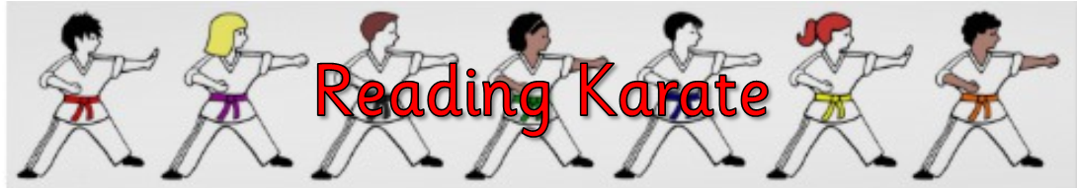
White band: Harry Wilson, Rhys Carpenter  Yellow band: Oli Hill, Freya Hill, Ben  Orange band: George Cluett-Bird | Blue band: Tyler Varley, Veryan Fanshawe, Seth Merrick, William Wilson, Sennen Bishop  Green band: Tabitha Curtis, Thomas Michell, Lawrie Agar, Annabelle Coghlan, Lydia Tame, Evarose Punton, Matilda Curtis, Carl Agar  Brown band: Finn Lury, Rory Hammond, Frank Wright-Lynch  Black band:

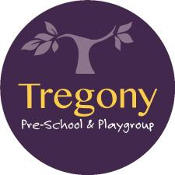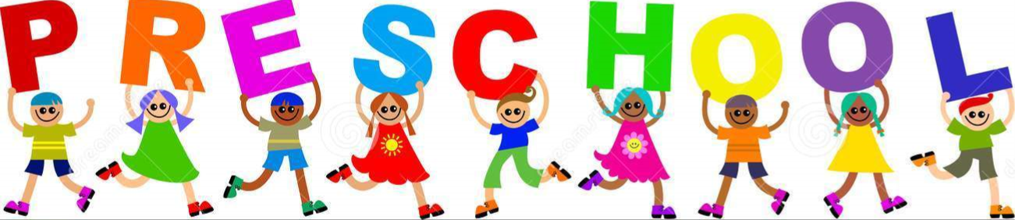

Star of the Week:
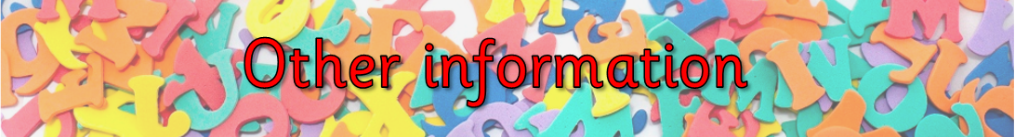
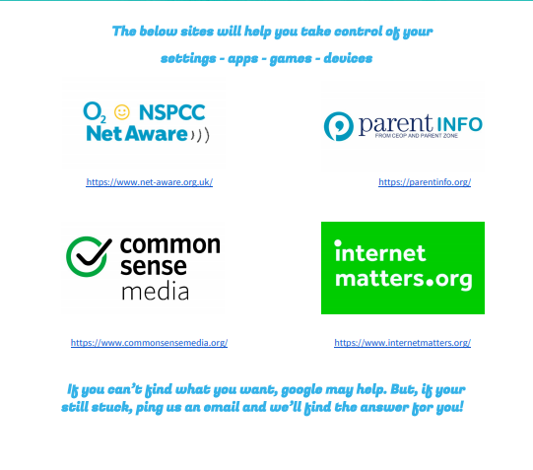
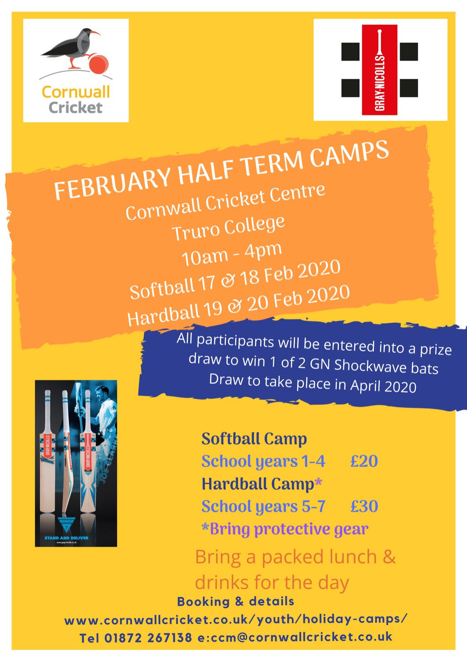

Tregony Clockhouse Players will be performing their pantomime during half-term week. Lots of our pupils will be performing so please support this community event.

