Friday 15th November
Dear Parents/Carers,
It was lovely to see so many of our pupils dressed in their Brownies, Beavers, Cubs and Scout uniforms to mark Remembrance Day on the 11th November. Some of our pupils also proudly represented these groups on Sunday 19th November during Tregony’s Remembrance Service in the village square.
On Wednesday, I visited last year’s Year 6 pupils at The Roseland Academy. It was lovely to see how well they have settled into life as Year 7 students. They were all happy to share their experience but also expressed how they had been well prepared for their transition by The Roseland Academy and Tregony School. The MAT are very proud of these arrangements and speaking to pupils helps us to reflect and continue to improve on the opportunities we put in place to ensure a smooth and seamless transition.
Wednesday also saw Portholland class visit Newquay Zoo as part of their Round and Round topic. They took part in a lifecycle workshop and examined the four main stages for all living things. They saw stick insects, giant African land snails and snakes.
On Thursday, Summers Class visited Truro Methodist Church cafe. They were conducting research for the cafe they will be setting up for parents on Friday 6th December. They were able to see what equipment and resources they may need for their cafe. Some children even served some customers and operated the till. They were also lucky to have a talk from Truro Foodbank and helped the volunteers by sorting the food ready for distribution. Well done Summers Class!
Pupils had fun today, dressing in spotty clothing and pyjamas to mark Children in Need Day. Thank you for your donations of cakes which helped to raise over £ 210 for this wonderful cause.
There have been more dates added to our ever busy calendar so please check below and on our website calendar. We are desperately seeking parental support for our School Christmas Fete on Wednesday 18th December at 9.15 am. We will be setting up the evening before so any help will be gratefully received. Please email me on head@tregony.cornwall.sch.uk if you can offer any fundraising ideas or support with setting up the night before and running stalls on the day. These fundraising opportunities are vital in raising money for all of the extra equipment and opportunities we like to offer our pupils.
Please remember that library change is now on a Monday for Key Stage 2 pupils. Please can I politely request that pupils have their P.E kit in school all week. Teachers have noticed an increasing amount of pupils without it. Kit is required for health and safety puporses.
The deadline for signing up for the flu vaccination, which will be administered at school on Monday 25th November, is Thursday 21st November at noon. Please follow the link https://www.kernowimmunisations.co.uk/Forms/Flu School Code: EE142668
Kate Douglass
Headteacher.

The weather was horrendous for our Par cross country team yesterday; well done to everyone that took part and ran so well considering the circumstances. Thank you to all of the helpers that transported the team, standing in the wind and rain to cheer our runners on.
Letters went out this week to a chosen few for the badminton tournament on Wednesday. Please can all slips come back by Monday.
Thank you

Miss Mulroy

P.E lead
- Nasal flu vaccination  - London trip letter  - MCSN Par cross country letter  - Pupil absence letter  - Year six Truro City of Lights parade  - St Austell Music Festival Letter  - Years 5/6 science letter | Lydia Tame showed resilience for continuing to manage her diabetes despite forgetting her packed lunch. She was nominated by Bella Curgenven.
- Wednesday 20th November - Year 6 City of LIghts Parade, Truro
- Wednesday 20th November - KS2 Cluster Badminton tournament
- Monday 25th November - Nasal flu vaccination
- Wednesday 27th November - St Austell Music Festival starts
- Sunday 1st December - Tregony Lantern Parade. Meet at the school at
- Tuesday 10th December - Portholland class topic celebration 1.30-4.00pm
- Wednesday 11th December Christmas dinner and jumper day
- Wednesday 11th December - Key Stage 1 Christmas Play (am)
- Thursday 12th December -Key Stage 1 Christmas play (pm)
- Friday 13th December - Towan Class Eden trip
- Tuesday 17th - Whole school cinema trip
- Wednesday 18th december School Christmas Fete 9.15am - 11.00 am
- Wednesday 18th December - Christmas parties (pm)
- Friday 20th December end of term Christmas assembly in the church at 9.15 am
- Friday 20th December - Break up for Christmas holidays 1.30pm finish - no wrap around care
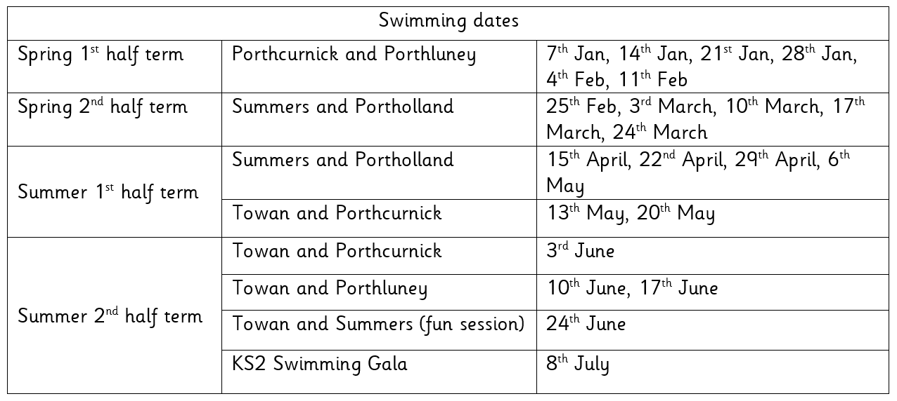
Finally, don’t forget to check our website for school related information, which we are in the process of updating. You can also add us on Facebook to keep up-to-date with news, reminders and photos

Harry Cotton, Evie Tuby, Ruby Keast, Maddie Heslip, Nancy Craddock, Issac Lockyer, Annabelle Coghlan for amazing mathematics when adding two, three digit numbers using the column method.  Veryan Fanshawe for an amazing cam toy made for her homework.  Tyler Varley for amazing improvement in phonics and showing amazing resilience by never giving up and learning from his mistakes.  All of Summers Class for super behaviour and manners during their school trip.  Oliver Baker for amazing behaviour for learning and excellent progress. | Towan:. Noah Heath- Jeffs for always following instructions and trying really hard with his letter formations.  Summers: Harriet Jones for making a real effort with her handwriting. Robert Tupper for showing more enthusiasm in his learning in class  Porthcurnick:. Jago Martin for an exemplary attitude to his learning. AnnabelleCoghlan for progress in maths.  Portholland: Huw Floyd Norris for brilliant enthusiasm and for being a wealth of knowledge on our visit to Newquay Zoo.  Porthluney: George Cluett-Bird - for approaching English lessons positively and proofreading effectively.  P.E: Henry Baker for an improved attitude towards P.E.
Godrevy: 1935  Trevose: 1671  St Antony: 1432  Lizard: 2408 | Towan: 93.28%  Summers: 97.39%  Porthcurnick: 96.54%  Portholland: 98.62%  Porthluney: 97.24%
White band: Tristan Rescorla,William Wilson, Dyaln Rescorala.  Yellow band: Sennen Fanshawe, Caitlin Beel, Summer Gibson, Annabelle Coghaln, Seth Merrick, Isobel Curgenvne, Merryn Floyd-~Norris, Hetty Rothwell, Toby Rounsevell, Bella Curgenven, Edward Ives | Orange band: Elizabeth Dicker, Taylor Cookman, Elowyn Appleyard, Otis Wilson, Mathilde Knight, Sennen Bishop, Jack Filbey  Blue band:  Green band:  Brown band:  Black band:

We are currently looking for a chair for the committee; If you would like to know anymore information or are interested, then please email Kirsty at tregony.preschool@gmail.co.uk

Star of the week: Freddie M for his improved self care, attitude and behaviour.

Tregony Christmas Lights Group will be erecting this year's display over the following weekends 16th/17 & 23rd/24th of this month and would like to have as much help as possible for the task, even if only for a couple of hours on any of the days mentioned. Please contact either John Smith on 01872 530374 or Des Mennear on 01872 530357 for further information.

The pre-school are holding a Bingo Fundraiser on the evening of Friday 13th December. Times to be confirmed.

