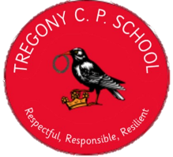
KS2 Reading Spine
Year A | Term 1 | Term 2 | Term 3 | Term 4 | Term 5 | Term 6
Porthcurnick | 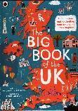  The Big Book of the UK (by Imogen Russell Williams) | 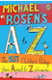  Michael Rosen's A-Z: The best children's poetry from Agard to Zephaniah | Iron Man by Ted Hughes  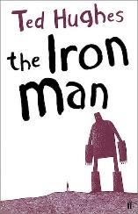 |  | The Boy in the Back of the Class by Onjali Q Rauf  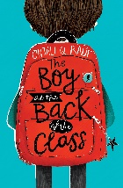
Portholland | 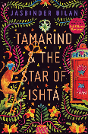  Tamarind and the Star of Ishta by Jasbinder Bilan |   The Undefeated by Kwame Alexander and Kadir Nelson | The Little Match Girl Strikes Back by Emma Carroll and Lauren Child  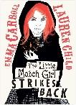 | 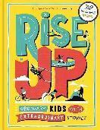  Rise Up: Ordinary Kids with Extraordinary Stories by Amanda Li | 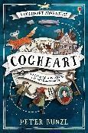  Cogheart by Peter Bunzl
Porthluney | 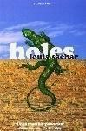  Holes by Louis Sachar |  | 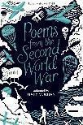  Poems from the Second World War by Gaby Morgan | 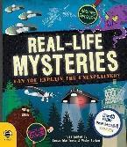  Real life Mysteries by Susan Martineau | 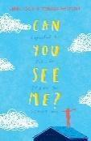  Can you see me? by Libby Scott
Tregony CP School

Year B | Term 1 | Term 2 | Term 3 | Term 4 |  | Term 5 | Term 6
Porthcurnick (Year 3 Cohort) | 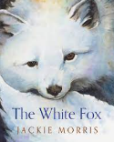  White Fox by Jackie Morris | 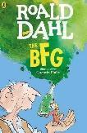  BFG by Roald Dahl  The Wild Robot? | 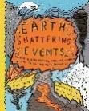  Earth shattering Events by Robin Jacobs | 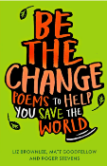  Be The Change: Poems to Help You Save the World |  | 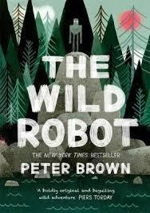  The Wild Robot by Peter Brown
Portholland | 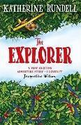  The Explorer by Katherine Rundell |  | 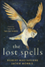  The Lost Spells by Robert MacFarlane and Jackie Morris | 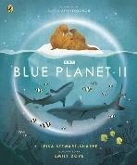  Blue Planet II by Leisa Stewart-Sharpe |  | 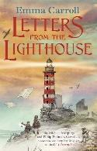  Letters to the Lighthouse by Emma Carroll
Porthluney | 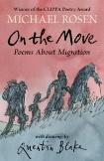  On The Move by Michael Rosen | 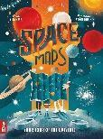  Space Maps: Your Tour of the Universe by Lara Albanese and Tommoso Vidus Rosin | 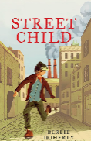  Street Child by Berlie Doherty |  | Mythologica by Stephen Kershaw  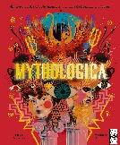 | 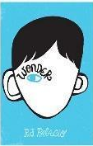  Wonder by RJ Palacio

