RE- Who is God to Muslims?
Place of worship:
A mosque

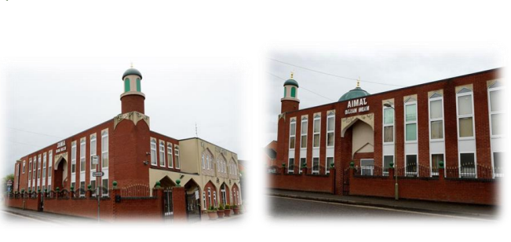
Holy book
Qur’an
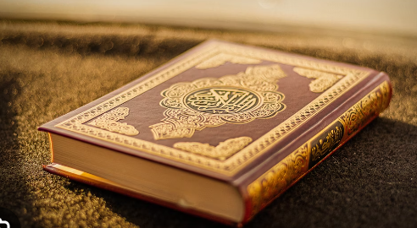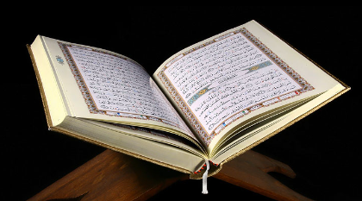

Allah has 99 names
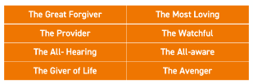Here are 8.

Key words | Definition
Qur’an | Holy book
Allah | God
Mosque | Place of worship
Attribute | A quality of someone’s character
Muslim | Someone who follows the religion Islam

