Friday 29th November
Dear Parents/Carers,
I can hardly believe that we are about to enter the season of magic and sparkle! ! We have lots of events and exciting activities planned this month; please keep an eye on the newsletter and our Facebook page to remain updated. Thank you to those of you who have volunteered to support our Christmas Fete on the morning of Wednesday 18th December. We will always welcome more help, so please let Debbie know or email me on head@tregony.cornwall.sch.uk . We will be holding a meeting about this on Monday morning at 9.00am, where we can make further plans. If you can't make this, but are prepared to help, please email me and let me know. Thank you.
On Tuesday, Porthluney class took part in an Egyptian Workshop at Truro Museum. There behaviour was excellent and staff there were impressed by the level of knowledge our pupils demonstrated.
Our Speech and Performance group have confidently and successfully competed in St Austell Music Festival poetry speaking competition. We always have positive comments about the standard of our pupils’ performances and this year was no exception. I was fortunate to attend the Year Three performances and was so proud of how they approached what was a very nerve wracking experience. I was truly proud of them all.
Don’t forget that, on Sunday evening, Tregony School pupils will be parading through the village with their willow lanterns for the Christmas lights ‘switch on’ in the village. There will be carols in the square and a competition for the best lantern. I have even heard that Father Christmas will be paying a visit! The school will be open from 5.30pm and we will leave at 5.45pm. If you have any spare battery operated lights, please bring them with you!
Our Wrap Around Care facility is very busy at the moment. Please can we ask that you book as early as possible, so that if we need additional staff we can try and organise this. We have to ensure that our ratios are compliant to ensure the health and safety of our pupils.
We have noticed that lots of pupils are not wearing coats to school. The weather is cold and damp and there are many nasty viruses around and we will be expecting all pupils to wear a coat during playtimes. Please can you remind your children to bring their coats to school every day

Kate Douglass
Headteacher.
Pupils took part in a long run during their running club yesterday. The team has been chosen based on effort, teamwork, behaviour and determination; these are all skills that are important when representing our school. Letters have been sent out today.
Please can I remind parents that P.E kits MUST be in school at all times. We are still seeing a number of pupils without trainers or the correct t-shirts, shorts or spare socks.
Thank you.

Miss Mulroy

P.E lead
- Payment for Cinema trip due  - Payment for Eden trip due | Value of the Week Winner: Daniel Dicker for praising a younger pupils on the quality of their work.
- Sunday 1st December - Tregony Lantern Parade. Meet at the school at 5.45pm
- Tuesday 10th December - Portholland class topic celebration 1.30-4.00pm
- Wednesday 11th December Christmas dinner and jumper day
- Wednesday 11th December - Key Stage 1 Christmas Play (am)
- Thursday 12th December -Key Stage 1 Christmas play (pm)
- Friday 13th December - Towan Class Eden trip
- Tuesday 17th - Whole school cinema trip
- Wednesday 18th December School Christmas Fete 9.15am - 11.00 am
- Wednesday 18th December - Christmas parties (pm)
- Friday 20th December end of term Christmas assembly in the church at 9.15 am
- Friday 20th December - Break up for Christmas holidays 1.30pm finish - no wrap around care
Finally, don’t forget to check our website for school related information, which we are in the process of updating. You can also add us on Facebook to keep up-to-date with news, reminders and photos

Sienna Andrew for competing in a gymnastics competition inBristol and achieving second place in the vault!  Lily Charles for super writing using question marks.  Poppy Taylor for amazing application of her phonics work in her independent writing.  Samanta Ryzak for amazing instructions about how to mummify a person and applying newly learnt punctuation within it.  Georgia Tuby and Maddie Heslip for beautifully presented reports about orangutans, using amazing language and a range of fronted adverbials and conjunctions.  Harry Cotton for great concentration and enthusiasm for our musical assembly. | Towan:. Neil Charles for good sitting and listening, even when there are distractions.  Summers:. Tyler Varley and Arya Insoll for working extremely hard to develop their reading  Porthcurnick:.Maddie Helsip for super handwriting, Eli Chidley for improved focus and Ollie Baker for excellent focus and behaviour for learning.  Portholland: Alix Varley for excellent use of drama to support his description when writing.  Porthluney: Rhys Carpenter - for showing great interest and enthusiasm during our museum trip  P.E: Taylor Cookman for always having an enthusiastic attitude towards P.E and working hard in lessons.
Godrevy: 2252  Trevose: 2031  St Antony: 1958  Lizard: 3116 | Towan: 94.78%  Summers: 93.31%  Porthcurnick: 96.92%  Portholland: 99.31%  Porthluney: 96.21%
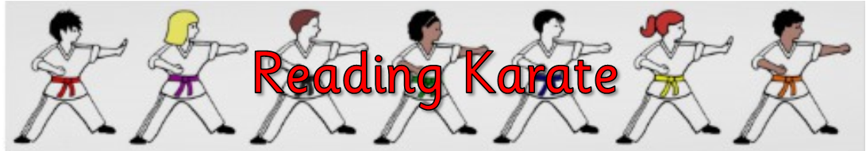
White band: Merryn Edwards  Yellow band: Samuel Broomhead, Jan Jedrysiak, Harry Spires, Liam Trebilco, Arya Insoll, Issac Lockyer, William Wilson, Saskia Curgenven, Oscar Grunberger- Miles, Grace Floyd- Norris | Orange band: Megan Keast, Riley F, Amie Grunberger-Miles, Hope Blades, Samanta Ryzak, Merryn Knight, Annalea Macrae, Robert Tupper, Lawrie Agar, Ashton Cookman, Veryan Fanshawe, Gabriel Welch, Megan Merrick, Joseph Hardiker, Tyler Williams, Carl Agar, Lydia Tame, Matilda Curtis, Evarose Punton  Blue band: Finn Lury  Green band:  Brown band:  Black band:

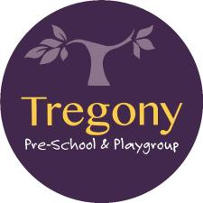

The time of bingo on Friday 13th December has been confirmed: doors open at 6.30pm and eyes down at 7pm.

We are currently looking for a chair for the committee; If you would like to know anymore information or are interested, then please email Kirsty at tregony.preschool@gmail.co.uk

Star of the week: Bethany Kendall - for always joining in and having a great can-do attitude.

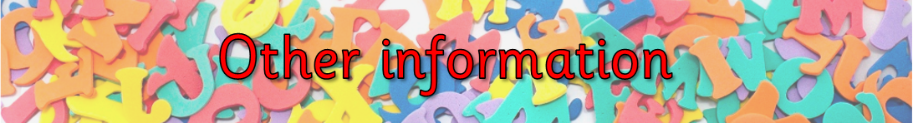
Thank you to Mr and Mrs Craddock for kindly donating a Christmas tree to help us get in the festive spirit! If anyone has a spare Christmas tree holder - we would be so grateful if we could borrow it.

On Monday afternoon, Towan Class will be sharing their end of topic celebration with parents, carers and family in the school hall from 2.30 - 4.00pm.

Porthluney Class will be opening their Ancient Egyptian Museum from 2.00pm - 4.00pm, to parents, carers and family to showcase all of their hard work this term.

Next Friday morning, Class Porthcurnick will be holding their ‘Rainforest Experience’ at 9.15am in the school hall. All Porthcurnick parents/carers/family are welcome to join them..
Summers Class will be opening their working, paying cafe from 2.00pm to to parents, carers and families to showcase all the skills and knowledge they have learned this term.
These events will have a fundraising element, so please bring your pennies!
Tregony Pre-School are holding a bingo fundraiser on Friday 13th December. Doors open at 6.30pm with eyes down at 7.00pm.

