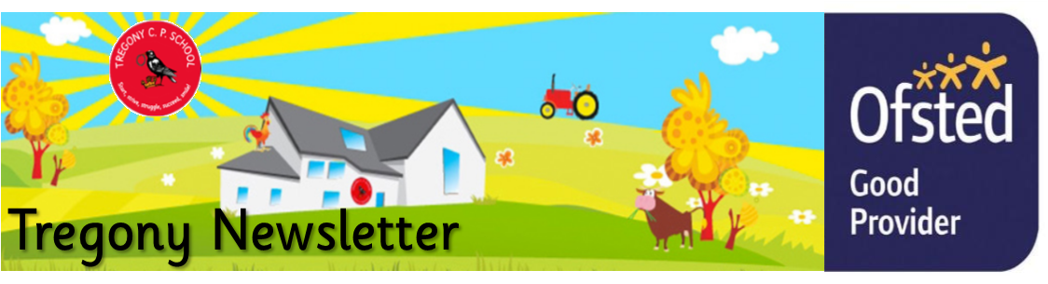
Friday 6th March 2020
Dear Parents/Carers,
This week has been very busy. Porthluney visited Flambards and The Britain in the Blitz exhibition. Pupils met an ARP warden, who guided them through the streets of a city in The Blitz, which included an Anderson shelter, shops, a train station, a pub and a recently-bombed house.
We have had a wonderful celebration of books in celebration of World Book Day. Pupils dressed up as book characters, wrote their own short stories and participated in a sponsored read to raise money for library books. Please can we ask that all sponsorship forms and money are returned by Monday so pupils can start selecting new books for the library. Year 4, 5 and 6 pupils had a visit from local author Scott Jones. His story, entitled Secrets of the Dark Woods, is about Billy, a 13-year-old boy, who loves playing pranks and has just moved to a new school. He meets Austin, the school bully. The boys find themselves lost deep in the woods where they embark on a journey, which involves mythical creatures, a sacred scroll and a dark battle. Our pupils were inspired by Scott’s book and his reading and, should they wish to purchase a signed copy of his book, please send £4.00 in by the 11th March. Scott will be returning on the 12th March, when he will conduct a book signing and distribute his books.
With this being a very short half-term, our end of topic celebrations are fast approaching. Please see the dates and times below so that you can put the date in your calendars! We also look forward to welcoming our Year 3 and 4 pupils and their parents/carers to our multiplication family learning evening on Monday March 9th at 6pm. This evening will include lots of hands on activities which will support the skill of instant recall of times tables facts and help to prepare pupils for their multiplication check during the Summer Term.
If you access Breakfast or After School Club, please be advised that from now on you will be invoiced by the Multi Academy Trust by email.
Unfortunately, there have been some parental concerns regarding the safety of parking at the end of the school day. Parents are parking on the pavement opposite the church and on the corners of junctions and in private driveways. This results in children needing to use the road to get past cars. We are concerned that this poses a risk to the safety of our pupils and could result in an accident. Whilst we understand that the school is short of parking, please use the car park in the football field, which is very close to the school. Thank you for your understanding with this. To reduce morning traffic, we offer a walking bus that leaves from the seats below Tregony Londis at 8.20am. We are still seeking a parent volunteer for Wednesday mornings; should anybody feel that they can support this, please let Debbie know. Thank you.
Have a wonderful weekend!
Kate Douglass
Headteacher.
Letters went out this week for our annual Roseland Cluster Funfest on Wednesday 11th; this event gives pupils the opportunity to take part in different team activities and work with other schools.

Letters also went out to our cross country semi-finalists for their race on Thursday 12th. We have had a record number of 11 qualifiers this year, which shows just how hard they have all been training. Well done all!

Miss Mulroy

P.E lead
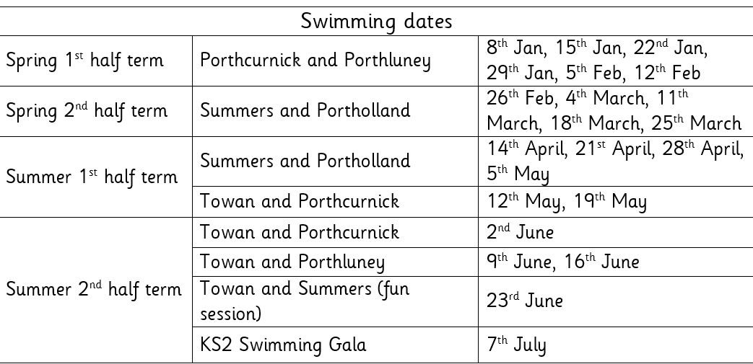

- Monday 9th March Year 4 Multiplication Test Family Learning  - 13th March Fun Fest  - Tuesday 17th March Summers’ trip to Truro Museum  - Thursday 19th March - NSPCC assemblies | Value of the Week: Care
- Monday 9th March Year 4 Multiplication Test Family Learning Evening 6.00pm
- 13th March Fun Fest - pupils will be informed
- Tuesday 17th March Summers’ trip to Truro Museum
- Tuesday 17th March Towan’s end of topic celebration 2-4 pm
- Thursday 19th March - NSPCC assemblies
- Friday 20th March Porthcurnick Book Launch Waterstones 10.00 am
- Tuesday 24th March Portholland class album launch 2-4pm
- Wednesday 25th Porthluney VE Day Party 2-4pm
- Thursday 26th March Summers ‘Danceathon’ all day drop in

Dylan Rescorla for super independent writing using and applying his phonics skills.  Riley Bennett for super, independent mathematics work when adding to make 10.  Ren Gianinni-Anderson, Delia Hook, Elizabeth Dicker, Annalea Macrae, Imogen Martin and Rowan Appleyard for writing some super, short stories and information books on World Book Day.  Finn Lury for an amazing entry to the Fowey short story competition (see the entry below) | Towan: Lilly Charles for being an absolute pleasure to teach this week. She is a brilliant role model to the class and will always try her best in everything she encounters.  Summers: Olive Bennett and Wilf Ollerearnshaw for each creating a brilliant book on World Book Day  Porthcurnick: Riley Kingsley-Heath for an excellent idea for our dragon book and a super, written dragon report. Eli Chidley for amazing ideas for his dragon description and accompanying artwork  Portholland: Summer Gibson for organising an excellent charity fundraising event.  Porthluney: Mathilde Knight for creating an excellent book on World Book Day and beginning a brilliant narrative based on ‘Beyond the Lines’  P.E: Imogen Martin for an excellent first week at running club.
Godrevy:  Trevose:  St Antony:  Lizard: | Towan: 94.20%  Summers: 96.30%  Porthcurnick: 96.58%  Portholland: 98.52%  Porthluney: 98.08%
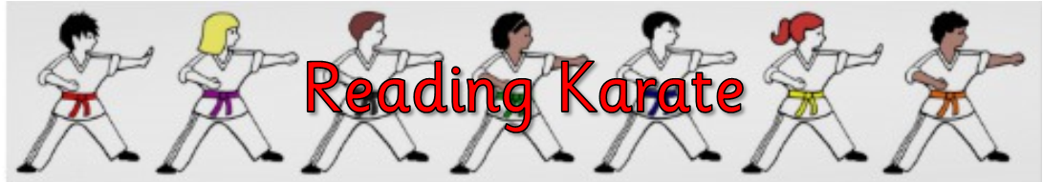
White band: Sennen Skeates  Yellow band:  Orange band: Oli Hill  Blue band: Merryn Floyd-Norris, Sennen Fanshawe, Wilf Ollerearnshaw, Isaach Lockyer, Riley Kingsley-Heath, George Collins, Samuel Broomhead | Green band: Veryan Fanshawe, Annalea Macrae, Hetty Rothwell, Eva Rothwell, William Wilson, William Michell  Brown band: Robert Tupper, Tabitha Curtis, Taylor Cookman, Otis Wilson, Riley Filbey, Sennen Bishop  Black band:

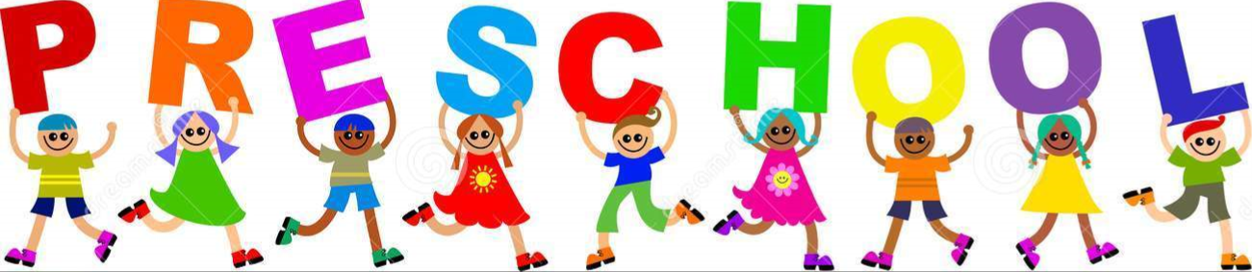

Star of the Week:
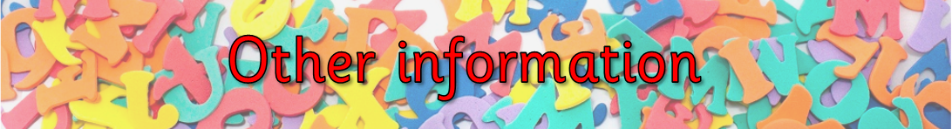
If you would like advice regarding Coronavirus (COVID-19), Please follow the link below https://www.gov.uk/government/topical-events/coronavirus-covid-19-uk-government-response

Below is the guidance given to schools from the Department of Education. We are following these procedures in order to reduce the risk of contracting the virus.
There is currently no vaccine to prevent COVID-19. The best way to prevent infection is to avoid being exposed to the virus. There are general principles anyone can follow to help prevent the spread of respiratory viruses, including:
- washing your hands often - with soap and water, or use alcohol sanitiser if handwashing facilities are not available. This is particularly important after taking public transport
- covering your cough or sneeze with a tissue, then throwing the tissue in a bin. See Catch it, Bin it, Kill it
- people who feel unwell should stay at home and should not attend work or any education or childcare setting
- pupils, students, staff and visitors should wash their hands:
  - before leaving home
  - on arrival at school
  - after using the toilet
  - after breaks and sporting activities
  - before food preparation
  - before eating any food, including snacks
  - before leaving school
- use an alcohol-based hand sanitiser that contains at least 60% alcohol if soap and water are not available
- avoid touching your eyes, nose, and mouth with unwashed hands
- avoid close contact with people who are unwell
- clean and disinfect frequently touched objects and surfaces
A Shard of Light
by Finn Lury
A single, lone shard of light pierced the raging clouds, splitting them. It shone like a star, gleaming, casting a glow onto the desolate, windswept land below. The light seemed to brighten the whole world, as if the storm was a hood that had just been pulled back. Far above, a fierce battle raged. The battle between despair, and the force that drove all living things: hope. Life appeared; it seemed that the planet itself was watching the phenomenon. The light expanded, enveloping the surroundings.
However, far away, on the Cornish cliffs, the glamour and radiance of the shard had not reached them. The dark might of the storm battered the hills. There were flashes of lightning. Someone looking from above would have had a glimpse of damp, red fur. A shivering, young fox cub lay, howling on the edge of a large wood. Its beautiful song was filled with yearning and loneliness. “Why?” the cub was asking. His brain was clouded, why had this force decided to taint his wonderful home with anger.
He had followed his father out on a hunt. He knew he shouldn’t have done so, but he was already the naughtiest cub in the litter. Then, the fury was upon them, and he was swept away. He had no choice now but to head back to the den. He would be scolded, no doubt, but being in trouble was better than catching pneumonia. However, the walk to get here had left him tired; the trek back would be exhausting. He really should have thought about that before he snuck out. Nevertheless, he gathered his strength, and dragged his tired body further into the woods. Memories drifted into his mind. His wriggling brothers and sisters, rich fatty milk, warmth. All of which he desired.
After what seemed like days, he felt he was getting close. Suddenly, a deafening crack. The cub’s eyes darted upward. What’s happened to the sky? he thought. It seemed to have split apart, and boiling ferocity had burst through it and was thundering downward. He felt like he had been shoved with immense force. As he twisted in mid-air, he saw a bright, blinding light before he smashed into something hard and was knocked out cold…
He awoke to heat, and the same blinding light he had seen before. He was lying in a bedraggled heap at the bottom of a dizzyingly tall tree. It seemed to watch him, its foreboding eyes piercing his young mind. He stared closer at the light. He seemed to, deep-down, know what it was. Then, he remembered his father’s tale. He had spoken of a great leaping beast, that could stretch for miles and miles. He had said that it could not be fought; it was too hot to touch. The creature noticed him, then swung a scalding, red paw at his body. He narrowly dodged it, just managing to sidestep before he was caught. Again, and again it surged towards him. Until, finally, he was in site of the clearing in which the den had been.
Except, the den was not there. Instead, there was a pile of smouldering bracken. Fallen trees bled, and he felt sorry for them: they had never hurt anyone. Then, he saw the footprints. They were a set of adult sized ones, and five different sets of his siblings’. Out of the litter, he was the best at tracking, but he still could not follow them. The trail they had taken was so burnt, so littered with branches, that it ended almost straight away. He had no choice but to find his father. He knew the area in which he was hunting. His father was determined, even the power of this storm may not have stopped him from delivering to his family.
Then, the cub looked once more at the sky, and changed his mind. No one could stalk in this weather. The fierce, pummelling rain was making the beast weak, so he made a break for it, his little legs pounding the ground. The seriousness of the situation hit him; he was alone in a burning forest with a storm raging around him: his chances of survival were bleak. But he knew that he would not give up. It was as if there was a spark inside him that would not let him give up. He thought of a name for that spark. He chose hope.
That, hope, was what he clung onto whilst he scampered past swaying trees and carcases of bears, wolves and lynxes, the very things that he had been told were indestructible. He carried on running, careering through the carnage-covered woods like a maddened rhino. Eventually, his little forelegs got caught on a root, sending him rolling forwards. He got up, but there seemed to be something wrong. Then, he remembered that he was a cub, and didn’t have the incredible stamina that his father did. He stumbled to a halt at the foot of a steep hill. He remembered the slope and took comfort in the knowledge that he was nearly there. He swallowed his fatigue and began his struggle up the rise. He knew that, at this point, all the ground around him began to climb quickly so he had no choice but to ascend the hill.
Finally, he arrived. He saw his father, a strong, muscled fox, with a magnificent crimson coat that seemed to shine. The sight of him seemed to feed the little cub strength. He raced down towards him and was once again with his father. He was on the cliff edge, staring out at a ray of light that was shining down on the sea. It was like hope in physical form. The radiance that it emitted was reflected in his eyes.
Then, suddenly, the clouds closed, and the light was put out like a candle, as was hope. His father turned, saw his son, then rushed towards him. A powerful gust of wind blew. The cub managed to stay where he was: he clutched tight to a rock that protruded from the ground. However, as he looked back, he saw his father desperately pawing at the unforgiving surface. He could not get hold of anything, and was swept off the cliff, into the roaring water.
The cub could not accept what he had seen, and when he did, he howled his grief to the cruel sky. His father had done nothing to deserve that fate, and now he was gone. His mother had told him that his father was one of the best hunters she had ever known. He heard footsteps behind him, and he twisted round. A tired-but- fierce looking vixen stood there, surrounded by about four or five younger foxes. They were, almost unmistakeably, his brothers and sisters, and the vixen, his mother. The clouds split, the light flooded in, and he was with his family…

