Friday 24th January 2020
Dear Parents/Carers,
Thank you to all Year 2 parents and pupils who attended our Year 2 SATS Family Learning Evening; this was very well supported by parents and children who worked through some SATs style questions together. We have lots of other family learning events planned over the next two terms and look forward to welcoming you to these. If you could not attend, all information can be found in our Family Learning section on our school website. We also have a Key Stage 1 and 2 Family learning session held at our school on a Tuesday. This is not run by the school but staff from ‘Link into Learning’. You do not have to attend all meetings, but can drop in and out at your convenience. Link into Learning have an online questionnaire for you to complete so that they can taylor workshops to parents needs. This can be accessed on https://tinyurl.com/Family-Learning . Also, our school website has areas which offer suggestions and advice on how to support your child with their learning at home. If you feel that you need further guidance on this, please speak to your child’s class teacher, or myself.
Before Christmas, Mrs Kirby sent out a copy of your child's/children’s data collection sheet which holds important information such as emergency contacts and your child's doctor and surgery. Please can we request that these are returned and signed, even if there are no changes to these details, so that we can ensure that we remain up-to-date. Thank you.
This week, year 6 have taken part in two Stay Safe workshops, which have focussed on the topics of bullying and stranger awareness (both online and in real-life). The children explored these topics through role play and games and they will be encouraged to apply this knowledge to their lives and to help others in the school and wider community.
Kate Douglass
Headteacher.
Well done to our Year 5 Benchball team that competed at The Roseland on Wednesday. They had great teamwork and showed good sportsmanship.
ESFA are asking pupils for their opinion on football by using the link below to complete a survey. Pupils can log the name of their school whilst completing the survey and this will automatically enter the school into a draw to win a free football kit for a squad of 15 from their Official Kit Suppliers, Pendle – https://www.surveymonkey.co.uk/r/SFWpupilsurvey

Miss Mulroy
P.E lead
- Key Stage 1 and Key Stage 2 Family Learning SATS group. | Value of the Week: Responsibility  Congratulations to Freya Hill for showing respect when she picked up some rubbish she found
Finally, don’t forget to check our website for school related information, which we are in the process.
- Thursday 30th January - MCSN Par Cross Country
- Tuesday 11th February - Safer internet day
- Monday 17th February - Half term
- Wednesday 26th February - Parents Evening
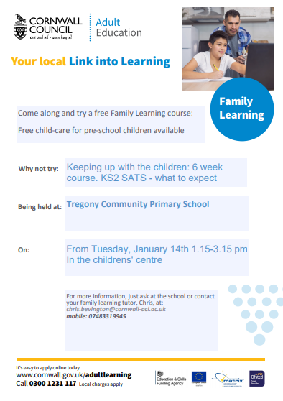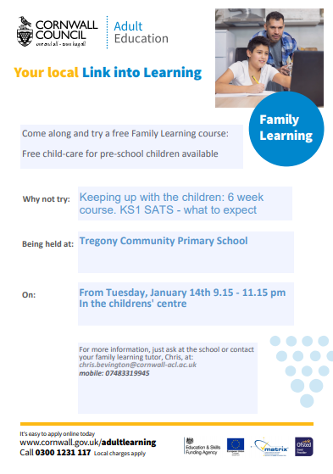

Ren Gianinni-Anderson for super independent writing. | Towan: Mikolaj Jedrysiak for improving his resilience and using his super writing skills during his literacy activity.  Summers: Imogen Martin for always working hard and following instructions  Porthcurnick: Noah Punch and Dylan Rescorla for challenging themselves in mathematics.  Eli Childey for an improved attitude towards writing and improvement with reading.  Portholland: Beau Matthews for focused, independent maths work and demonstrating his understanding excellently.  Porthluney: Jack Bowden for showing great skill, tactics and sportsmanship during PE.  P.E: Rhys Carpenter for an excellent swimming session and great technique
Godrevy: 466  Trevose: 481  St Antony: 761  Lizard: 751 | Towan: 94.78%  Summers: 93.31%  Porthcurnick: 96.92%  Portholland: 99.31%  Porthluney: 96.21%
White band: Aiden Lewis  Yellow band: Harry Cotton, Maizey Gilbert  Orange band: Riley K-H, Jayden Gregory, Beau Matthews | Blue band: Eva Rothwell, Curtis Andrew, William Michell, Edward Ives, Jack Bowden  Green band: Robert Tupper, Taylor Cookman, Joseph Hardiker  Brown band:  Black band:

Star of the Week: Freddie Clements for his fantastic writing skills

Swimming Dates
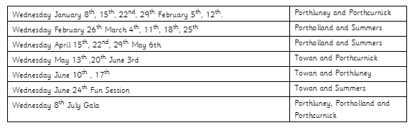
Tregony Clockhouse Players will be performing their pantomime during half-term week. Lots of our pupils will be performing so please support this community event.

