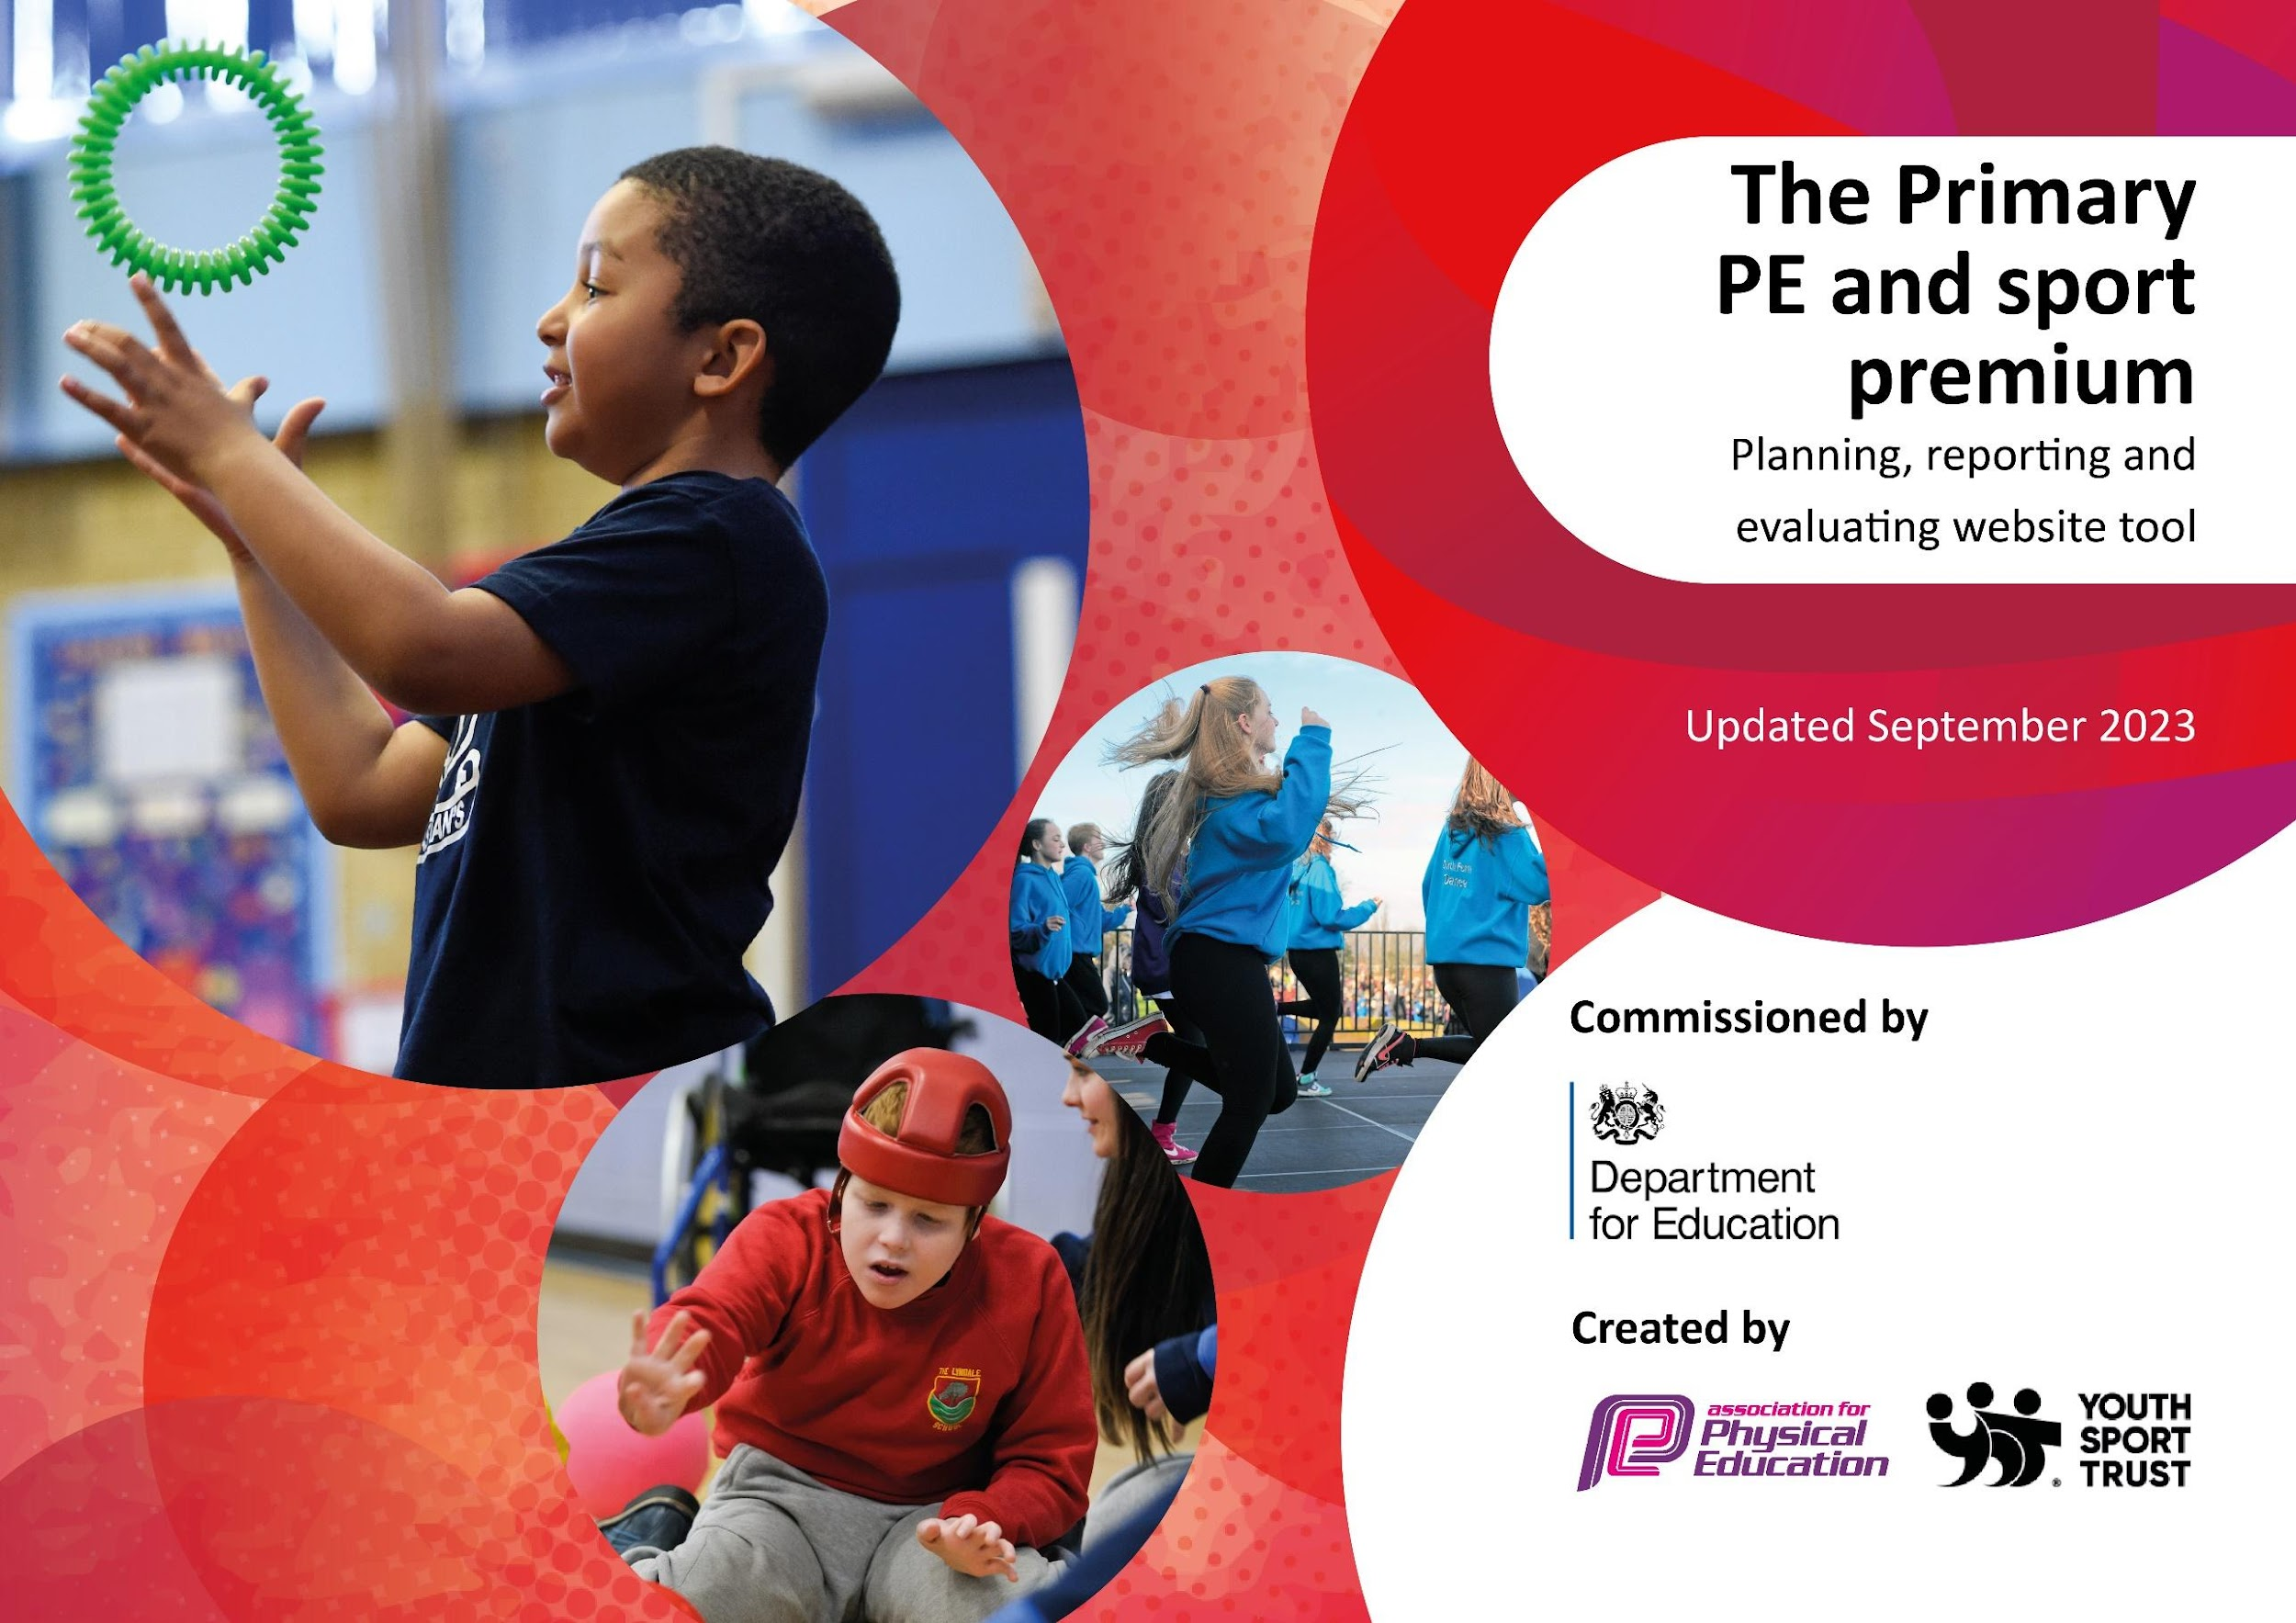

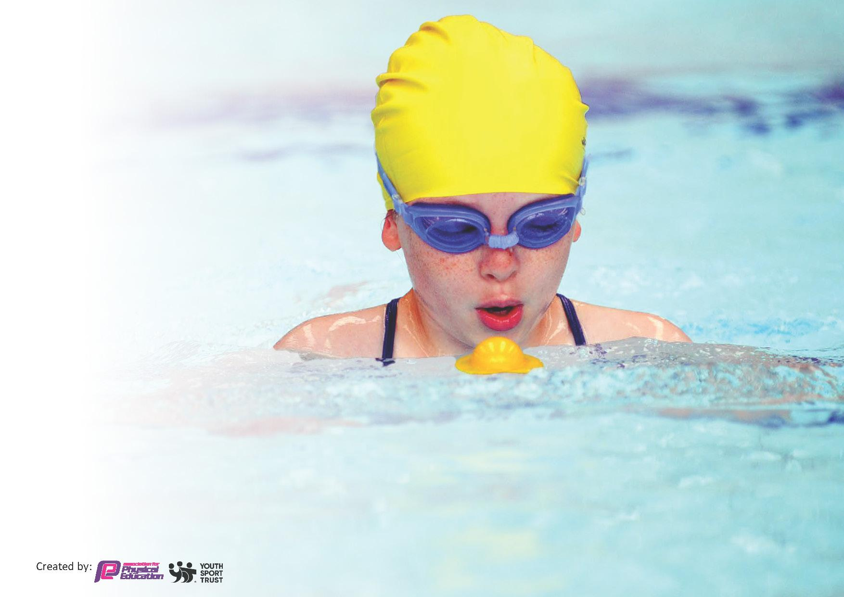
This template can be used for multiple purposes:
by:
- It enables schools to effectively plan their use of the Primary PE and sport premium
- It helps schools to meet the requirements (as set out in guidance) to publish information on their Primary PE and sport premium
- It will be an effective document to support Ofsted inspections enabling schools to evidence progress in Physical Education (PE) and evidence swimming attainment, which forms part of the PE National Curriculum. We would recommend schools consider
the Intent, Implementation and Impact of any spend, as examined within the Education Inspection Framework.

It is important that your grant is used effectively and based on school need.

Schools must use the funding to make additional and sustainable
improvements to the quality of the PE, School Sport and Physical Activity (PESSPA)
they offer. This means that you should use the Primary PE and sport premium to:

- Build capacity and capability within the school to ensure that improvements made now will benefit pupils joining the school in future years
- Develop or add to the PESSPA activities that your school already offers.

The Primary PE and sport premium should not be used to fund capital spend projects; the school’s core budget should fund these. Further detail on capital expenditure can be found in the updated Primary PE and sport premium guidance.

The Primary PE and sport premium guidance, outlines 5 key priorities that funding should be used towards. It is not
necessary that spending has to meet all the key priorities, you should select the priorities that you aim to use any funding towards.

Although completing this template is not a requirement for schools, schools are required to publish details of how they spend this funding. Schools must also outline what the impact this funding has had on pupils’ PE and sport participation and attainment and how any spending will be sustainable in the future. All funding must be spent by 31st July 2024.

The Department for Education has worked closely with the Association for Physical Education (afPE) and the Youth Sport Trust (YST) to develop this template and encourages schools to use it. This template is an effective way of meeting the reporting requirements of the Primary PE and sport premium.
Review of last year’s spend and key achievements (2022/2023)

Activity/Action | Impact | Comments
Employment of a sports specialist teacher | Continued employment of specialist PE lead overseeing all aspects of PE curriculum and after school clubs, including off site competition  - Increased pupil participation of active clubs and events  - Upskill all members of staff  - Additional provision for swimming  - Improvement of outdoor facilities on school site has increased physical activity  - Attainment levels at individual pupil level and school team level continue to improve.  - Positive impact on self-esteem.  - Opportunity for majority of children in school to represent school in competition against other schools  - Improved range of opportunities for children to be engaged in physical activity at break times and in outdoor learning within curriculum time. Cross curricular provision greatly improved  To lead P.E and sport, provide teachers with advice/coaching/CPD for improving lessons. To help to upskill other members of staff by offering guidance/CPD/Planning support to develop their subject knowledge. By doing so, class teachers have more confidence in their own ability and deliver high quality P.E lessons on a twice weekly basis. Pupils will experience and benefit from quality P.E teaching and we have seen an increased progression in skills.  Organisation and running of both intra school sports day and The Roseland Cluster Inter School Sports Day. As well as active camps, swimming, sailing and other sporting activities. A range of after school clubs alongside outside coaches to offer a wider range of sports and in doing so get more pupils involved in extracurricular sports clubs. Cornwall is surrounded by sea and as result swimming and water activities are provided to ensure that pupils can keep themselves safe in their locality.  P.E and Sports Funding Grant expenditure  equipment purchasing needs for both lessons and break times to ensure that physical activity is prioritised and curriculum resource requirements are available. Increased uptake of clubs for PP pupils.  This year we have offered different clubs to appeal to more pupils. Meetings were held with pupils to help decide on which clubs would run each half term. The different variety of clubs has appealed to our SEN and PP, where we have seen an uptake in these pupils attending clubs. See below.  Year 1 62%  Year 2 85%  Year 3 84%  Year 4 88%  Year 5 81%  Year 6 91%  The above has enabled the engagement of all pupils in regular physical activity – the Chief Medical Officer guidelines recommend that all children and young people aged 5 to 18 engage in at least 60 minutes of physical activity per day, of which 30 minutes should be in school. | Our planning provides opportunities for pupils to self and peer assess during lessons, and  also challenge themselves to their own abilities. Teachers are able to improve planning through  their own knowledge or asking the P.E lead for guidance on how to challenge/support pupils.  Pupils are able to lead warm ups within lessons and take on an active role by coaching and  refereeing which provides more challenge to talented sportsmen.  Pupils are actively engaged in all lessons and teachers can see progression throughout each half term in the sport/activity that they  are focussing on.
The Roseland School Sports Network and meebrship to the TRLC | To organise and run sporting events within our cluster. These then lead on to the second level with MCSN. These sporting events also include ones that are targeted at those less active and engaged in sports and Pupil Premium pupils which ensures more/reluctant pupils are involved in sporting activities.  Pupils across KS2 have taken part in various cluster competitions as well as cross country for Mid Cornwall. High involvement across KS2 in sport.  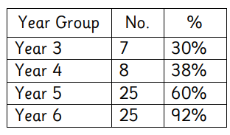  TRLC competitions aimed at different groups of pupils to increase opportunity, improve resilience, self-esteem and well-being. | It is the school’s aim that all pupils take part in some competitive sports by the time they leave the school.
Equipment | To ensure that we have a wide range of sports kit that will aid us in offering a variety of sports during lessons, in clubs and during break times.  There was significant investment in the nursery outside area which now meets the developing physical needs of our youngest pupils. As a result, children are more actively engaged with outdoor play which is essential in developing gross motor skills. | An inventory was taken to find out  what equipment needed to be replaced and if there were shortfalls that we needed to facilitate our new curriculum. Items were purchased.  We ensure that staff always have what is needed for lessons and our outside club providers also make use of our equipment. School Council regularly take note of equipment that is needed.
Transport, supervision and CPD of swimming | To ensure that all pupils across the school (inducing EYFS and Key Stage 1) have an opportunity to engage in sporting events and swimming. To ensure that specialist swimming instructors teach pupils to swim whilst upskilling teachers in this process.  As the school is located by the coast, EYFS and KS1 pupils also swim each year as this is deemed necessary for their safety. This also provides them with a base confidence for when they are swimming more in KS2.  All KS2 have taken part in swimming during the Spring term and this year we changed it so that they swim for five consecutive afternoons in a week and pupils were taught be a specialist swimming instructor rather than school-based staff. The impact of this was significant in that pupils’ progressed at a more rapid rate.  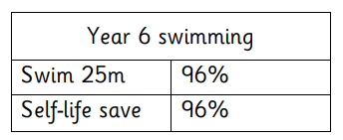 | All Year 6 pupils are taught to swim with the correct technique. Those Year 6 pupils that can swim more than 25 metres are also taught how to self-life save  All pupils are taught to swim with the correct technique. Those Year 6 pupils that can swim more than 25 metres are also taught water life saving techniques.  Staff have received mini-bus training so that we can support pupils’ involvement in these events as transportation costs were a significant barrier to attend these events. This investment will have a long-term impact.
Sporting events and activities throughout the year. | Year 6 take part in sailing yearly which gets all pupils involved and has led to some taking up sailing outside of school, as well as some gifted and talented [pupils being supported to compete in sailing regattas. PP pupils took part in sailing within the Autumn term.  KS2 surf days provide pupils with the opportunity to try something new and each year we see an increase in confidence from pupils, due to them trying something outside of their comfort zone.  Active, sports focussed camps are chosen where pupils have the opportunity to take part in land and sea sports, including outdoor learning such as making fires and orienteering.  Bikeability cycle training equips children with vital life skills. Pupils not only learn to cycle, they gain independence, social skills and a sense of wellbeing. After Bikeability, children are better at responding to risk. As a result, more children cycle to school which in turn improves mental health and wellbeing. This allows children to get more out of the classroom, improving their attention span and engagement. Healthier habits lead to increased attendance and improved academic results | One member of support staff Is upskilled in supporting the yearly sailing lessons.

Key priorities and Planning

Total Funding Received Year 2023-2024 | £17,300

Action – what are you planning to do | Who does this action impact? | Key indicator to meet | Impacts and how sustainability will be achieved? | Cost linked to the action
Sport and physical activity opportunities on the playground to allow pupils to engage with more physical activity, every day.  To purchase new equipment in order to offer a variety of physical activities during both PE and break times.  Support staff time, CPD and resources in order to run fun-fit sessions to children with SEN and TIS needs and promote engagement in regular physical activity. | Lunchtime supervisors / teaching staff, coaches - as they need to lead the activity  Sports Leaders to raise the profile of sport and physical activity by promoting physically active playtimes as well as helping improve playground behaviour and encourage the development of team work  Pupils – as they will take part. | Key indicator 2 -The engagement of all pupils in regular physical activity – the Chief Medical Officer guidelines recommend that all children and young people aged 5 to 18 engage in at least 60 minutes of physical activity per day, of which 30 minutes should be in school.  Key Indicator 3: The profile of PE and sport is raised across the school as a tool for whole school improvement. | More pupils meeting their daily physical activity goal, more pupils encouraged to take part in sporting activities.  Improved behavior on the playground.  Staff are upskilled in encouraging physical activity. | £3000 costs for additional CPD to support lunchtime sessions and resources

Swimming CPD for teachers and swimming lessons for all EYFS and Key Stage 1 pupils.  To purchase a PE curriculum that provides teachers with specialist plans that will support them with the appropriate skills and knowledge | Primary generalist teachers.  Pupils | Key Indicator 1: Increased confidence, knowledge, and skills of all staff in teaching PE and sport. | Primary teachers more confident to deliver effective swimming supporting pupils to undertake extra activities inside and outside of school, including teaching water safety and swimming and as a result improved pupil’s attainment in PE.  To lower the reliance on coaches from outside agencies.  To lower the reliance on coaches from outside agencies by buying into and implementing, an evidence backed, scheme of work. Specialist member of staff to run CPD sessions to secure implementation of this | £4000 for 5 teachers to undertake CPD alongside swimming lessons and the additional staffing and transport costs.  £1000 curriculum  To implement, and embed, a PE scheme of work throughout school and actively promote this change throughout school.
To take part in interschool sporting events run through the partnership with The Roseland Cluster to promote PE across the school in conjunction with the cluster sports lead  To partake in sporting fixtures with local schools to initiate a team/community feel to current school culture.  To attend as many cluster, and TRLC sporting events as possible, giving all children equal opportunities not entirely based on ability | Pupils | Key indicator 5: Increased participation in competitive sport | Upskilling of staff from specialist coach  Transport costs are a huge barrier due to our geographical location. Investing in staff training will facilitate pupils attendance at sporting events and activities | Employment of cluster schools coach  £1000  Additional staffing and mini-bus costs  £1000  Further staff mini-bus training (and cover costs)  £1000  To continue to deliver different sporting and physical activity opportunities during camp week.
To provide pupils with wider sporting activity opportunities  To ensure there are wide and varied opportunities to engage in a wide range of extracurricular activities  To run bikeability for children in years 5 and 6 to promote cycling as a means of being active  To run sailing lessons for Year 6 pupils  To run a key stage 2 surf school  Staff to teach alongside specialist coaches (employ specialist coaches in a range of other sports)  To employ specialist coaches to lead a variety of extracurricular sports clubs to give children access to a range of different sporting activities in order to promote life-long participation for all. | Pupils  Staff | Key indicator 4: Broader experience of a range of sports and activities offered to all pupils. |  | Sailing  £1500  Bikeability costs and staffing  £500  To promote a variety of outside of school sports opportunities when communicating with parents/guardians and children. 5. To make greater links with a wider range of local sports clubs.

Swimming Assessments

Meeting National Curriculum requirements for swimming and water safety.
Priority should always be given to ensuring that pupils can perform safe self-rescue even if they do not fully meet the first two requirements of the National Curriculum programme of study

Question | Stats: | Further context  Relative to local challenges
What percentage of your current Year 6 cohort can swim competently, confidently and proficiently over a distance of at least 25 metres? | 96 % | All KS2 have taken part in swimming. This year we changed it so that they swim for five consecutive afternoons in a week and pupils were taught be a specialist swimming instructor rather than school-based staff. The impact of this was significant in that pupils’ progressed quicker. As a result, 96% of KS2 pupils achieved the national swimming distance.  Small group/one-to-one sessions have been provided for some pupils who are at risk of not meeting the national expectations at Year 6.
What percentage of your current Year 6 cohort can use a range of strokes effectively [for example, front crawl, backstroke, and breaststroke]? | 96 %

What percentage of your current Year 6 cohort are able to perform safe self-rescue in different water-based situations? | 96%
If your schools swimming data is below national expectation, you can choose to use the Primary PE and sport premium to provide additional top-up sessions for those pupils that did not meet National Curriculum  requirements after the completion of core lessons. Have you done this? | Yes/No | Additional money has been used to target pupils with additional sessions and one-to –one adult support
Have you provided CPD to improve the knowledge and confidence of staff to be able to teach swimming and water safety? | Yes/No | The school has paid for qualified instructors at the pool whereas previously, our teachers and/or support staff have delivered swimming lessons. Each teacher attends the sessions in order to upskill themselves so that in time, confidence levels of staff will improve.

Signed off by:

Head Teacher: | Kate Douglass
Subject Leader or the individual responsible for the Primary PE and sport premium: | Kayleigh Mulroy/Julie Elvy
Date: | December 2024

Key achievements 2023-2024

This template will be completed at the end of the academic year and will showcase the key achievements schools have made with their Primary PE and sport premium spending.

Activity/Action | Impact | Comments
Swimming Data 2022-2023

