Friday 22 nd November
Dear Parents/Carers,
On Tuesday, we were delighted to welcome Mr Challis; Executive head of the Multi Academy Trust to our school. He spent time in each class observing mathematics and talking to pupils. He was impressed by the positive attitudes and hard work of our pupils.
Our value for the next two weeks is ‘Respect’ . We discussed this in our assembly and pupils can nominate peers who demonstrate this value, for our ‘value of the week’ award. I have already seen some wonderful examples of respect across the school.
On Monday evening, some Year 4 and 5 pupils took part in a Science workshop at The Roseland Academy. They had the opportunity to conduct scientific experiments in a real laboratory setting and had great fun!
On Wednesday evening our Year 6 pupils participated in Truro’s City of Light Parade. They have been working on their lanterns on the theme of ‘Under the Clocktower’. It was lovely for our pupils to be involved in a wider community event with many other schools and children from the Truro area. Pupils conducted themselves in a mature way and were as usual, wonderful representatives of our school. Don’t forget that all pupils of Tregony School are making lanterns ready for Tregony’s parade on the evening of Sunday 1st December.
This is our final plea for parental support for our School Christmas Fete which is due to be held on Wednesday 18th December at 9.15 am. Father Christmas is awaiting confirmation of whether he needs to pay us a visit! However, due to a lack of interest, we are considering cancelling this event which is a shame as these fundraising opportunities help to subsidise trips such as our cinema visit, outside play equipment, books for our library, lantern making, outside visitors and workshops etc. These things all enhance our pupils enjoyment of learning. Our plan was to set up after school, the evening before. On the day, we need parents support with stalls, teas/coffees etc. Any help will be gratefully received by us and our pupils. Please email me on head@tregony.cornwall.sch.uk or see Debbie at the office. Please let us know by Monday so that we can decide whether we can go ahead. The more people, the merrier!
Please remember that library change is now on a Monday for Key Stage 2 pupils. Please can I politely request that pupils have their P.E kit in school all week. Teachers have noticed an increasing amount of pupils without it. Kit is required for health and safety purposes. May we also remind you that cinema trip money is due - this is at a reduced rate as we have subsidised the cost using our fundraising money.
The deadline for signing up for the flu vaccination, which will be administered at school on Monday 25th November, is Thursday 21st November at noon. Please follow the link https://www.kernowimmunisations.co.uk/Forms/Flu School Code: EE142668
Kate Douglass
Headteacher.
Congratulations to the 12 pupils who took part in the Roseland Cluster Badminton tournament on Wednesday. Both teams finished in the top 3, with our Y3/4 team coming 2nd and our Y5/6 team finishing 3rd.

Miss Mulroy

P.E lead
- Payment for Cinema trip due | Lydia Tame showed resilience for continuing to manage her diabetes despite forgetting her packed lunch. She was nominated by Bella Curgenven.
- Monday 25th November - Nasal flu vaccination
- Wednesday 27th November - St Austell Music Festival starts
- Sunday 1st December - Tregony Lantern Parade. Meet at the school at 5.45pm
- Tuesday 10th December - Portholland class topic celebration 1.30-4.00pm
- Wednesday 11th December Christmas dinner and jumper day
- Wednesday 11th December - Key Stage 1 Christmas Play (am)
- Thursday 12th December -Key Stage 1 Christmas play (pm)
- Friday 13th December - Towan Class Eden trip
- Tuesday 17th - Whole school cinema trip
- Wednesday 18th december School Christmas Fete 9.15am - 11.00 am (to be confirmed)
- Wednesday 18th December - Christmas parties (pm)
- Friday 20th December end of term Christmas assembly in the church at 9.15 am
- Friday 20th December - Break up for Christmas holidays 1.30pm finish - no wrap around care
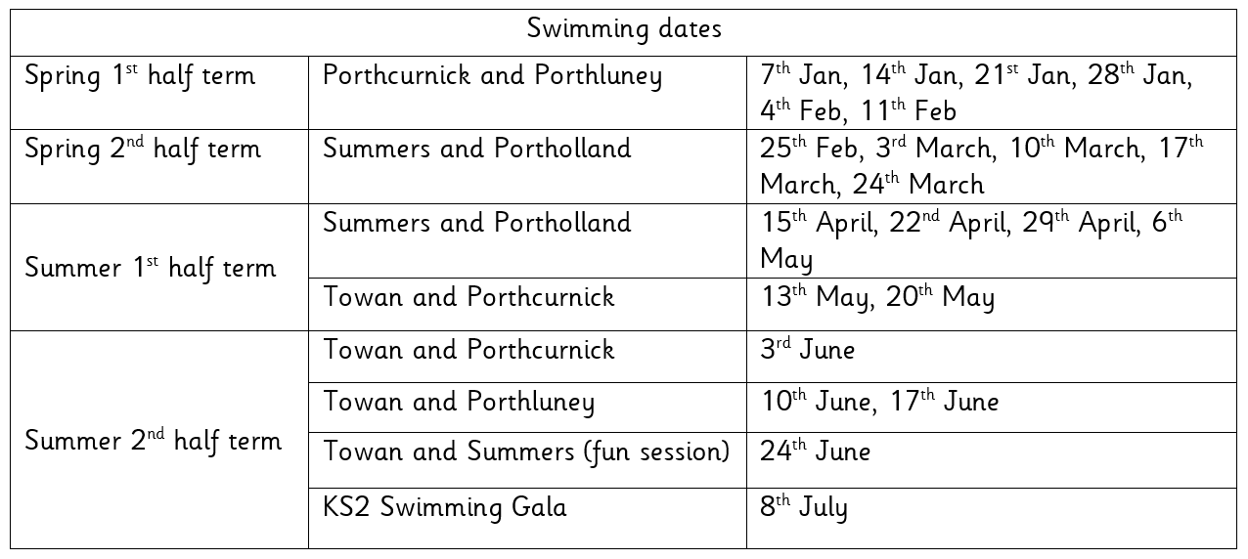
Finally, don’t forget to check our website for school related information, which we are in the process of updating. You can also add us on Facebook to keep up-to-date with news, reminders and photos

Tyler Varley for amazing addition and subtraction work in mathematics.  Daniel Dicker for a brilliant design and construction of a cams toy made completely from recycled products.  Poppy Taylor for super independent writing about a duck!  Riley Kingsley-Heath for amazing design skills, teamwork, organisation, maturity and for being a budding architect whilst making willow lanterns. | Towan:. Maizey Gilbert for always following instructions to the best of her ability.  Summers: Tabitha Curtis for being a great help to all when making our lanterns  Porthcurnick:.Georgia Tuby for excellent focus in maths.  Alfie Whale for beautiful handwriting.  Portholland: Ben Stobart for an entertaining and well written letter of invitation.  Porthluney: G.  P.E: Samanta Ryzak for winning all of her badminton matches at the cluster tournament.
Godrevy: 2100  Trevose: 1853  St Antony: 1619  Lizard: 2795 | Towan: 93.28%  Summers: 97.39%  Porthcurnick: 96.54%  Portholland: 98.62%  Porthluney: 97.24%
White band: Oliver Hook, Mia Giannini-Anderson, James Trudgeon, Ava Giannini-Anderson, Layla Bush, Oli Hill, Evie Tuby  Yellow band: Rosie Curgenven, Matthew Dinsdale, Huw Floyd-Norris, Ethan Humphries, George Gray, Tabitha Curtis, Tyler Varley, Jayden Gregory, Arthur Coghlan, Riley K-H, Noah Punch | Orange band: Megan Keast, Riley F  Blue band:  Green band:  Brown band:  Black band:

The time of bingo on Friday 13th December has been confirmed: doors open at 6.30pm and eyes down at 7pm.

We are currently looking for a chair for the committee; If you would like to know anymore information or are interested, then please email Kirsty at tregony.preschool@gmail.co.uk

Star of the week: Darcy Rouncivel for always being so kind and helpful.

Tregony Christmas Lights Group will be erecting this year's display over the following weekends 16th/17 & 23rd/24th of this month and would like to have as much help as possible for the task, even if only for a couple of hours on any of the days mentioned. Please contact either John Smith on 01872 530374 or Des Mennear on 01872 530357 for further information.

