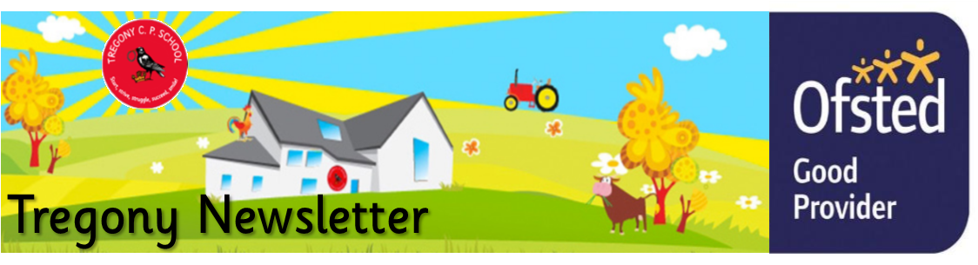
Friday 13th March 2020
Dear Parents/Carers,
We have had another busy week. On Monday, our pupils celebrated British Science Week by carrying out investigations based on our diverse planet. In Key Stage 1, pupils compared their height to hand span to investigate whether taller people had bigger hands. In Key Stage 2, they focused on Antarctica and carried out experiments that investigated the best materials for coats and sledges. Porthcurnick class visited The Roseland Academy where they carried out an investigation to discover the preferred habitat of woodlice.
On Monday evening, we held a multiplication family learning evening. Year 3 and 4 pupils challenged their parents to beat them on Times Tables Rockstars, many of whom, were considerably quicker than the adults. They also found out more about the new times table check in June. If you were unable to attend, we have copies of all our Family Learning presentations on our school website. We will also be sending home a parent information leaflet about the new times tables check.
Unfortunately, due to unforeseen circumstances, our planned NSPCC assemblies will be cancelled next week. Also, the book signing for the book, Secret of the Dark Woods, will now be on Friday 20th March.
At the bottom of this page, I have added a link that will give you up-to-date advice and guidance on the Coronavirus. We will continue to update you on the school’s response to Government advice from The Department of Education, as we receive it.
Kate Douglass
Headteacher.
Congratulations to the 11 pupils who raced in the MCSN semi final cross country race in Newquay yesterday. They all had great races, especially considering the hail storm!

We also had 23 pupils who went to The Roseland Academy on Wednesday to take part in the FunFest and it was great to see such enthusiasm from them all.

Miss Mulroy

P.E lead
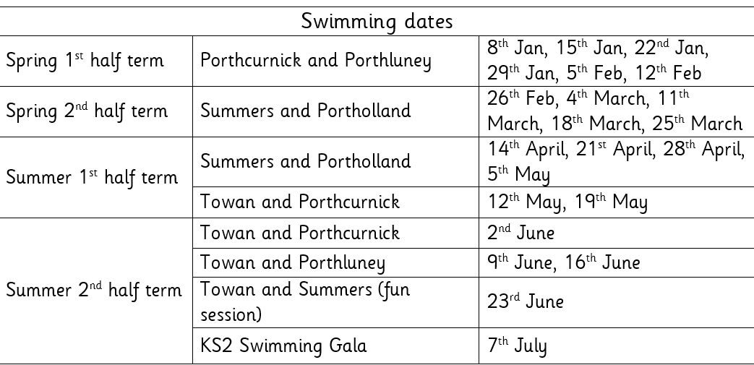

- Tuesday 17th March Summers’ trip to Truro Museum  - Thursday 19th March - NSPCC assemblies  - End of topic celebrations | Value of the Week:

- Tuesday 17th March Summers’ trip to Truro Museum
- Tuesday 17th March Towan’s end of topic celebration 2-4 pm
- Thursday 19th March - NSPCC assemblies
- Friday 20th March Porthcurnick Book Launch Waterstones 10.00 am
- Tuesday 24th March Portholland class album launch 2-4pm
- Wednesday 25th Porthluney VE Day Party 2-4pm
- Thursday 26th March Summers ‘Danceathon’ all day drop in

Dylan Rescorla, Jago Martin, Isobel Curgenven and Saskia Curgenven for beautiful descriptive writing about a dragon.  Harriet Jones for super effort and improvement with her handwriting and letter formation.  Seth Merrick for showing responsibility by supporting young children with their behaviour on the playground.  Jasper Wicks for super independent writing using and applying his phonics learning | Towan: Riley Bennett for settling in well and trying really hard in all areas of his learning.  Summers: Hetty Rothwell for becoming more confident in the water at swimming.  Porthcurnick: Dylan Rescoral for super handwriting and a beautiful dragon description.  Portholland: Freya Hill for working hard to overcome challenges and excelling when subtracting fractions.  Porthluney: Enyaj Taylor and Megan Merrick for producing an excellent narrative based on ‘Beyond the Lines’  P.E: Harriet Jones for an improved confidence; taking part in FunFest and moving up a group at swimming.
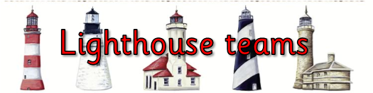  Godrevy: 1282  Trevose: 1520  St Antony: 1945  Lizard: 1581 | Towan: 94.20%  Summers: 96.30%  Porthcurnick: 96.58%  Portholland: 98.52%  Porthluney: 98.08%
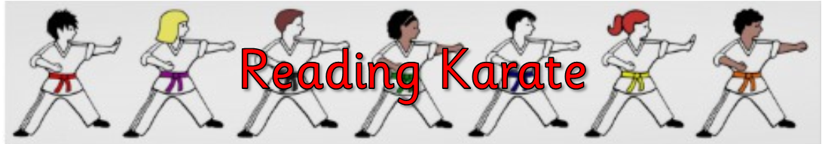
White band: Finn Lury  Yellow band: Isaac Scholes, Alix Varley, Olive Bennett, Tristan Rescorla  Orange band: Mia Giannini Anderson, Harry Cotton, Evie Tuby, Georgia Tuby.  Blue band: Beau Matthews | Green band: Noah Punch  Brown band: Bella Curgenven, Megan Merrick, Megan Keast, Toby Rounsevell  Black band: Daniel Dicker, Jack Filbey, Hope Blades, Amie Grunberger Miles, Elizabeth Dicker

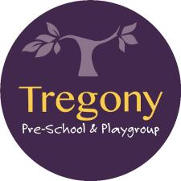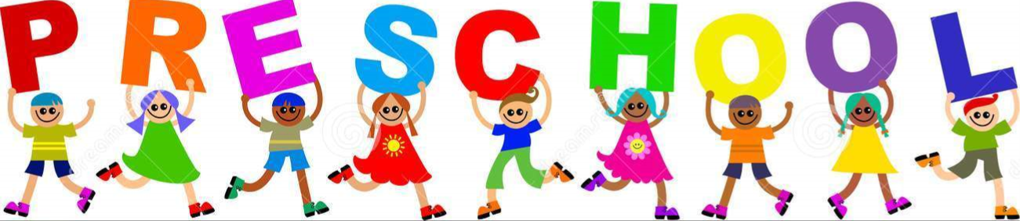

Star of the Week:
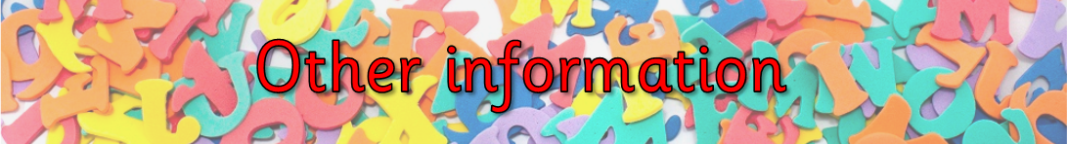
If you would like advice regarding Coronavirus (COVID-19), Please follow the link below https://www.gov.uk/government/topical-events/coronavirus-covid-19-uk-government-response
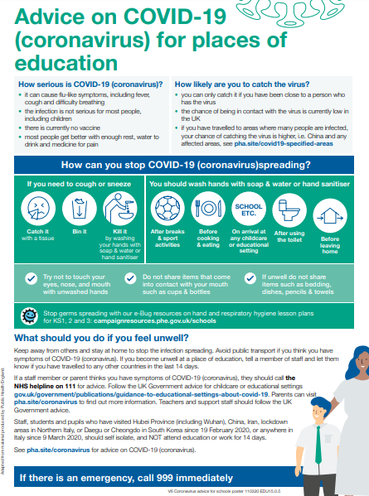
Hello,
As the Coronavirus spreads, we’re aware that more schools are closing and pupils’ learning is being disrupted. Parents, carers and teachers are looking for ways to ensure the continuity of education during school closures so that no children miss out on valuable learning time.
To support you during this period, we (Twinkl) are offering every parent and carer in the school free subscription so your pupils can still have access to high-quality learning during any periods of disruption.
Setting this up is really easy to do - go to www.twinkl.co.uk/offer and enter the code UKTWINKLHELPS
It’s easy to arrange access yourself through our website. If you do have any questions please get in touch with our TwinklCares team. As we are supporting people globally please bear in mind that we are receiving a large number of enquiries so please only get in touch if your enquiry is of an urgent nature at twinklcares@twinkl.co.uk
You can also visit our website - www.twinkl.co.uk
Our thoughts are with everyone affected by the Coronavirus outbreak and we hope that this will go some way towards helping.
Best wishes,

Jonathan Seaton

