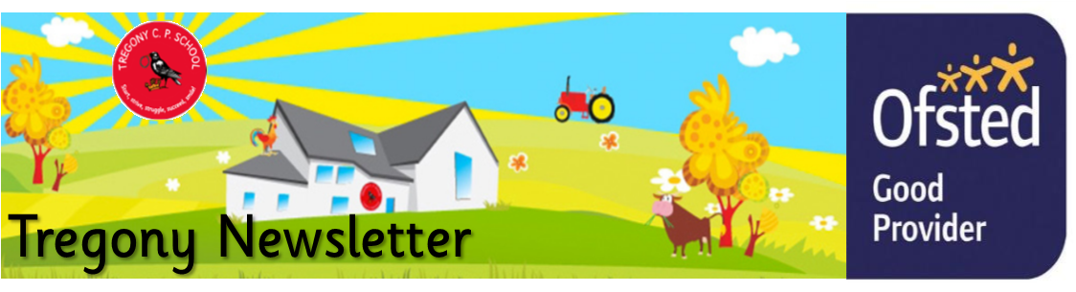
Friday 20th March 2020
Dear Parents/Carers,
I must confess, as a new headteacher, I could never have anticipated the unexpected events of the past two weeks. However, I am incredibly proud of the staff and pupils in the supportive, calm and committed way they have worked together to continue to function as a school, despite the ever changing guidance and advice (or indeed the lack of it). Uncertainty causes concern for all and these are indeed uncertain times. But I believe we have continued to give our children structure and routine.
Moving forward, you will all have received my letter regarding an enforced school closure for the majority of our pupils. We have worked hard to ensure that we can continue to provide an education for your children by setting up Google Classroom. There are copies of the guidance and all other related letters on the school website. These can be found in the ‘News’ tab on the top bar. Please let us know by email if you are experiencing problems with this, as it is likely that we may need to use this outlet as a long term method to educate your children.
I appreciate that these unprecedented circumstances will be challenging for us all and we, as a community, must work together to support one another as best we can. I also understand that many of you will be facing the difficulty of working at the same time as supporting your child with their education on a daily basis. Myself and my staff will do our very best to support you and your children at this time. Details of how to contact us are in the aforementioned letter. Please do not forget to check the school website, Facebook and your emails in order to remain up-to-date with any changes.
You will all have received a letter regarding pupils of key workers and this is to be used as a last resort only and is available to a limited number of pupils. I urge you to follow the Government's advice whereby, If it is at all possible for children to be at home, then they should be. This is essential in reducing the spread of the virus to other children, staff and our most vulnerable.
Finally, I thank you enormously for your support and wish you and all of your families the best and hope that you manage to stay fit and healthy.
Kate Douglass
Headteacher.

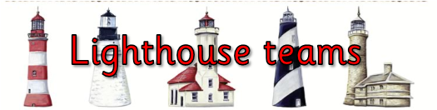  Godrevy: 1282  Trevose: 1520  St Antony: 1945  Lizard: 1581 | 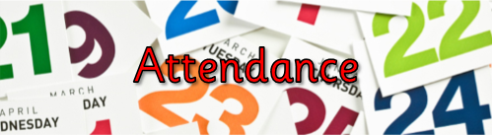  Towan: 94.20%  Summers: 96.30%  Porthcurnick: 96.58%  Portholland: 98.52%  Porthluney: 98.08%
White band: Finn Lury  Yellow band: Isaac Scholes, Alix Varley, Olive Bennett, Tristan Rescorla  Orange band: Mia Giannini Anderson, Harry Cotton, Evie Tuby, Georgia Tuby.  Blue band: Beau Matthews, George Cluett-Bird, Harry Spires | Green band: Noah Punch  Brown band: Lydia Tame, Mathilde Knight  Black band: Joseph Hardiker, Annabelle Coughlan

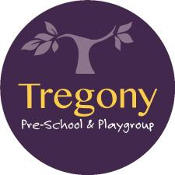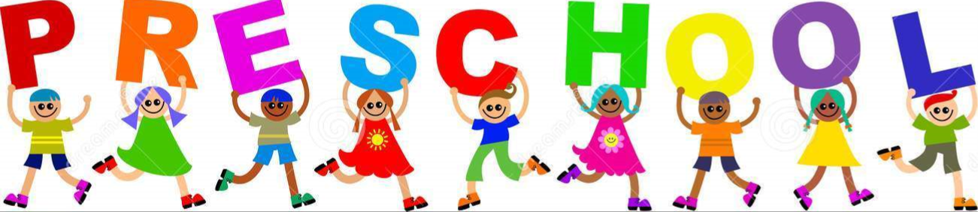

Star of the Week:
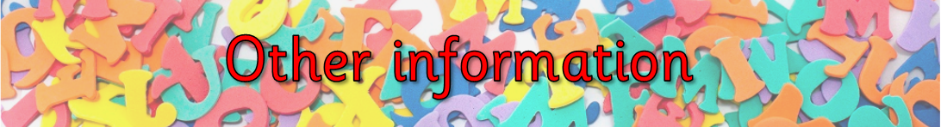
If you would like advice regarding Coronavirus (COVID-19), Please follow the link below https://www.gov.uk/government/topical-events/coronavirus-covid-19-uk-government-response
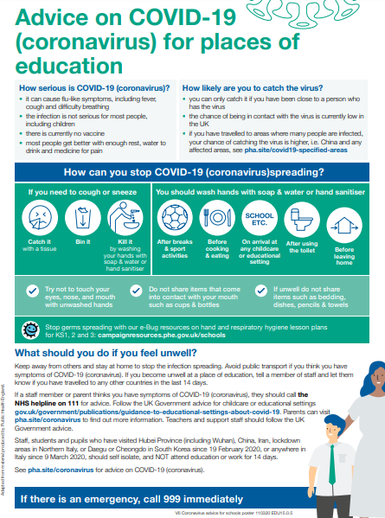

Jonathan Seaton
