Friday 28th February 2020
Dear Parents/Carers,
Welcome back to the second half of the Spring Term! This is a short but exceptionally busy time. There have been lots of letters distributed this week. We have a Year 6 SATs Family Learning Evening on Wednesday 4th March, which will focus on supporting your child through this time. We also have a times tables Family Learning evening on Monday 9th March for all Year 4 pupils. This is a new priority as evidence suggests that not knowing your times tables is one of the biggest barriers to mathematics. We also have our annual World Book Day celebration on Thursday 5th March.
Thank you to everyone who attended our Parents' Evening on Wednesday; if teachers didn’t see you, we will make another appointment soon.
On Monday, in assembly, we discussed how we could improve our lunchtime dining experience. It is always a challenge to feed 136 pupils in a calm and orderly manner. We revisited behavioural expectations and manners and how this will be a focus for us as a school. We have also started a reward system whereby pupils are placed into a prize draw to have lunch on a ‘Golden Table’ with hats.
On Tuesday, School Council helped to plant a new flower garden beneath the Tregony sign. It was a very wet and muddy affair, but the children are looking forward to looking after and maintaining it throughout the year.
Next Tuesday, Porthluney will be going to Flambards Museum as part of their Battle of Britain topic. Please can all children come to school with a packed lunch, a drink and a coat, as well as wearing full school uniform.
Today, we said goodbye to Mrs Bishop. She has worked with us at Tregony School for 8 years! We wish her luck in her next adventures and thank her for everything she has done.
Please can we politely request that you book Breakfast Club and Wrap-Around-Care in advance. It is important that we have accurate numbers to ensure staffing ratios. If you need a last minute booking, please call the school office to check that there is a space available. Thank you.

Kate Douglass
Headteacher.
We haven’t had a very good year for cross country, with several races having to be postponed. Unfortunately, the KS1 race was also postponed this week; I will send out information with the new date on once I know.

Within the next week, I should also find out who has qualified for the semi final race on the 12th March. Once I know who this involves, I will send letters out.

Miss Mulroy

P.E lead
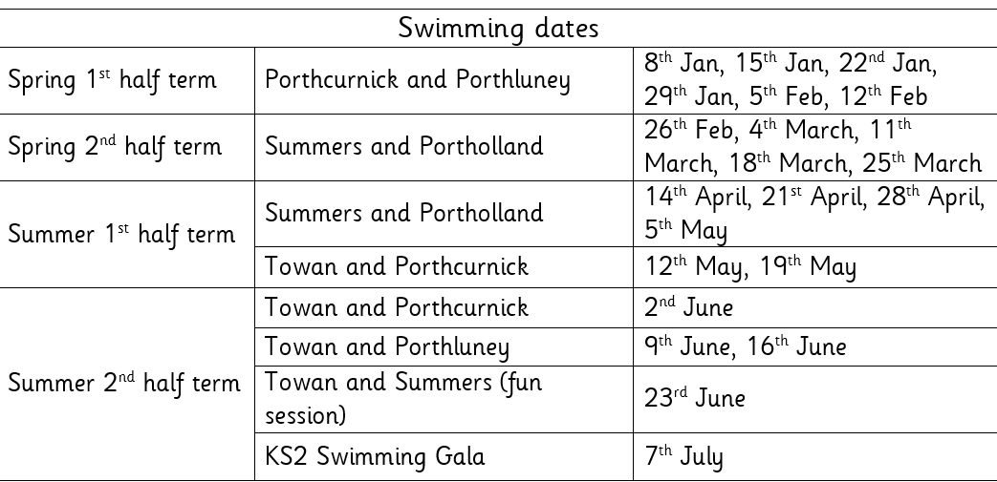

- Multi-academy Trust letter  - Parents’ Evening Letter  - Clubs letter | Value of the Week: Care
- St Piran’s Day Menu 5th March
- Tuesday 3rd March - Year 6 Flambards/Britain in the Blitz trip
- Wednesday 4th March Year 6 SATs information evening
- Thursday 5th March World Book Day
- Monday 9th March Year 4 Multiplication Test Family Learning
- 13th March Fun Fest
- Tuesday 17th March Summers’ trip to Truro Museum
- Thursday 19th March - NSPCC assemblies

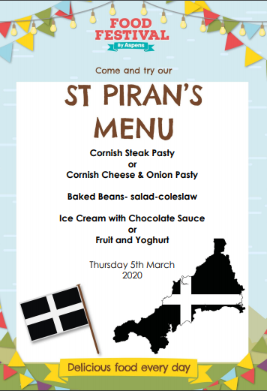

Finally, don’t forget to check our website for school related information, which we are in the process of updating.

Carl Agar and Jack Bowden for creating excellent, thought-provoking poetry based on the importance of letters in World War Two. | Towan: Grace Floyd-Norris for showing super resilience in phonics this week and for demonstrating confidence by answering questions on the carpet.  Summers: Arya Insoll for having a great swimming session  Porthcurnick: Alfie Whale for much better focus in lessons  Portholland: Ben Stobart for being a kind and supportive friend. Henry Bedford for an excellent start at Tregony.  Porthluney: Oliver Lockyer for striving to apply prior knowledge when learning about percentages.  Arthur Blewett for passing his 99 Club test and dramatically improving his arithmetic mark—all in one day!  P.E: Morgan Collard for showing an improved confidence at swimming and working hard on his technique.
Godrevy: 945  Trevose: 1011  St Antony: 1504  Lizard: 1233 | Towan: 93.52%  Summers: 93.83%  Porthcurnick: 97.01%  Portholland: 94.07%  Porthluney: 95.79%
White band:  Yellow band: James Trudgeon, Harry Wilson, Neil Charles, Ren Giannini-Anderson  Orange band: Kyden Gilbert, Oliver Lockyer, Alfie Whale, Isabella Bonney, Oscar Grunberger-Miles, Lilly Charles | Blue band: Huw Floyd Norris, Rosie Curgenven, Summer Gibson, Caitlin Beel, Saskia Curgenven  Green band: Edward Ives, Bella Curgenven, Enyaj Taylor, Mathilde Knight, Merryn Knight, Samanta Ryzak, Curtis Andrew, Seth Merrick, Otis Wilson, Megan Keast  Brown band: Thomas Michell, Matilda Curtis, Joseph Hardiker, Carl Agar, Evarose, Gabriel Welch Punton, Annabelle Coghlan  Black band: Finn Lury, Frank Lynch Wright, Rory Hammond, Henry Baker

Star of the Week:
