Porthcurnick – Year 3 and 4 Punctuation and Grammar Overview
Year A
Unit One | Unit Two | Unit Three | Unit Four | Unit Five | Unit Six | Unit Seven | Unit Eight
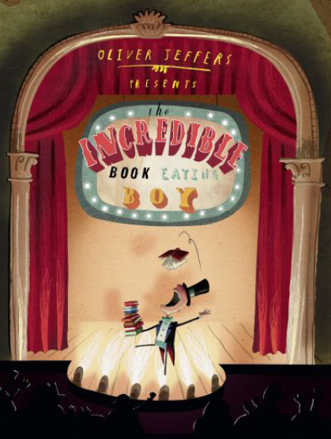  Narrative – Comedy – The Incredible Book Eating Boy (Oliver Jeffers)  Year 3  Independent Write: Big idea replicated to new plot  Relative clauses  Conjunctions  Alliteration  Colon  Figurative language  Adverbials  Onomatopoeia  Question  Dialogue  Prefix  Prepositions  Adverbs  Past perfect | 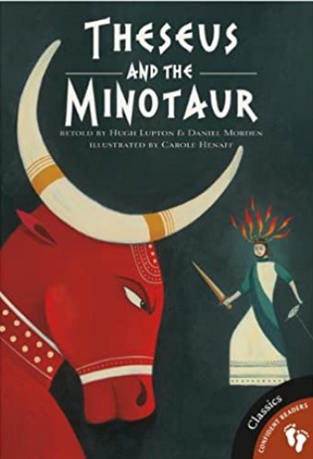  Narrative – Myth – Theseus and the Minotaur (retold by Hugh Lupton and Daniel Morden)  Year 3  Independent Write: New viewpoint on the same plot  Adjectives  Conjunctions  Fronted adverbials  Preposition  Repetition  Relative clauses  Dialogue  Figurative language  Alliteration  Onomatopoeia  Show not tell  Present perfect | 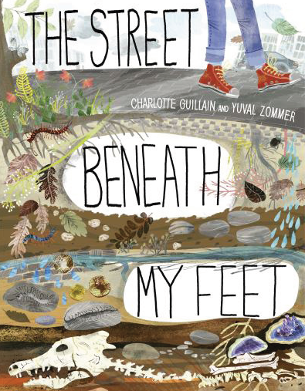  Non-Fiction –  Explanation – The Street Beneath My Feet (Charlotte Guillain and Yuval Zommer)  Year 3  Independent Write:  Read 'The Skies Above my Eyes' and write an explanation of what is above.  Questions  Prepositions  Relative clause  Figurative language  Dialogue  Joke/pun  Alliteration  Question  Repetition  Adverbials  Onomatopoeia  Caption  Imperative verbs  Exclamation | 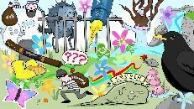  Non-Fiction – Poetry – The Colour Collector (Roger McGough)  Year 3  Independent Write: Own poem based on someone stealing something around them e.g. word collector  Onomatopoeia  Rhyme  Adjectives  Suffixes  Alliteration  Rhetorical question  Figurative language  Adverbs  Preposition  Apostrophe | 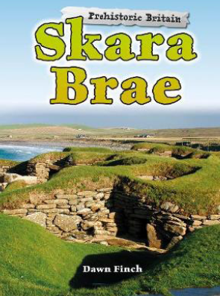  Non-fiction – Brochure - Skara Brae  Year 3  Independent Write: Write a holiday brochure for Stone Henge  Pun  Rhyme  Rhetorical question  Complex sentence  Figurative language  Adjectives  Imperative verbs  Alliteration  Noun phrase | 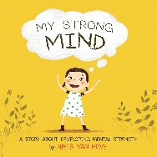  Non-Fiction – Non-fiction - Instructions - My Strong Mind  Year 3  Independent Write: Write instructions on how to create a strong mind  Adjectives  Title  Bullet points  Adverbials  Rhetorical questions  Noun phrases  Subheading  Technical vocabulary  Complex sentences  Conjunctions  Imperative verbs  Brackets | 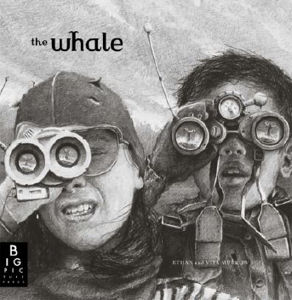  Narrative – Mystery – The Whale  (Ethan Murrow and Vita Murrow)  Year 4  Independent Write: Continuation with plot  Noun phrase  Questions  Exclamations  Relative clause  Fronted adverbial  Figurative language  Inverted commas  Alliteration  Dialogue  Adjectives  Dash  Adverbs  Rhetorical questions  Headline  Strapline  Introduction | 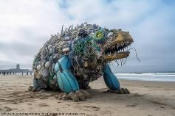  Non-Fiction - Newspaper Report - The Creature  Year 4  Independent Write: Pupils write a newspaper report describing the unusual  creature or undiscovered species found on the beach  Headline  Strapline  Caption  Rhetorical question  Five Ws  Adjectives  Relative clause  Direct speech  Noun phrases  Adverbials  Colon  Complex sentence  Figurative language  Formal/informal  Alliteration
Year B
Unit One | Unit Two | Unit Three | Unit Four | Unit Five | Unit Six | Unit Seven | Unit Eight
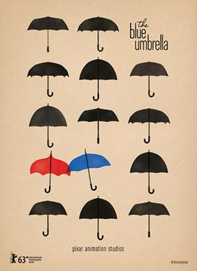  Narrative – Romance -  The Blue Umbrella  (Pixar Animation Studios)  Year 3  Independent Write: Big idea replicated to a new plot - following hats, shoes, bags etc.  Fronted adverbial  Complex sentence  Prefix  Question  Imperative verb  Dialogue  Preposition  Figurative language  Adjectives  Onomatopoeia  Adverbs | 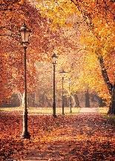  Poetry – Autumn is Here  Year 3  Independent Write: Winter or Spring is Here  Figurative language  Adjectives  Adverbs | 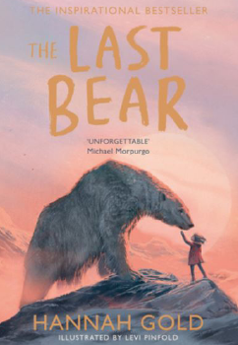  Narrative – Adventure – The Last Bear (Hannah Gold)  Year 3  Independent Write: New viewpoint on the same point  Commas in a list  Figurative language  Conjunctions  Direct speech  Suffixes  Adverbials of time  Complex sentences  Alliteration | 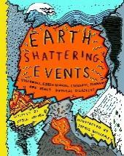  Non-Fiction – Non-Chronological Report – Earth Shattering Events (Robin Jacobs)  Year 3  Independent Write:  Adjectives  Alliteration  Adverbials of time  Figurative language  Rhyme  Preposition  Complex sentences  Technical vocabulary  Subheading  Onomatopoeia  Adverbs  Conjunctions  Noun phrases  Teach compound words as expanded noun phrases | 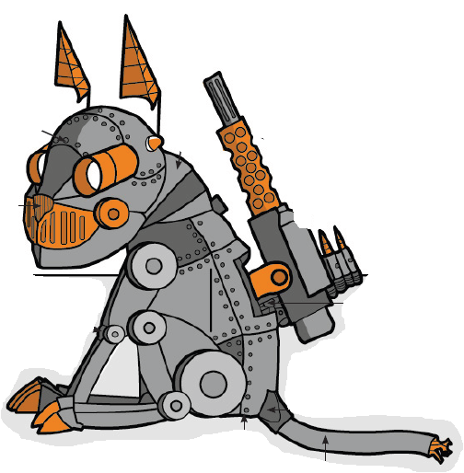  Non-fiction – Explanation – How a Robot Dog Works  Year 3  Independent Write: Write an explanation for an electronic household pet such as an i-cat, i-rabbit or i-hamster)  Heading  Repetition  Hyperbole  Alliteration  Adjectives  Technical vocabulary  Adverbials of time  Adverbs  Imperative verbs  Onomatopoeia  Question mark  Conjunctions  Figurative language  Exclamation mark  Dialogue | 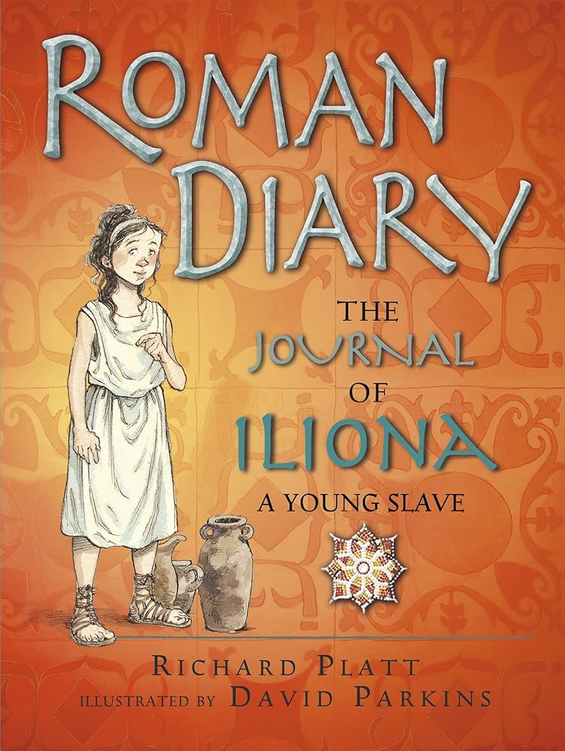  Non-Fiction – Diary - Journey of a Ilonia A Young slave (Richard Platt and David Parkins)  Year 4  Independent Write: Diary entry - Day 6 - the separation of Ilonia and her brother, Apollo  Exclamation mark  Colon  Question  Adverbials of time  Repetition  Figurative language  Adjectives  Conjunctions  Rhetorical question | 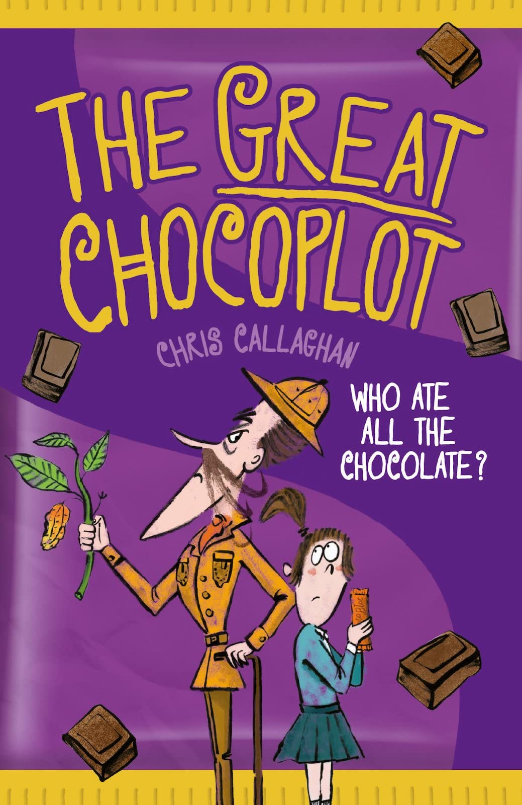  Narrative – Mystery - The Great Chocoplot (Chris Callaghan)  Year 4  Independent Write: Continuation of plot  Noun phrase  Repetition  Onomatopoeia  Relative clause  Fronted adverbials  Complex sentences  Alliteration  Figurative language  Conjunctions  Dialogue  Alliteration | 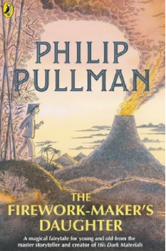  Narrative – The Firework Maker’s Daughter (Philip Pullman)  Year 4  Independent Write: New viewpoint on the same plot: Write the story from the father's perspective.  Relative clause  Alliteration  Repetition  Onomatopoeia  Conjunctions  Colon  Modal verbs  Brackets  Figurative language

Portholland – Year 4 and 5 Punctuation and Grammar Overview
Year A
Unit One | Unit Two | Unit Three | Unit Four | Unit Five | Unit Six | Unit Seven | Unit Eight
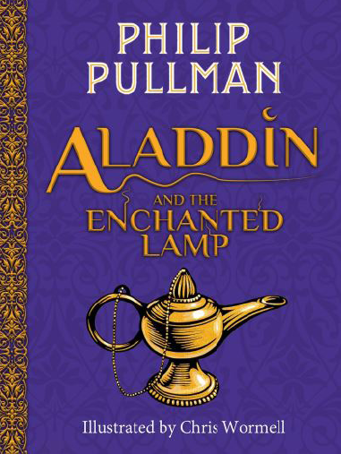  Narrative – Traditional Tale – Aladdin and the Enchanted Lamp (Philip Pullman)  Year 4  Independent Write: Continuation with plot  Complex sentences  Adverbs  Figurative language  Question  Apostrophes  Dialogue  Alliteration  Adverbials  Repetition | 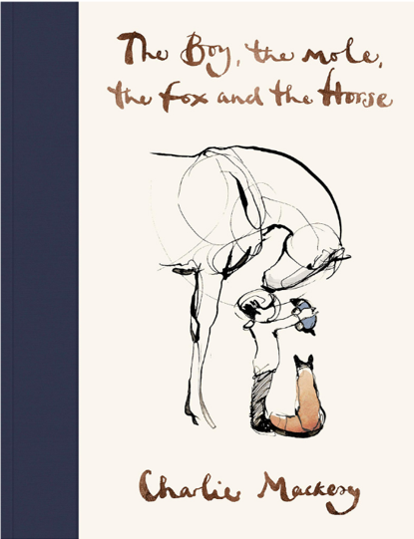Narrative – Story of Love and Hope – The Boy, The Mole, The Fox and The Horse (Charlie Mackesy)  Year 4  Independent Write: New viewpoint on the same plot  Fronted adverbial  Question  Dialogue  Repetition  Figurative language  Preposition  Apostrophes  Conjunctions  Alliteration | 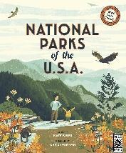  Non-Fiction – Balanced Argument – National Parks of the USA (Chris Turnham)  Year 4  Independent Write: Write a balanced argument titled - Which National Park is better to visit: Glacier Bay or Virgin Islands?  Alliteration  Colon  Relative clause  Quote  Fronted adverbial  Conjunctions  Apostrophe  Formal/informal  Adjectives | 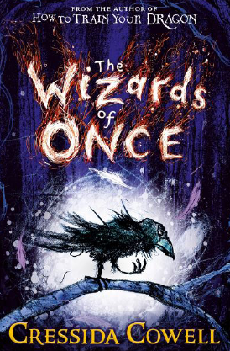  Non-Fiction – Newspaper Report – Wizard of Once (Cressida Cowell)  Year 4  Independent Write: ‘Troll in the Girl’s Bathroom!’  newspaper article  Headline  Pun  Strapline  Alliteration  Conjunctions  Figurative language  Expanded noun phrase  Hyperbole  Preposition  Quote  Alliteration  Adverbs  Reported speech  Informal/Formal  Relative clause  Fronted adverbials | 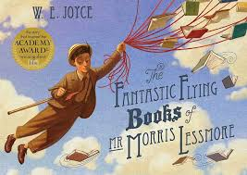Narrative – The Fantastic Flying Books of Mr Morris Lessmore (W E Joyce)  Year 5  Independent Write: New viewpoint on the same plot  Fronted adverbials  Dash  Modal verbs  Onomatopoeia  Adverb  Parenthesis  Repetition  Figurative language  Colon  Conjunctions  Dialogue  Relative clause | 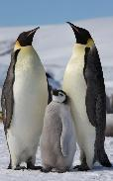  Non-Fiction – Non-Chronological Report - Emperor Penguins  Year 5  Independent Write:  Non chronological report based on different breeds of Penguin  Alliteration  Pun  Relative clause  Expanded noun phrase  Rhetorical question  Modal verb  Adjectives  Complex sentences  Adverb  Adverbial  Colon  Technical language  Parenthesis  Conjunctions  Rhyme  Passive voice  Labels  Captions  Bullet points | 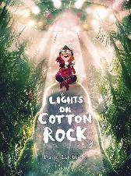  Narrative – Lights on Cotton Rock (David Litchfield)  Year 5  Independent Write: New viewpoint on the same plot  Figurative language  Adverbs  Repetition  Onomatopoeia  Prefixes  Questions  Dialogue  Rhyme  Fronted adverbials  Suffixes  Alliteration  Conjunctions  Hyphens | 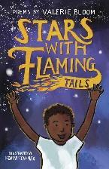  Poem - The Most Dangerous Animal in the World (Valerie Bloom)  Year 5  Independent Write: Poem  Dash  Rhyme  Repetition  Alliteration  Hyperbole  Modal verbs  Adjectives  Adverbs

Year B
Unit One | Unit Two | Unit Three | Unit Four | Unit Five | Unit Six | Unit Seven | Unit Eight
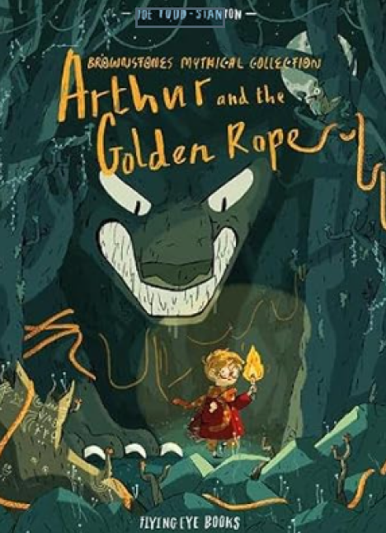Narrative - Norse Myth - Arthur and The Golden Rope (Joe Todd Stanton)  Year 4  Independent Write: Create another quest that Thor sends Arthur on – he needs to collect two strange items to solve a problem in the town  Adverbial of time  Dialogue  Repetition  Apostrophes  Onomatopoeia  Superlatives  Adverbs  Complex sentences  Rhetorical question  Conjunctions  Brackets (Parenthesis) | 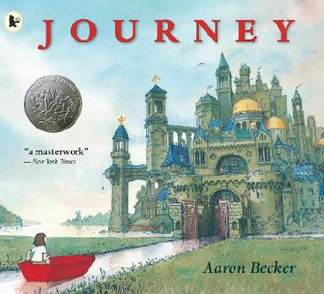  Narrative – Adventure – The Journey (Aaron Becker)  Year 4  Independent Write: Continuation with plot  Dialogue  Onomatopoeia  Metaphor  Pathetic fallacy  Repetition  Preposition  Simile  Adverbial of time  Noun phrase  Personification  Alliteration  Fronted adverbials  Rhetorical question  Subordinating conjunction | 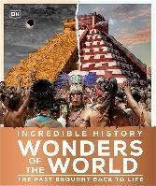  Non-Fiction – Recount – Incredible History – Wonders of the World – The Past Brought Back to Life (DK)  Year 4  Independent Write: Write a recount of a visit to a Greek theatre  Adjectives  Adverbs  Simile  Fronted adverbials  Onomatopoeia  Complex sentences  Alliteration  Subordinating conjunction | 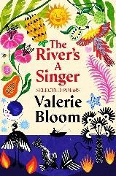  Poetry – The River (Valerie Bloom)  Year 4  Independent Write:  Pupils write a poem about their local river describing the different parts of the river as it flows from the source to its mouth  Metaphor  Rhyme  Personification | 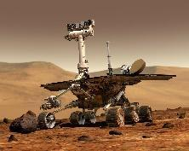Non-fiction – Journal – Mars Rover  Year 5  Independent Write: New Viewpoint – write a transmission from the POV of a different astronaut  Acronym  Informal speech  Apostrophes  Technical vocabulary  Adverbial of time  Dash  Question  Subordinating conjunction  Metaphor  Personification  Conjunctions  Repetition | 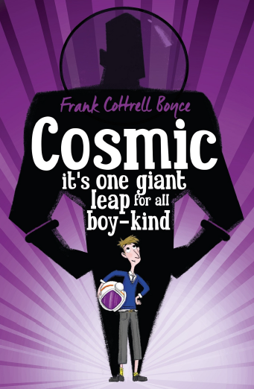  Fiction – Narrative – Cosmic (Frank Cottrell-Boyce)  Year 5  Independent Write: New viewpoint on the same plot  Adjectives  Questions  Dialogue  Brackets  Relative clauses  Commas  Complex sentences  Pathetic fallacy  Modal verbs  Adverbs | 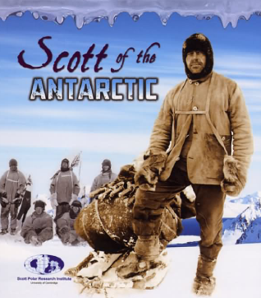  Non-Fiction – Diary – Scott of the Antarctic (Evelyn and Julian Dowdeswell)  Year 5  Independent Write: Children to write diaries or a blog as a member of the camera crew  Fronted adverbial  Dash  Personification  Simile  Modal verbs  Onomatopoeia  Brackets  Adverbs  Parenthesis | 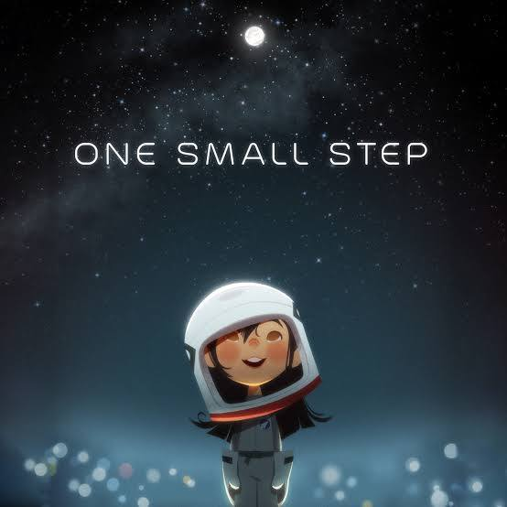  Narrative – Story – One Small Step (Taiko Studios)  Year 5  Independent Write: New viewpoint on the same plot - dad  Modal verbs  Question  Complex sentences  Colon  Commas in a list  Alliteration  Dialogue  Conjunction  Adjectives  Adverbials  Relative clause  Repetition  Simile  Pathetic fallacy  Repetition  Metaphor

Porthluney – Year 5 and 6 Punctuation and Grammar Overview
YEAR A
Unit One | Unit Two | Unit Three | Unit Four | Unit Five | Unit Six | Unit Seven | Unit Eight
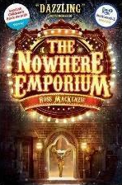  Narrative – Mystery – The Nowhere Emporium (M.A. Rosa)  Year 5  Independent Write: Continuation of plot  Modal verbs  Adverbials of time  Similes and metaphors  Relative clauses  Alliteration  Parenthesis (Brackets)  Prepositions  Rhetorical questions  Prefixes  Dialogue (action)  Personification  Colon  Semi-colon | 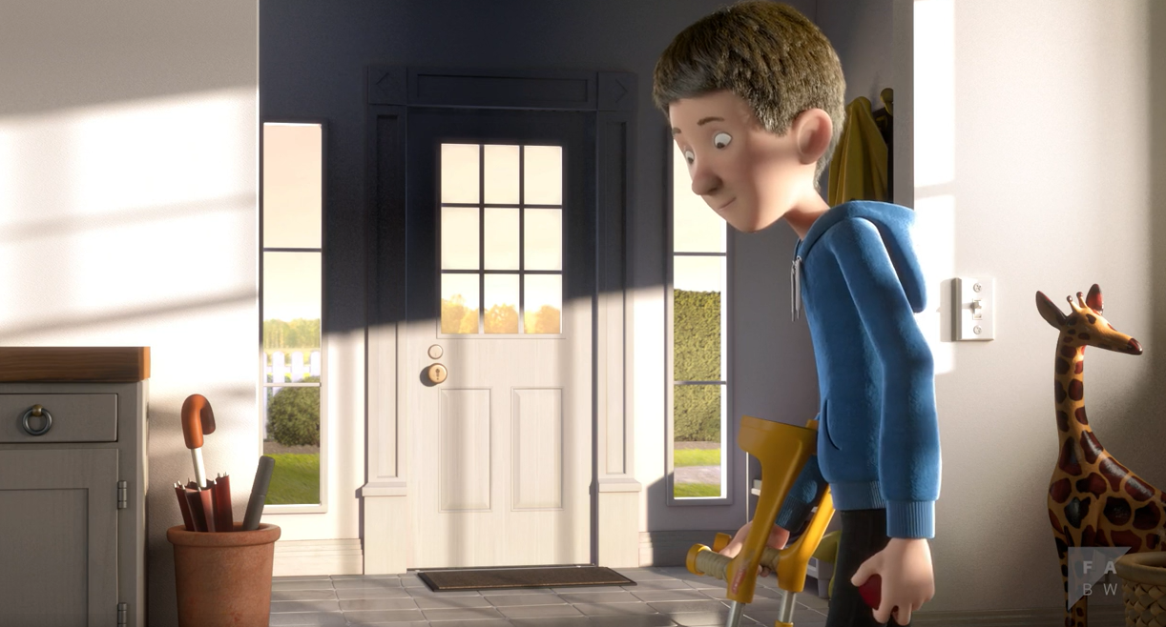  Narrative – Story – The Present (Literacy Shed)  Year 5  Independent Write:  New viewpoint on the same plot (Mum’s point of view)  Colon  Onomatopoeia  Relative clauses  Adverbials of time  Dialogue  Prefixes  Figurative language  Conjunctions  Brackets  Modal verbs  Comparatives and superlatives  Adverbs  Dashes  Complex sentences  Passive voice? | 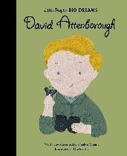  Non-Fiction – Biography – David Attenborough (Little People, Big Dreams)  Year 5  Independent Write: Biography based on other scientists  Alliteration  Colon  Parenthesis  Exclamation  Rhetorical questions  Modal verbs  Complex sentences  Conjunctions  Onomatopoeia  Adverbs  Quotes  Prefixes | 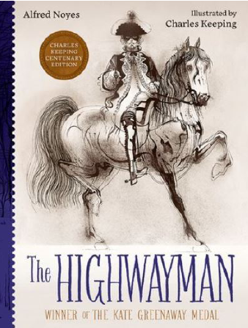  Poetry – Narrative Poem – The Highway Man (Alfred Noyes)  Year 5  Independent Write: Narrative poem with alternative ending  Adjectives  Repetition  Figurative language  Alliteration  Dialogue  Onomatopoeia  Conjunctions | 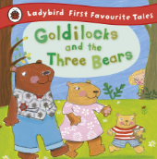  Non-Fiction – Newspaper Report - Goldilocks  Year 6  Independent Write: Hansel and Gretel found in a sweet house  Headline  Strapline  Caption  Five Ws  Hyperbole  Questions  Dialogue (formality)  Passive voice  Subjunctive form  Bullet points  Parenthesis  Formality shifts | 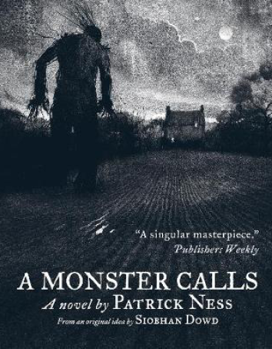  Narrative – Horror – A Monster Calls (Patrick Ness)  Year 6  Independent Write: Same characters, different plot  Fronted adverbials  Rhetorical questions  Complex sentences  Relative clauses  Alliteration  Adjectives  Onomatopoeia  Dialogue  Subjunctive form  Figurative language Conjunctions | 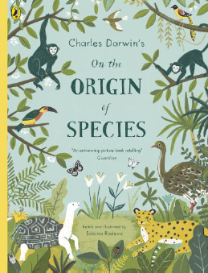  Non-Fiction – Non-Chronological Report – The Origin of Species (Sabina Radeva)  Year 6  Independent Write: Non-Chronological report on evolution  Title  Rhetorical questions  Conjunctions  Relative clauses  Apostrophes  Pun  Fronted adverbials  Adverbs  Adjectives  Colon  Sub-headings  Figurative language Scientific terminology  Summary  Conclusion | 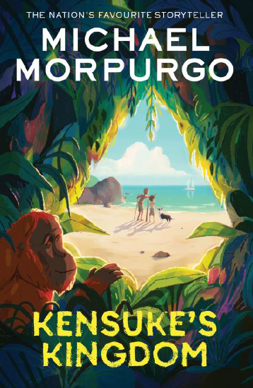Narrative – Adventure - Kensuke’s Kingdom (Michael Morpurgo)  Year 6  Independent Write: New viewpoint on the same plot  Repetition  Prepositions  Adjectives  Complex sentences  Modal verbs  Onomatopoeia  Personification  Figurative language  Alliteration  Passive voice  Semi-colon  Dialogue

YEAR B
Unit One | Unit Two | Unit Three | Unit Four | Unit Five | Unit Six | Unit Seven | Unit Eight
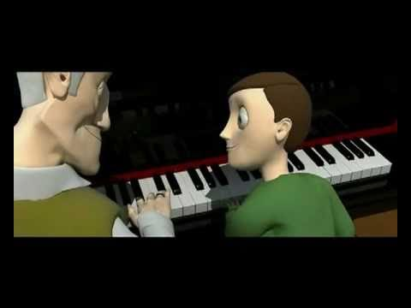  Narrative – The Piano (Aidian Gibbons)  Year 5  Independent Write: Write from the viewpoint of the grandson  Repetition  Figurative language  Conjunctions  Commas in a list  Onomatopoeia  Dash  Suffixes  Rhetorical question  Relative clause | 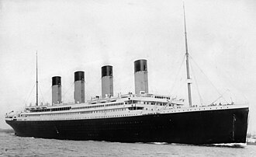  Non-Fiction - Newspaper Report - The Titanic  Year 5  Independent Write: Write a newspaper report about the Titanic sinking  Alliteration  Adverbs  Fronted adverbials  Figurative language  Dashes  Repetition  Parenthesis  Relative clauses  Questions  Conjunctions  Hyphens | 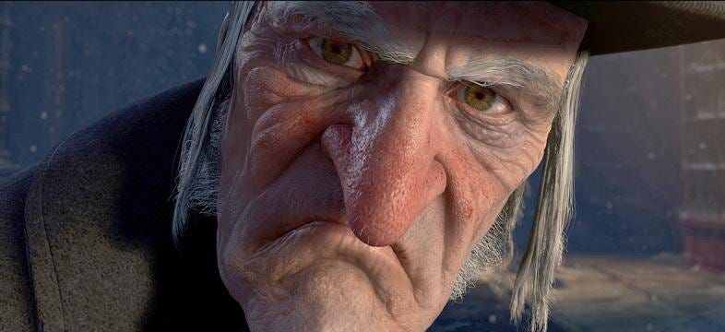Non-Fiction - Persuasive Letter - Letter to Scrooge  Year 6  Independent Write: Letter to the Grinch  Complex sentence  Alliteration  Repetition  Fronted adverbial  Adverbs  Figurative language Conjunctions  Parenthesis  Alliteration  Rhetorical questions  Dialogue  Noun phrase | 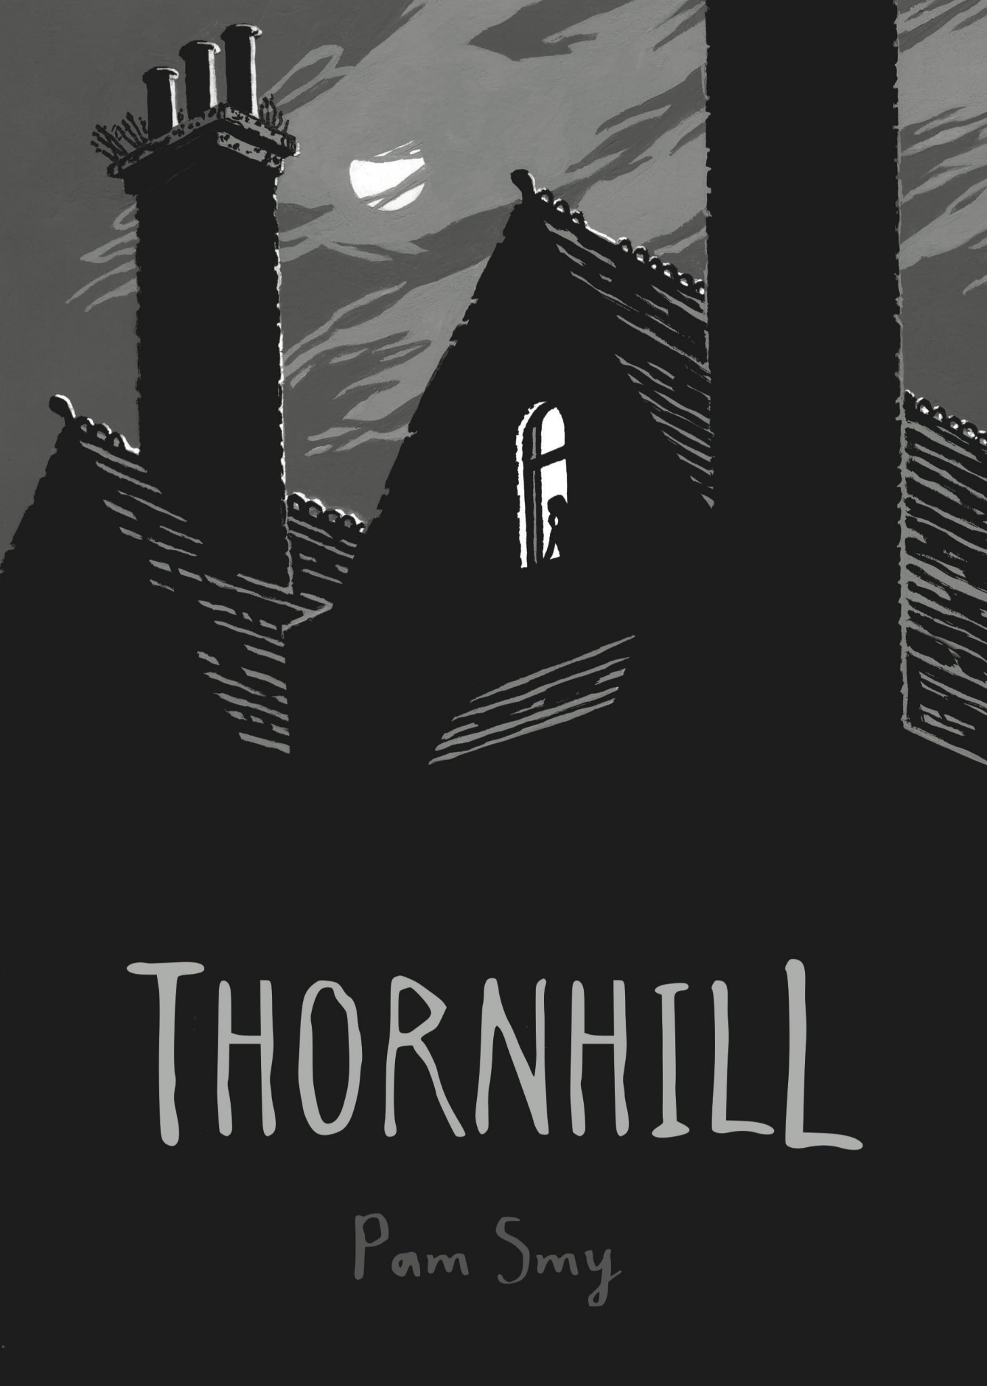Narrative – Ghost Story – Thornhill (Pam Smy)  Year 6  Independent Write: Write a diary entry from Ella.  Colon  Figurative language  Preposition  Relative clause  Exclamation  Passive voice  Question  Alliteration  Adverbs  Adverbials of time  Hyphens  Adjectives  Repetition | 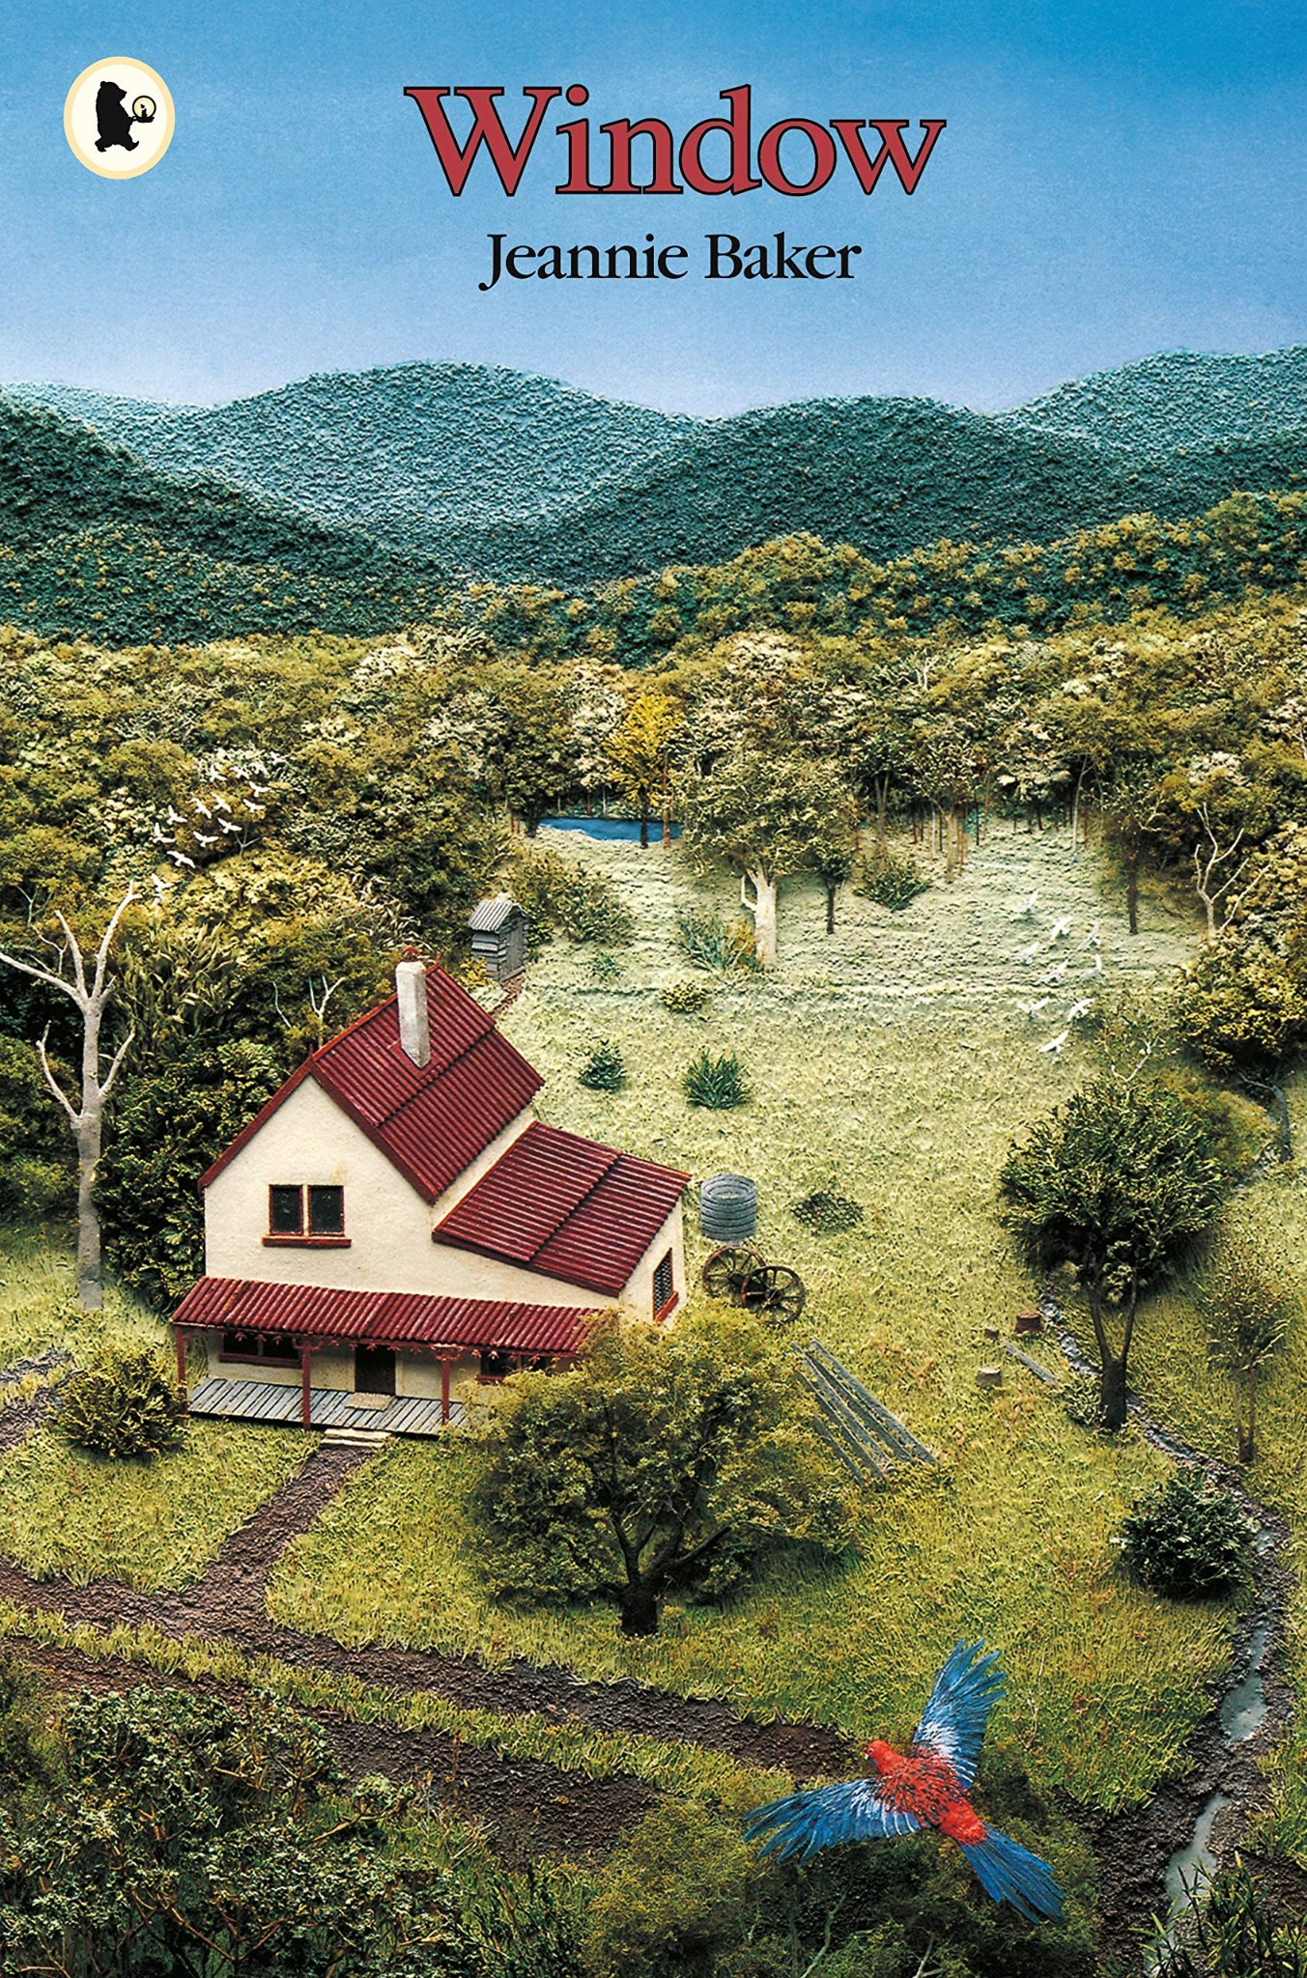  Narrative – Window (Jeannie Baker)  Year 6  Independent Write: New viewpoint on the same plot  Figurative language  Semi-colon  Dialogue  Adverbs  Adverbial phrases  Repetition  Onomatopoeia  Relative clause  Modal verbs  Questions  Suffixes  Exclamation  Rhyme  Alliteration | 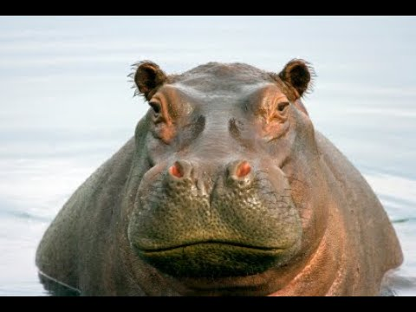  Poetry - Narrative Poetry - Hope-O-Potamus  Year 6  Independent Write:  Choose an animal, like a Hope-lodocus, and write a poem detailing their journey of hope  Preposition  Rhyme  Dialogue  Adverbial of time  Parenthesis | 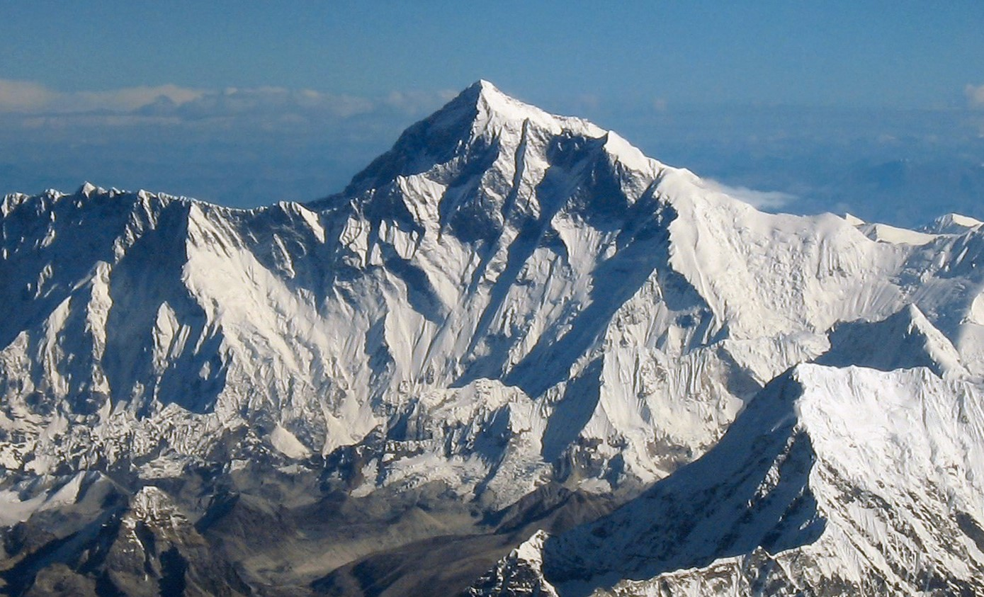  Non-Fiction - Non-Chronological Report – Everest (Sangma Francis)  Year 6  Independent Write:  Research and write a non-chronological website on the seven summits: the highest peaks of the 7 continents  Figurative language Relative clause  Colon  Subheading  Prepositions  Technical vocabulary  Fronted adverbial  Adverb  Conjunctions  Noun phrase | 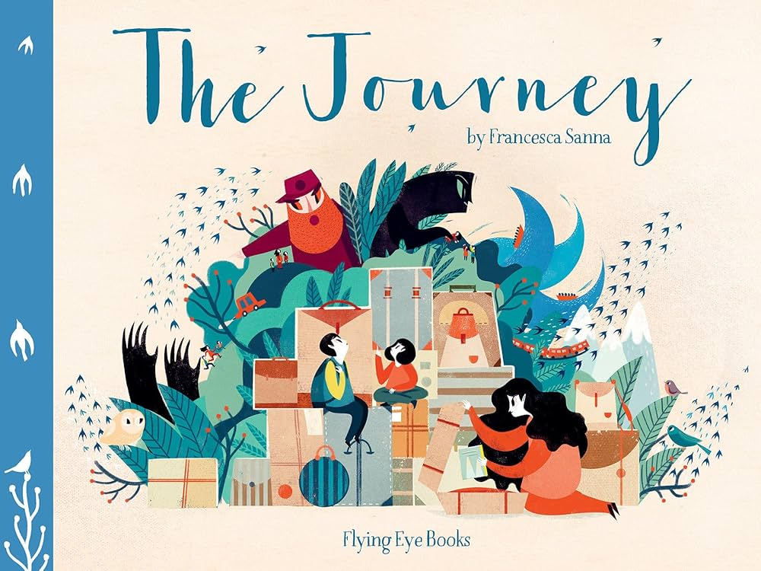Narrative - Romance - The Journey (Francesca Sanna)  Year 6  Independent Write  Read ‘Azzi in Between’ and write your own story about refugees fleeing their homes  Repetition  Complex sentences  Alliteration  Passive voice  Colon  Hyphens  Dialogue  Adverbs  Relative clauses  Conjunction  Figurative language

