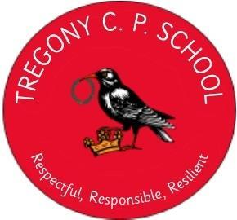

**Tregony School Curriculum Drivers**

Alongside teaching the requirements of the national curriculum, key drivers have been identified.  We use these 'drivers' to underpin the learning and experiences we undertake in all areas of school life and to ensure our curriculum offer is enriched.  These key drivers are personal to our school while reflecting the social and educational needs of our local area at this point in time. They will be regularly reviewed and adapted accordingly.

**Locality**

We embrace our locality within our curriculum. We do this by celebrating and using the incredible resources we have on our doorstep as a vehicle to enhance our understanding of humanities, the arts and sports within our beautiful rural, Cornish environment. This allows pupils to appreciate and comprehend their learning relating to what they can see and experience in the world around them.

**Diversity**

Careful consideration is made when selecting literature, experiences and role models, which expand pupils’ horizons. We promote, celebrate, understand and appreciate diversity within our school community. Furthermore, we challenge stereotypes so that our children recognise the achievements and contributions from all faiths, races, cultures and genders have made - and continue to make - to our unique and diverse world. In doing so, our pupils will be tolerant and understanding citizens of the future.

**Language**

We believe that the ability to communicate effectively is an essential life skill. We prioritise language development with a clear emphasis on building vocabulary in every lesson, developing oracy by ensuring that all spoken interactions are language rich. Talk is used as a tool for success in every lesson and beyond so that our children are confident and articulate communicators. Explicit vocabulary instruction is an integral part of every lesson; it is woven into explanations, high-quality talk, the development of reading skills and opportunities for all pupils to articulate themselves confidently.

**Back Lane, Tregony, Truro, TR2 5RP**

**Telephone: 01872 530643**

**Headteacher: Mrs Kate Douglass**

**Email: secretary@tregony.cornwall.sch.uk**

**Website: www.tregonycpschool.co.uk/website**

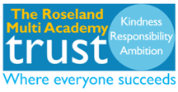

Yours sincerely

**Mrs Kate Douglass**

**Headteacher**