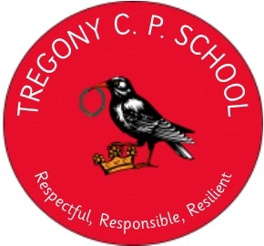

Privacy Notices:
Children in need or children looked after: information held by local authorities
The Data Protection Act 1998: How we use your information
We collect and process information about children in our care and children to whom we provide services. We use this personal data to:
• support these children and monitor their progress
• provide them with pastoral care; and
• assess the quality of our services
We are required, by law, to pass on some of this information to the Department for Education (DfE) which uses it to; develop national policies, manage local authority performance, administer and allocate funding and identify and encourage good practice. Under certain conditions, DfE may share some of the information we provide to them with third parties (e.g. for the purpose of research). Any such sharing by DfE is strictly controlled and in compliance with the Data Protection Act 1998.
If you require more information about how we and/or the DfE use this information, please visit:
• our website at: www.gerrans.cornwall.sch.uk
• the DfE’s website at: https://www.gov.uk/data-protection-how-we-collect-and-share-research-data
If you are within one of these groups of children and want to see a copy of information about you that we hold, please contact:
- secretary@tregony.cornwall.sch.uk
- www.cornwall.gov.uk

