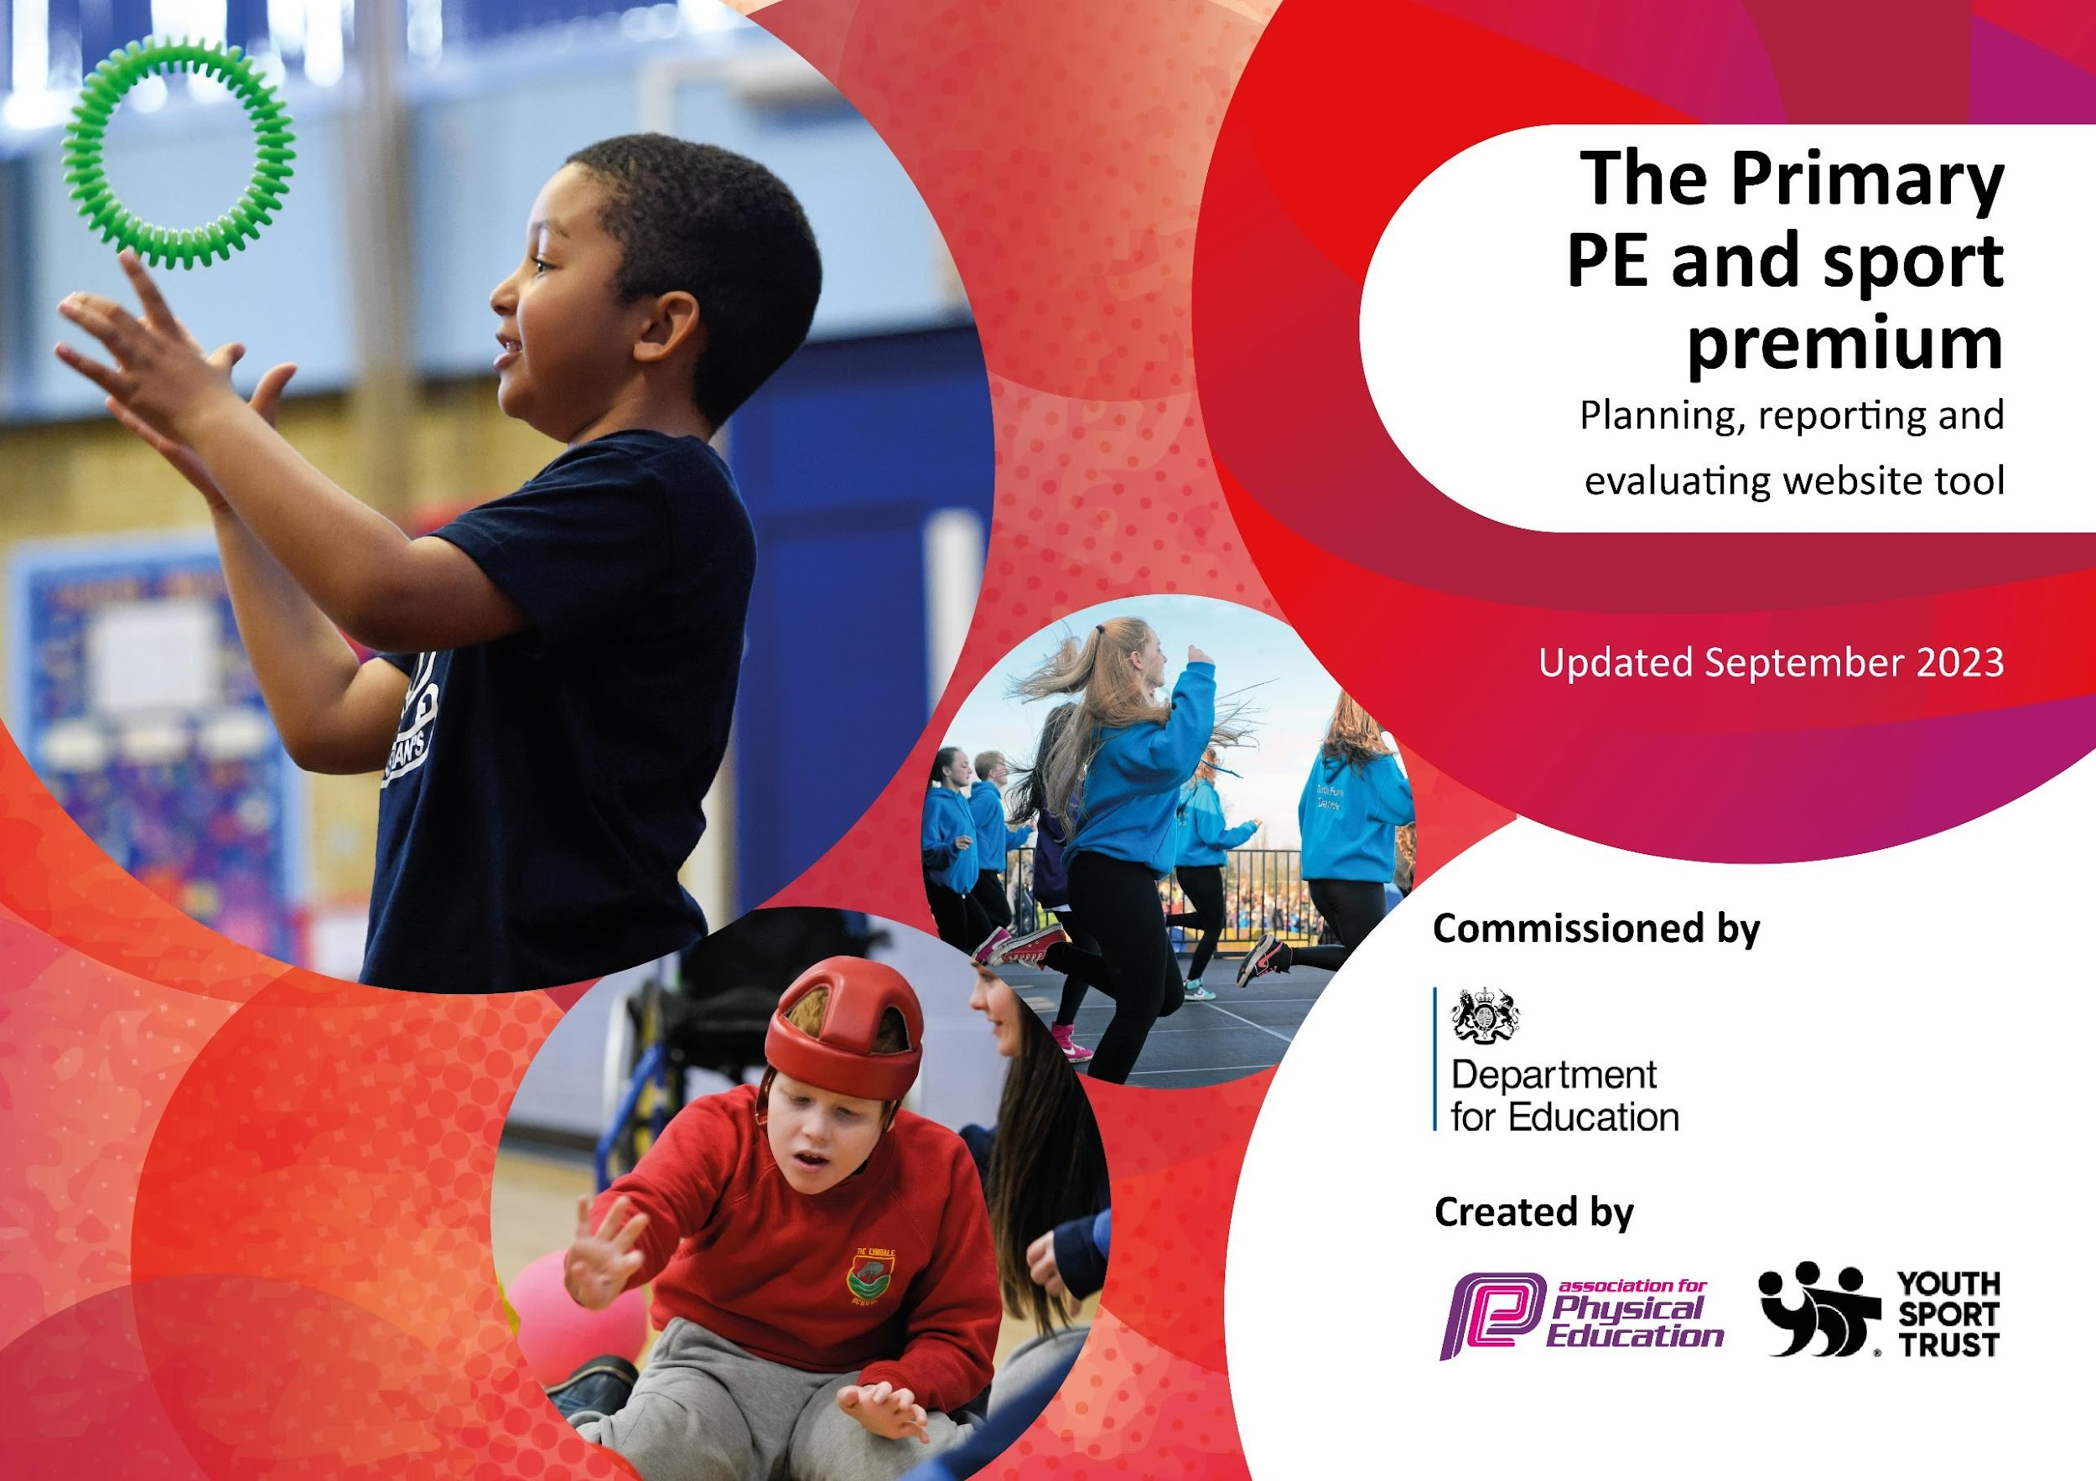

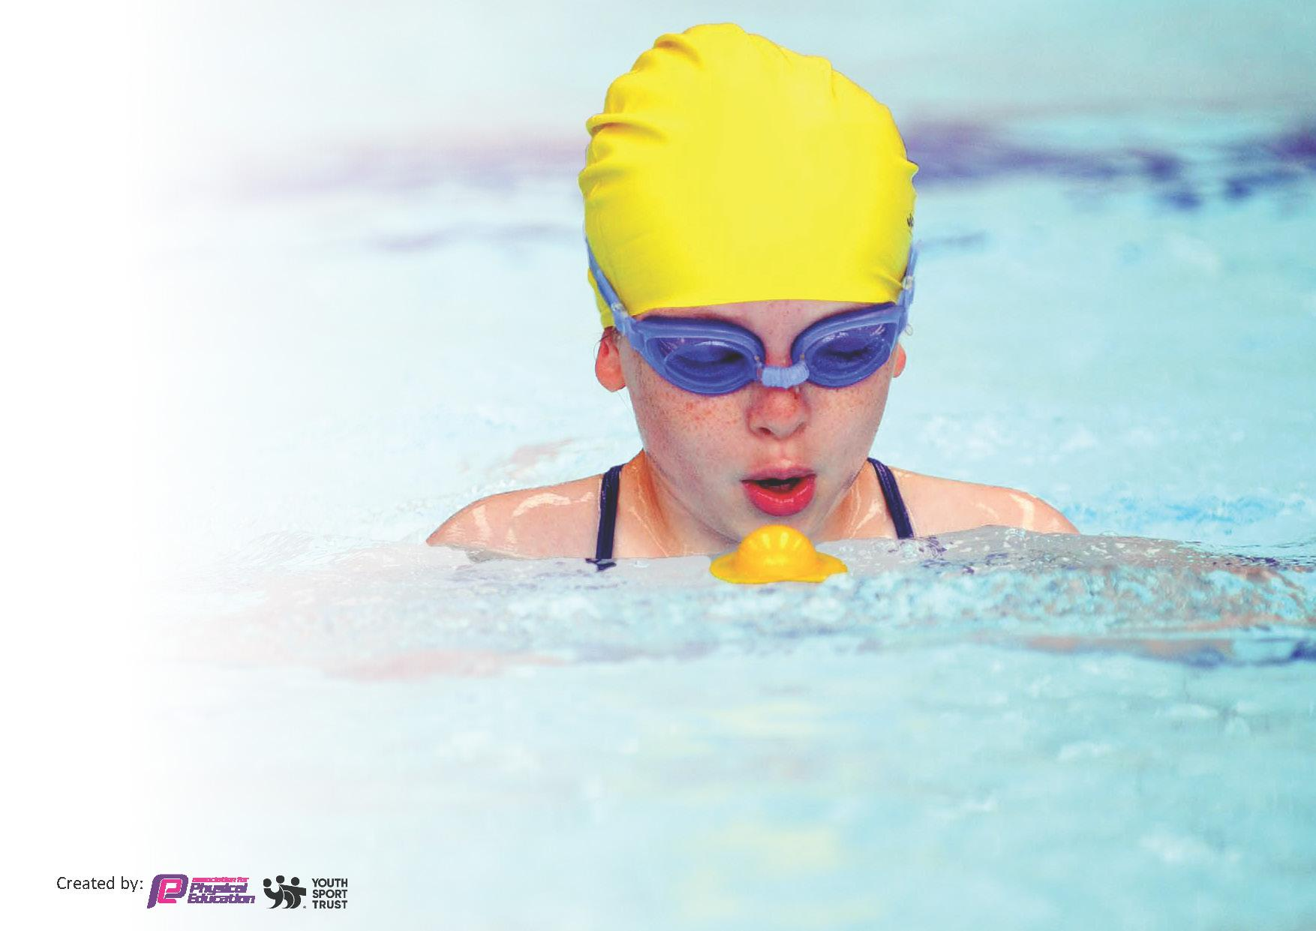
This template can be used for multiple purposes:
by:
- It enables schools to effectively plan their use of the Primary PE and sport premium
- It helps schools to meet the requirements (as set out in guidance) to publish information on their Primary PE and sport premium
- It will be an effective document to support Ofsted inspections enabling schools to evidence progress in Physical Education (PE) and evidence swimming attainment, which forms part of the PE National Curriculum. We would recommend schools consider
the Intent, Implementation and Impact of any spend, as examined within the Education Inspection Framework.

It is important that your grant is used effectively and based on school need.

Schools must use the funding to make additional and sustainable
improvements to the quality of the PE, School Sport and Physical Activity (PESSPA)
they offer. This means that you should use the Primary PE and sport premium to:

- Build capacity and capability within the school to ensure that improvements made now will benefit pupils joining the school in future years
- Develop or add to the PESSPA activities that your school already offers.

The Primary PE and sport premium should not be used to fund capital spend projects; the school’s core budget should fund these. Further detail on capital expenditure can be found in the updated Primary PE and sport premium guidance.

The Primary PE and sport premium guidance, outlines 5 key priorities that funding should be used towards. It is not necessary that spending has to meet all the key priorities, you should select the priorities that you aim to use any funding towards.

Although completing this template is not a requirement for schools, schools are required to publish details of how they spend this funding. Schools must also outline what the impact this funding has had on pupils’ PE and sport participation and attainment and how any spending will be sustainable in the future. All funding must be spent by 31st July 2025.

The Department for Education has worked closely with the Association for Physical Education (afPE) and the Youth Sport Trust (YST) to develop this template and encourages schools to use it. This template is an effective way of meeting the reporting requirements of the Primary PE and sport premium.
Review of last year’s spend and key achievements (2024/2025)

Activity/Action | Impact | Comments
Purchase a curriculum that works for our school. | This will ensure that pupils receive high-quality, progressive lessons that build on prior knowledge, while staff feel confident delivering the curriculum and clearly see the progression across year groups. | Due to our KS2 structure being split across three groups, we have found that many existing curricula do not easily accommodate this model. We believe we have now developed a curriculum that ensures high-quality lessons are delivered by confident staff, with clear progression throughout the key stages.
Organise extra swimming sessions for less confident/low achievers.  Promote a variety of other sports to these pupils as well as SEN. These include surf sessions, bike-a-bility and sailing. | This will increase pupils' confidence and support them in achieving the 25m swimming target by Year 6, while providing varied experiences and opportunities to enjoy a range of different sports. | Our aim is for this additional session to support pupils in meeting the expectation of swimming 25 metres by Year 6, while also building their water confidence.  We will continue to maintain links with a range of sports providers to offer varied opportunities and encourage all pupils to participate and ‘have a go’.
To take part in interschool sporting events run through the partnership with The Roseland Cluster to promote PE across the school in conjunction with the cluster sports lead. Provide all children equal opportunities not entirely based on ability | Pupils benefit from access to a wide range of sporting opportunities, enhancing their experiences and encouraging participation in physical activity. | A greater number of pupils have the opportunity to participate in sporting activities and competitions against other schools. To support this, staff are minibus trained, enabling safe and efficient transport for pupils to events.

Key priorities and Planning

Total Funding Received Year 2025--2026 | £17,400

Action – what are you planning to do | Who does this action impact? | Key indicator to meet | Impacts and how sustainability will be achieved? | Cost linked to the action
Implement and embed a progressive PE curriculum across all year groups, ensuring clear progression of skills and knowledge. Provide staff training and curriculum resources where needed. | All pupils and teaching staff. | Key Indicator 1: Increased confidence, knowledge and skills of all staff in teaching PE and sport. | Staff confidence and subject knowledge will improve through CPD and shared planning. A well-sequenced curriculum will ensure consistent, high-quality PE provision that can be sustained in future years without additional support. | £4,800
Provide opportunities for all pupils to participate in inter-school competitions and festivals through the Roseland Cluster Sports Partnership, ensuring inclusive participation rather than selection based solely on ability. | All pupils, particularly those who would not normally represent the school. | Key Indicator 5: Increased participation in competitive sport. | Regular participation in festivals and competitions will develop confidence, teamwork and resilience while strengthening links with local schools. The partnership provides a sustainable annual programme of events. | £2,600
Broaden pupils' sporting experiences by offering alternative activities such as surfing, sailing and Bikeability, with a particular focus on SEND pupils and those less engaged in traditional PE. SEND pupils, less active pupils and all children through enrichment opportunities. | SEND pupils, less active pupils and all children through enrichment opportunities. | Key Indicator 4: Broader experience of a range of sports and physical activities offered to all pupils. | Pupils will develop confidence and experience activities they may not otherwise access. Strong links with external providers will enable these opportunities to continue and support lifelong participation in physical activity. | £3,400
Provide a wide range of extra-curricular sports clubs, including football, netball, athletics and seasonal activities, led by school staff and external coaches where appropriate. | Pupils across all year groups. | Key Indicator 2: Engagement of all pupils in regular physical activity. | A varied extra-curricular programme will increase participation in physical activity, improve health and wellbeing, and create pathways into competitive sport. Staff involvement will ensure clubs remain sustainable year on year. | £5,000
Raise the profile of PE and physical activity across the school by promoting active and healthy lifestyles through improved playground provision, whole-school participation events and healthy living initiatives. This includes purchasing playground equipment to encourage active playtimes, organising a whole-school Mini Marathon and promoting healthy morning snacks. | All pupils and staff. | Key Indicator 3: The profile of PE and sport is raised across the school as a tool for whole-school improvement. | New playground equipment has increased opportunities for active play at break and lunchtime, encouraging pupils to be more physically active throughout the school day. The whole-school Mini Marathon ensured every pupil participated in a shared physical challenge, promoting inclusion, perseverance and enjoyment of exercise. The promotion of healthy morning snacks reinforces healthy lifestyle choices and supports pupils' wellbeing and readiness to learn. Playground equipment will continue to be used by future cohorts, and annual events such as the Mini Marathon will become established features of the school calendar, embedding a positive culture of health and physical activity. | £1,500

Swimming Assessments (2025-26)

Meeting National Curriculum requirements for swimming and water safety.
Priority should always be given to ensuring that pupils can perform safe self-rescue even if they do not fully meet the first two requirements of the National Curriculum programme of study

Question | Stats: | Further context  Relative to local challenges
What percentage of your current Year 6 cohort can swim competently, confidently and proficiently over a distance of at least 25 metres? | 95% | All KS2 have taken part in swimming. They swim for five consecutive afternoons in a week and pupils were taught by a specialist swimming instructor. The impact of this is significant as pupils’ progress quicker. As a result, 100% of Y6 that attended swimming sessions (one did not) and 60% KS2 pupils achieved the national swimming distance.
What percentage of your current Year 6 cohort can use a range of strokes effectively [for example, front crawl, backstroke, and breaststroke]? | 95%
What percentage of your current Year 6 cohort are able to perform safe self-rescue in different water-based situations? | 95%
If your schools swimming data is below national expectation, you can choose to use the Primary PE and sport premium to provide additional top-up sessions for those pupils that did not meet National Curriculum  requirements after the completion of core lessons. Have you done this? | Yes/No
Have you provided CPD to improve the knowledge and confidence of staff to be able to teach swimming and water safety? | Yes/No | The school has paid for qualified instructors at the pool whereas previously, our teachers and/or support staff have delivered swimming lessons. Each teacher attends the sessions in order to upskill themselves so that in time, confidence levels of staff will improve.

Head Teacher: | Kate Mitchell
Subject Leader or the individual responsible for the Primary PE and sport premium: | Kayliegh Mulroy
Date: | July 2026
Signed off by:

Key achievements 2025-2026

This template will be completed at the end of the academic year and will showcase the key achievements schools have made with their Primary PE and sport premium spending.

Activity/Action | Impact | Comments
Implement and solidify a new curriculum that ensures progression throughout the year groups. | A clear, progressive PE curriculum has been embedded across all year groups. Pupils demonstrate improved knowledge, skills and confidence, with lessons building effectively on prior learning. Assessment information shows increased attainment and engagement in PE. | Curriculum maps, progression documents and assessment tools have been introduced. Staff have received support and training to ensure consistent delivery across the school. Curriculum will continue to be reviewed and refined in response to pupil outcomes.
To take part in interschool sporting events run through the partnership with The Roseland Cluster to promote PE across the school in conjunction with the cluster sports lead. Provide all children equal opportunities not entirely based on ability | Increased participation in competitive and festival events has enabled a wider range of pupils to represent the school. Pupils have developed teamwork, resilience, confidence and sportsmanship. Participation has been inclusive, with opportunities available to children of all abilities. | Strong links with the Roseland Cluster have provided a varied calendar of events. Selection has focused on inclusion as well as performance, ensuring children who may not usually access competition have had opportunities to participate. Positive feedback has been received from pupils and parents.
Promote a variety of other sports to less confident/low achievers as well as SEN. These include surf sessions, bike-a-bility and sailing. | Pupils who are less engaged in traditional PE have shown increased confidence, motivation and enjoyment through alternative activities. Participation rates among SEND pupils and targeted groups have improved, supporting physical, social and emotional development. | Alternative sporting opportunities have broadened pupils' experiences and encouraged lifelong participation in physical activity. Staff will continue to identify activities that meet the needs and interests of all learners to ensure inclusive provision.
Provide a range of extra-curricular sporting activities through teachers leading different sporting clubs e.g. netball, football, athletics | A wide range of extra-curricular clubs has increased pupil participation in physical activity beyond the curriculum. Pupils have developed their sporting skills, confidence, teamwork and resilience, while promoting healthy, active lifestyles. Participation has increased across different year groups, with opportunities available for pupils of all abilities and interests. | Teachers have successfully led a variety of after-school clubs including netball, football, athletics and other seasonal activities. Clubs have provided pathways into inter-school competitions and encouraged sustained engagement in sport. Registers show good attendance, and pupil voice indicates high levels of enjoyment and enthusiasm. The programme will continue to be reviewed to ensure it remains inclusive and reflects pupils' interests.
Raise the profile of PE and physical activity across the school to promote healthy lifestyles and whole-school participation. This includes purchasing new playground equipment, organizing a whole-school Mini Marathon and promoting healthy morning snacks. | The profile of PE and sport has been raised across the school, contributing to improved physical activity levels, wellbeing and a positive school culture. All pu0pils took part in the Mini Marathon, showing perseverance and teamwork. Active playtimes have increased due to new equipment, and healthy snack choices are now promoted as part of a balanced lifestyle. | New playground equipment has increased active play at break and lunchtimes. The Mini Marathon is now an annual event on the school calendar, ensuring continued participation. Promotion of healthy morning snacks supports pupils’ wellbeing and readiness to learn and will continue through ongoing communication with parents and carers.

