Friday 7th February 2020
Dear Parents/Carers,
On Thursday, we welcomed Headteachers and trustees from The Roseland Multi-Academy Trust. These days form part of our ongoing monitoring of teaching and learning in our school. I am delighted to report that visitors commented on pupils' excellent behaviours for learning and how articulately they explained their learning. During the School Council meeting, children said that they felt cared for and safe and discussed all of the exciting camps and extra curricular activities we offer. They were enthusiastic about our end of term topic celebrations. During the afternoon, we visited Gerrans Primary School and their enviable geographical location, overlooking the sea. Being a smaller school than ourselves, with only two classes, it was a delight to spend time in a setting whereby older pupils nurtured younger peers with such care.
There are always ways in which to develop the teaching and learning in our schools and these improvements are part of our ongoing School Improvement Plan. The monitoring visits help us to identify these areas of focus. One such area, across all schools, is reading. Ensuring that pupils are equipped with the phonetic knowledge required to enable pupils to read. Then, once becoming fluent readers developing and embedding the skills of reading comprehension and inciting a love of reading is crucial. We ask that pupils read at home at least four times a week as no other skill is more important. It is the gateway to all other knowledge. If children do not learn to read efficiently, the path to learning is blocked to every subject they encounter in their school years.
As the mornings and evenings are starting to get lighter, it is lovely to see so many children playing around the village and walking to and from school. However, some members of our staff and members of the community have noticed that children are not always exercising road safety rules. I have reminded them of these in assembly but it may be a good idea to reinforce them further at home. Our local PCSO will be visiting us on Tuesday to deliver an internet safety assembly, but will also be talking to our older students about this further.
During February half-term, Roseland Dental would like to extend an offer to any children from Tregony School without a dentist. This is for infant and preschool aged pupils only. Please contact; contact@roselanddental.co.uk stating that they are from Tregony School or at Tregony Preschool. There is no charge for children.
Please remember to call the school mobile on a Friday afternoon and during wrap around care hours rather than the school number. The number is 073948186336. Thank you.
I hope you all have a warm and safe weekend, sheltering from the predicted ferocity of Storm Ciara!
Kate Douglass
Headteacher.
Letters went out this week for the Par cross country;. after next weeks’ race, we will know for certain who will have qualified for the semi finals. Once I know, I will send out letters of invitation. Letters also went out for the basketball tournament next week. Unfortunately I have had to change the team for this due to the year 6’s swimming the same afternoon..

Miss Mulroy

P.E lead
- Multi-academy Trust letter  - Basketball letter | Value of the Week: Care
Finally, don’t forget to check our website for school related information, which we are in the process of updating.
- Tuesday 11th February - Safer internet day
- Monday 17th February - Half term
- Wednesday 26th February - Parents Evening

Swimming Dates
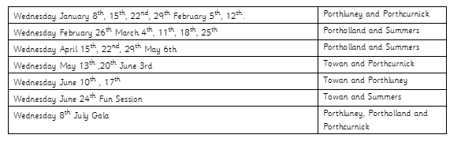

James Trudgeon for amazing fractions work  Saskia Curgenven for showing a love of reading | Towan: Otis Wilson for super discussion skills on the carpet and encouraging children to play with a purpose.  Summers: Sennen Fanshawe for working hard in maths this week  Porthcurnick: Nancy Craddock and Evie Tuby for super artwork. Ollie Baker for super explanations of his learning.  Portholland: Huw Floyd Norris for excellent motivation and accuracy when looking at fractions in maths. James Trudgeon for an accurate explanation of how to use fractions when dividing.  Porthluney: Rhys Carpenter for having an excellent attitude towards maths and showing his growing understanding through his SATs homework  P.E: Sienna Andrew for always working hard in lessons and being a great role model to others
Godrevy: 661  Trevose: 711  St Antony: 1059  Lizard: 989 | Towan: 93.20%  Summers: 93.83%  Porthcurnick: 94.02%  Portholland: 97.32%  Porthluney: 93.87%
White band:  Yellow band: Hope Baker, Oliver Hook, Mia Giannini-anderson  Orange band: Arya Insoll, Arthur Coghlan,  Jago Martin | Blue band: Noah Punch  Green band: Sennen Bishop, Elowyn Appleyard, Toby Rounsevell  Brown band: Jack Filbey, Elizabeth Dicker, Daniel Dicker, Henry Baker  Black band: Taylan Hodgkiss

Star of the Week:

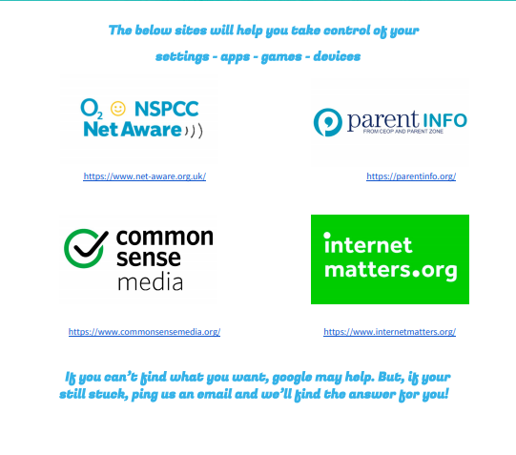

Tregony Clockhouse Players will be performing their pantomime during half-term week. Lots of our pupils will be performing so please support this community event.

