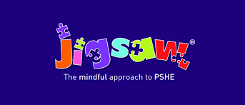

Promoting the Protected Characteristics at Tregony Primary School
.
The Equality Act became law in 2010. It covers everyone in Britain and protects people from discrimination, harassment and victimisation. Everyone in Britain is protected. This is because the Equality Act (2010) protects people against discrimination because of the protected characteristics that we all have.

Under the Equality Act (2010), there are nine Protected Characteristics:

- Age
- Disability
- Gender reassignment
- Race
- Religion or belief
- Marriage or civil partnership
- Sex
- Sexual orientation
- Pregnancy and maternity

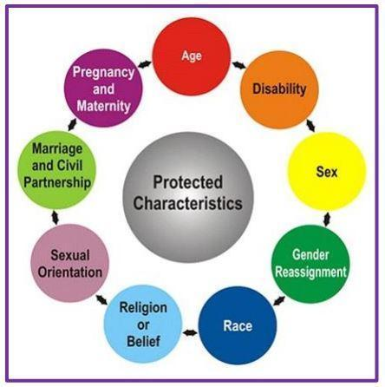

At Tregony Primary School, we actively promote these in our curriculum and work to embed them into our school culture, as part of PSHE lessons and in the wider curriculum.

Jigsaw, our PSHE curriculum, takes a multi-faceted approach to the teaching of protected characteristics. Equality and diversity are promoted within the PSHE curriculum, during school assemblies, in science and where applicable, other subjects too. The school has its ‘Three Rs’ of ‘Respect, Resilience and Responsibility’. Our reading material both in the library, book corners and the texts we study have been selected carefully to prevent unconscious bias and to raise and respond to issues relating to protected characteristics.

Our inclusive approach starts with children in Nursery and Reception (ages 2-5) and continues to develop through the age ranges. Jigsaw establishes ground rules that are fundamental to creating and maintaining an inclusive and safe teaching and learning environment. Establishing such an environment for both our pupils and teachers is important for PSHE education lessons – especially those focusing on equality and the protected characteristics as it

• enables them to feel comfortable exploring values and attitudes
• enables them to express their own opinions and consider the views and opinions of others, without the fear of negative feedback, and only if they choose to.

Jigsaw establishes a safe, open and inclusive learning environment based on trusting relationships between all members of the class, adults and pupils alike. To enable this, ‘ground rules’ are agreed and referred to as ‘The Jigsaw Charter’. This creates a space where pupils can feel safe and their wishes are taken seriously by all. Pupils choose whether they speak or not and their right to pass is upheld and respected. Pupils are taught to respect the privacy of others and to do their best to keep what is said confidential during lessons, although it is recognised that complete confidentiality is impossible as adults teach children that any information relating to safeguarding concerns must be reported.

Throughout Jigsaw, the mindful approach to PSHE, students are encouraged by staff to ask questions, to find someone who can help them, and ultimately to help themselves by becoming more independent; in terms of content, the Puzzle ‘Celebrating Difference’ is the most pertinent of units for teaching about the protected characteristics, as it focuses on similarities and differences and teaches about diversity, such as disability, racism, gender, family composition, friendships, and conflict. Children learn to accept everyone’s right to ‘difference’, and most year groups explore the concept of ‘normal’. Bullying – what it is and what it isn’t, including cyber and homophobic bullying – is an important aspect of this Puzzle. The ‘Relationships’ puzzle also has a wide focus, looking at diverse topics such as families, friendships, equality in relationships, and love and loss – all of which can help to deliver the vital messages behind the Equality Act. A vital part of this puzzle is about safeguarding and keeping children safe; this links to cyber safety and social networking, as well as attraction and assertiveness; children learn how to deal with conflict, their own strengths and self-esteem. They have the chance to explore roles and responsibilities in families and look at stereotypes. All Jigsaw lessons are delivered in an age- and stage-appropriate way so that they meet pupils’ needs and can help them understand the wider world. The Jigsaw curriculum aligns to the Equality Act.

Another way we embed a culture of developing pupils’ understanding of the protected characteristics is by learning about and advocating equality and diversity. One way we do this is through the literature we use. Our books ensure that gender and gender identity, religion, race, sexual orientation, disability and age is explored. The focus of the literature is to notice, celebrate and develop resilience around diversity. Through discussion, children are encouraged to show respect and develop their understanding of diversity.

The grid below shows how particular Jigsaw lessons address themes relating to protected characteristics:

Protected Characteristic | What this refers to | Links to Jigsaw
Age | Where this is referred to, it refers to a person belonging to a particular age (for example 32 year olds) or range of ages (for example 18 to 30 year olds). | Celebrating Difference Ages 10-11 Piece 3: Power Struggles
Gender Reassignment | The process of transitioning from one gender to another. | Celebrating Difference Ages 5-6 Piece 6: Celebrating Me. Ages 7-8 Piece 5: Gender diversity Ages 8-9 Piece 1: Judging by appearances Ages 10-11 Piece 2: Understanding difference
Marriage | Marriage is no longer restricted to a union between a man and a woman but now includes a marriage between a same-sex couple. Same-sex couples can also have their relationships legally recognised as 'civil partnerships'. Civil partners must not be treated less favourably than married couples (except where permitted by the Equality Act). | Celebrating Difference Ages 7-8 Piece 1: Families
Being pregnant or on maternity leave | Pregnancy is the condition of being pregnant or expecting a baby. Maternity refers to the period after the birth, and is linked to maternity leave in the employment context. In the non-work context, protection against maternity discrimination is for 26 weeks after giving birth, and this includes treating a woman unfavourably because she is breastfeeding. | Celebrating Difference Ages 3-4/4-5 Piece 3: Families Ages 7-8 Piece 1: Families
Disability | A person has a disability if she or he has a physical or mental impairment which has a substantial and long term adverse effect on that person's ability to carry out normal day-to-day activities. | Celebrating Difference Ages 10-11 Piece 5: Celebrating difference
Race including colour, nationality, ethnic or national origin | Refers to the protected characteristic of Race. It refers to a group of people defined by their race, colour, and nationality (including citizenship) ethnic or national origins. | Celebrating Difference Ages 9-10 Piece 2: Racism
Religion, belief or lack of religion/belief | Religion has the meaning usually given to it but belief includes religious and philosophical beliefs including lack of belief (such as Atheism). Generally, a belief should affect your life choices or the way you live for it to be included in the definition. | Celebrating Difference Ages 9-10 Piece 1: Different Cultures
Sex | A man or a woman. | Celebrating Difference Ages 6-7 Pieces 1&2: Boys and Girls
Sexual Orientation | Whether a person's sexual attraction is towards their own sex, the opposite sex or to both sexes. | Changing Me Ages 10-11 Piece 4: Boyfriends and girlfriends

